PATIENT SAFETY INCIDENT RESPONSE FRAMEWORK POLICY

27th of April 2023
Authorship: | Deputy Director of Nursing and Quality for North East Lincolnshire Place, Integrated Care Board.
Committee Approved: | ICB Quality Committee.
Approved date: | 27th of April 2023
Equality Impact Assessment: | April 2023
Target Audience: | ICB and its Committees and Sub-Committees, ICB Staff, agency and temporary staff & third parties under contract.
Policy Number: | ICB49
Version Number: | 0.1
The on-line version is the only version that is maintained. Any printed copies should, therefore, be viewed as ‘uncontrolled’ and as such may not necessarily contain the latest updates and amendments.

AMENDMENTS
Amendments to the policy may be issued from time to time. A new amendment history will be issued with each change.

New Version Number | Issued by | Nature of Amendment | Approving body | Approval date | Date published on website
V1 | Quality Team | New Policy | Quality Committee | 27.04.23

Contents
1 Organisational Responsibilities - PSIRF 4
2 ICB infrastructure to discharge PSIRF responsibilities. 5
3 Introduction 6
4 Purpose 6
5 Scope of the Policy 6
6 Duties/ Accountabilities and Responsibilities 7
6.1 Duties within the organisation 7
6.2 ICB Executive Director of Nursing 7
6.3 ICB PSIRF Lead Director of Nursing and Quality 7
6.4 ICB Quality Leads 7
6.5 ICB Learning Response Leads 7
6.6 Place Quality Groups 8
6.7 System Quality Group 8
6.8 ICB PSIRF Group 8
6.9 ICB Quality Committee 8
7 Our Patient Safety Culture 8
8 Collaboration 8
9 Oversight Roles and Responsibilities 8
10 Responding to/Learning from cross-system incidents/issues 9
11 Patient Safety Plan 10
12 Consultation 10
13 Training 10
14 Monitoring Compliance 11
15 Arrangements for Review 11
16 References 11
17 Appendices 12
18 Impact Assessments 12
18.1 Equality 12
18.2 Sustainability 12
18.3 Bribery Act 2010 12
18.4 General Data Protection Regulations (GDPR) 12

Organisational Responsibilities - PSIRF
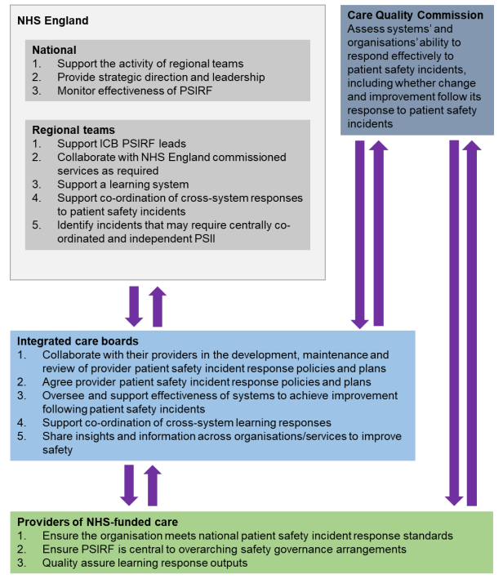

ICB infrastructure to discharge PSIRF responsibilities.

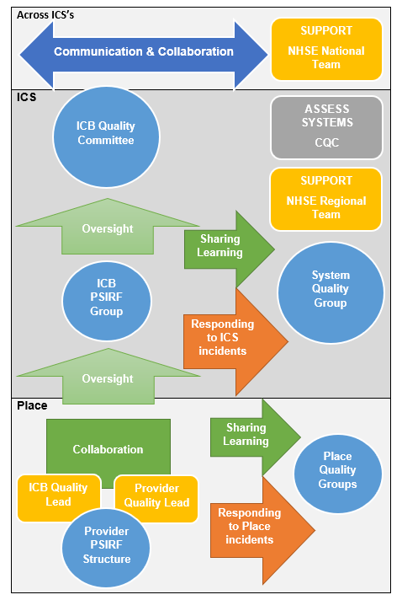

Introduction
This document is a policy which is a set of statements of principles, values, and intent in relation to the Humber and North Yorkshire Integrated Care Board’s adoption of the National Patient Safety Incident Response Framework.

Purpose
This policy supports the requirements of the Patient Safety Incident Response Framework (PSIRF) and sets out the NHS Humber and North Yorkshire Integrated Care Board’s approach to developing and maintaining effective systems and processes for responding to patient safety incidents and issues for the purpose of learning and improving patient safety.

The PSIRF advocates a co-ordinated and data-driven response to patient safety incidents. It embeds patient safety incident response within a wider system of improvement and prompts a significant cultural shift towards systematic patient safety management.

This policy supports development and maintenance of an effective patient safety incident response system that integrates the four key aims of the PSIRF:
- compassionate engagement and involvement of those affected by patient safety incidents.
- application of a range of system-based approaches to learning from patient safety incidents.
- considered and proportionate responses to patient safety incidents and safety issues.
- supportive oversight focused on strengthening response system functioning and improvement.

Scope of the Policy
The policy applies to NHS Humber and North Yorkshire Integrated Care Board and all its employees and must be followed by all those who work for the organisation, including the Integrated Care Board, Integrated Care Partnership, those on temporary or honorary contracts, secondments, pool staff, contractors and students.

This policy is specific to patient safety incident responses conducted solely for the purpose of learning and improvement across Humber and North Yorkshire Integrated Care Board.

Responses under this policy follow a systems-based approach. This recognises that patient safety is an emergent property of the healthcare system: that is, safety is provided by interactions between components and not from a single component. Responses do not take a ‘person-focused’ approach where the actions or inactions of people, or ‘human error’, are stated as the cause of an incident.

There is no remit to apportion blame or determine liability, preventability or cause of death in a response conducted for the purpose of learning and improvement. Other processes, such as claims handling, human resources investigations into employment concerns, professional standards investigations, coronial inquests and criminal investigations, exist for that purpose. The principle aims of each of these responses differ from those of a patient safety response and are outside the scope of this policy.

Information from a patient safety response process can be shared with those leading other types of responses, but other processes should not influence the remit of a patient safety incident response.

Duties/ Accountabilities and Responsibilities

Duties within the organisation
It is the responsibility of all staff to support the delivery of the patient safety incident response framework.

ICB Executive Director of Nursing
This is the person with overall accountability for this policy.

ICB PSIRF Lead Director of Nursing and Quality
The Director of Nursing and Quality is responsible for the administrative co‐ordination of
this policy.

The Director of Nursing and Quality is responsible for ensuring staff, providers of NHS funded activity and stakeholders are aware of this policy and processes to be followed.

The ICB PSIRF Lead Director of Nursing and Quality is responsible for:
- Ensuring there are ICB arrangements in place for collaborating with NHS healthcare providers in the development, maintenance and review of provider patient safety incident response policies and plans.
- Recommending the approval of provider patient safety incident response policies and plans.
- Overseeing and supporting effectiveness of systems to achieve improvement following patient safety incidents.
- Supporting the co-ordination of cross-system learning responses.
- Sharing insights and information across organisations/services to improve safety.

ICB Quality Leads
Named Quality Leads within the ICB will be identified to be responsible for:
- Collaborating with named providers/provider collaboratives.
- Overseeing and supporting effectiveness of the Place system to achieve improvement following patient safety incidents.
- Identifying learning and improvement agendas to be shared within Place at the Place Quality Group.
- Identifying incidents that require an ICS response.
- Supporting the identification of learning to be shared across the ICS.

ICB Learning Response Leads
ICB Learning Response Leads will be identified across the directorates to lead and implement Quality Improvement at Place or across the system (This role is not specific to a job title but is identified within Job Descriptions/functions of roles where the staff member is required to lead quality improvement/learning responses).

ICB Learning Response Leads are responsible for:
- Leading the response to learning within the ICB, across Places or Systems.

Place Quality Groups
The Place Quality Group is responsible for:
- Overseeing learning responses within Place.
- Receiving learning and identifying learning for Place.
- Identifying and recommending learning for System.

System Quality Group
The System Quality Group is responsible for:
- Overseeing ICS learning responses.
- Receiving learning and identifying learning for System.

ICB PSIRF Group
The ICB PSIRF Group is responsible for:
- Ensuring compliance with the ICB Policy.
- Overseeing the discharge of the ICB’s responsibilities.
- Forming an oversight statement for the Quality Committee.

ICB Quality Committee

The ICB Quality Committee is responsible for:

The approval of this policy document.
- Seeking assurance that the ICB is discharging its duties in relation to PSIRF.

Our Patient Safety Culture
Humber and North Yorkshire Integrated Care Board supports open and transparent reporting. The organisation strives to create a climate that fosters a just and open safety culture.

Collaboration
The National Patient Safety Incident Response Standards (NHSE, 2022) place a responsibility upon ICB’s to collaborate with Providers.

Collaboration is described as the act of working together to achieve or create something.

To enable effective collaboration:
- Trust and respect must be established.
- There must be a willingness to work together.
- Communication must be effective.
- Both parties must feel empowered.

The ICB’s responsibility to collaborate with providers will require the ICB to work with the relevant provider collaborative arrangements as well as with individual providers.

Oversight Roles and Responsibilities
ICB’s are responsible for agreeing provider incident response plans and policies. This responsibility must be discharged prior to implementation of PSIRF, and the oversight function must be maintained post implementation.

Oversight must be:
- Proportionate.
- Appropriate.
- Mutually Agreed.

The focus should be on collaboration and learning, and it must not add burden to any party.

There must be a clear understanding of the oversight role and function. To support this an implementation checklist is in place (please see appendix two).

Oversight role during the implementation phase.
An ICB Quality Lead will be identified to engage with a named provider. The ICB Quality Lead will join provider meetings to support collaboration and to enable the oversight responsibility to be discharged. The Provider Quality Lead and ICB Quality Lead will mutually agree the ‘ready to implement’ status by reviewing the criteria and evidence against the implementation checklist. The Provider Quality Lead and ICB Quality Lead will present the ‘ready to implement’ case to the ICB PSIRF group and, once supported, the ICB PSIRF lead will present the recommendation to implement to the ICB Quality Committee for formal sign off.

Oversight role post the implementation phase.
The ICB Quality Leads will maintain relationships with the providers to enable the ongoing oversight of provider incident response plans and policy implementation. For each provider this is likely to be a different arrangement, which will be proportionate, appropriate, and mutually agreed and will take account of provider collaborative arrangements where these exist. The ICB Quality Committee will receive a regular report on the discharge of the organisational responsibilities from the ICB PSIRF Lead.

Responding to/Learning from cross-system incidents/issues
All providers must have a process to recognise incidents or issues that require a
cross-system learning response. They must use their judgement and seek the views of
local partners to ensure learning responses are co-ordinated at the most appropriate level of the system. Where there is insufficient capacity and/or capability, providers must engage early with their ICB, which can identify the right person to support the co-ordination of a cross-system learning response.

The ICB lead will liaise with relevant providers/provider collaboratives (and other ICBs if necessary) to agree how the learning response will be led and managed, how safety actions will be developed, and how the implemented actions will be monitored for sustainable change and improvement. ICB leads appointed to support cross system learning responses must have the required time and training.

Providers and ICBs are expected to work together to establish and undertake cross-system learning responses, but where issues arise, support must be sought from the NHS England regional team.

The infrastructure to support learning responses to cross-system incidents is as follows:
- Place learning response required – Place based Quality Groups.
- Cross-places learning response required – System Quality Group.
- Cross-ICB learning response required – System Quality Group to System Quality Group.

Where required an ICB can commission an investigation (or other learning response)
that is independent of the provider. This may occur when:
- an organisation is too small (for example, does not have the workforce) to provide an objective response and analysis.
- an investigation independent of the provider is deemed necessary to ensure public confidence in the investigation integrity.
- a multi-agency incident occurs, and no single provider is the clear lead for an investigation.
- the incident(s) represent significant learning potential for the wider system (regional or national).

Advice must be sought on accessing relevant procurement frameworks from the NHS England Regional Independent Investigation Team (RIIT). All multi-agency incidents and those representing significant learning potential for the wider system should be discussed with the RIIT. This includes all incidents of mental health related homicide.

The ICB must seek to identify and share areas of good practice in relation to patient safety incident response.

Patient Safety Plan
The ICB will work with providers to support the development and oversight of their Patient Safety Plans. Oversight arrangements must be focused on enabling demonstration of improvement, and therefore arrangements are likely to be different for each of the NHS providers.

Consultation
This policy has been formed from a National directive to implement PSIRF. PSIRF has been consulted upon nationally. Locally the ICB has engaged with ICB Quality Leads and staff with an executive responsibility for quality within provision. We intend to continue an open dialogue with stakeholders as we implement PSIRF.

Training
Specific knowledge and experience are required for those leading learning responses and those in oversight roles. This includes knowledge of systems thinking and system-based approaches to learning from patient safety incidents.

Those in system oversight roles must have knowledge of effective oversight and supporting processes, including effective use of data for assurance and patient safety incident response system development. Staff in oversight roles must be appropriately trained to support the practical application of PSIRF oversight principles and standards.

 | Frequency | All Staff | Board Members | Staff leading learning responses | Those in a PSIRF oversight role
Patient safety  syllabus level 1:  Essentials for  patient safety | Annual | X | X | X | X
Patient safety syllabus level 1: Essential of patient safety for boards and senior leadership teams | Annual |  | X
Patient safety  syllabus level 2:  Access to  practice | Annual |  |  | X | X
Continuing  professional  development  (CPD) | Annual |  |  | X | X
Systems  approach to  learning from  patient safety  Incidents | Once |  |  | X | X
Oversight of  learning from  patient safety  incidents | Once |  |  |  | X
Involving those  affected by  patient safety  incidents in the  learning  process | Once |  |  | X | X

Monitoring Compliance
Compliance will be monitored by the ICB PSIRF group and will be reported to the ICB PSIRF Lead and ICB Quality Committee.

Arrangements for Review
This policy is a new policy and will be reviewed within one year.

References
NHSE (2022) Patient Safety Incident Response Framework. Version One.
NHSE (2022) Patient Safety Incident Response Framework supporting guidance. Engaging and involving patients, families and staff following a patient safety incident. Version One.
NHSE (2022) Patient Safety Incident Response Framework supporting guidance. Guide to responding proportionately to patient safety incidents. Version 1.1
NHSE (2022) Patient Safety Incident Response Framework supporting guidance. Oversight roles and responsibilities specification. Version One.
NHSE (2022) Patient Safety Incident Response Standards. Version One.
NHSE (2022) Patient Safety Incident Response Framework. Preparation guide. Version One.

Appendices
Appendix 1 - Anti-Fraud, Bribery and Corruption
Appendix 2 - Implementation Checklist
Appendix 3 - Questions to guide ICB understanding the effectiveness of provider
learning response systems.

Impact Assessments

Equality
NHS Humber and North Yorkshire ICB is committed to creating an environment where everyone is treated equitably and the potential for discrimination is identified and mitigated. It aims to design and implement services, policies and measures that meet the diverse needs of our service, population and workforce, ensuring that none are placed at a disadvantage over others.

It is required that a Quality and Equality Impact Assessment (QEIA) is carried out on a
new policy that is likely to impact on patients, carers, communities, or staff.

The QEIA toolkit can be found at (and insert link).

Potential adverse impact on any protected group identified through the QEIA will be monitored as part of the routine work to monitor compliance with the policy.

Sustainability
A Sustainability Impact Assessment has been undertaken. No positive or negative impacts were identified against the twelve sustainability themes. The results of the assessment are displayed on the internet with this policy.

Bribery Act 2010
Due consideration has been given to the Bribery Act 2010 in the development (or review, as appropriate) of this policy document, further details can be found in appendix 1.

General Data Protection Regulations (GDPR)
The UK General Data Protection Regulation (GDPR)/ Data Protection Act 2018 includes the requirement to complete a Data Protection Impact Assessment for any processing that is likely to result in a high risk to individuals. Consideration should be given to any impact the policy may have on individual privacy; please consult NHS Humber and North Yorkshire ICB Data Protection Impact Assessment Policy. If you are commissioning a project or undertaking work that requires the processing of personal data, you must complete a Data Protection Impact Assessment.

The ICB is committed to ensuring that all personal information is managed in accordance with current data protection legislation, professional codes of practice and records management and confidentiality guidance. More detailed information can be found in the Data Protection & Confidentiality Policy and related policies and procedures.

Appendix 1 - Anti-Fraud, Bribery and Corruption

The ICB has a responsibility to ensure that all staff are made aware of their duties and responsibilities arising from the Bribery Act 2010. Under the Bribery Act 2010 there are four criminal offences:

• Bribing or offering to bribe another person (Section 1)
• Requesting, agreeing to receive or accepting a bribe (Section 2);
• Bribing, or offering to bribe, a foreign public official (Section 6);
• Failing to prevent bribery (Section 7).

These offences can be committed directly or by and through a third person and, in many cases, it does not matter whether the person knows or believes that the performance of the function or activity is improper.

It should be noted that there need not be any actual giving and receiving for financial or other advantage to be gained, to commit an offence.

All individuals should be aware that in committing an act of bribery they may be subject to a penalty of up to 10 years imprisonment, an unlimited fine, or both. They may also expose the organisation to a conviction punishable with an unlimited fine because the organisation may be liable where a person associated with it commits an act of bribery.

Individuals should also be aware that a breach of this Act renders them liable to disciplinary action by the ICB, whether or not the breach leads to prosecution. Where a material breach is found to have occurred, the likely sanction will be loss of employment and pension rights.

To raise any suspicions of bribery and/or corruption please contact the Executive Director of Finance and Investment. Staff may also contact the Local Counter Fraud Specialist (LCFS) at – Audit Yorkshire, email: nikki.cooper1@nhs.net or mobile 07872 988939.

The LCFS or Executive Director of Finance and Investment should be the contact for any suspicions of fraud. The LCFS will inform the Executive Director of Finance and Investment if the suspicion seems well founded and will conduct a thorough investigation. Concerns may also be discussed with the Executive Director of Finance and Investment or the Audit Committee Chair.

If staff prefer, they may call the NHS Counter Fraud reporting line on 0800 028 40 60 between 8am-6pm Monday-Friday or report online at www.reportnhsfraud.nhs.uk. This would be the suggested contact if there is a concern that the LCFS or the Executive Director of Finance and Investment themselves may be implicated in suspected fraud, bribery or corruption.

Appendix 2 – Implementation Checklist

Is there a clear plan for engaging and involving those affected by patient safety incidents?

Is there a PSIRF policy in place? Does the PSIRF policy articulate how PSIRF is embedded into the organisations governance arrangements? Will the Policy be published on the providers website?

Is a Patient Safety Plan in place? Does the plan demonstrate a thorough analysis of relevant organisational data? Is there a clear rationale for each response to each patient safety incident type? Has the plan been agreed at executive level?

Is there a plan for the management and closure of legacy Serious Incidents? What is the plan for operating a dual system?

Is there a planned arrangement to enable the ICB to discharge their responsibility regarding ‘ongoing’ oversight and collaboration?

Are there dedicated learning response leads?

Is there a dedicated staff resource to support engagement and involvement of those affected?

Is there a training needs analysis and training plan?

Is there a plan for enabling proportionate responses to be met?

Appendix 3 – Questions to guide ICB understanding the effectiveness of provider
learning response systems.

Engagement and involvement of those affected by patient safety incidents
What is the provider’s understanding of engagement and involvement?
What improvement work is ongoing to facilitate good quality engagement and involvement?
Is there evidence of continuous work in progress?
Is compassionate engagement equitable for all?
How extensive is the evidence of a just culture (eg does ‘blame’, or focusing on individual actions or omissions in investigations still occur)?
What do external data sources (eg NHS staff survey, GMC training survey, Health Education England (HEE) reviews) say about staff experience?
Is the organisation aware of its successes and challenges regarding staff support in response to incidents?

Policy, planning and governance
Is the patient safety incident response plan being updated as required and in accordance with emerging intelligence and improvement efforts?
Does the patient safety incident response plan accurately address the known patient safety-related challenges for this organisation?
Is patient safety and improvement work across the organisation aligned?
Is work progressing to fulfil any gaps identified in meeting national patient safety incident response standards?
What learning is emerging through collaborative external (peer) review? How is this contributing to improvement?
What is the quality management process for the outputs of patient safety incident response (eg PSII reports)?
Does quality management involve key stakeholders (eg safety experts, patient safety partners, staff representatives)?

Competence and Capacity
Are oversight training and competence requirements met within the ICS?
Can the organisation describe its capacity to effectively deliver its patient safety incident response plan?
Is staff time protected or dedicated full-time roles in place for patient safety incident response?
Do the organisational stakeholders (e.g., patient safety partners, clinical teams, support staff) have continuous professional development opportunities to enable them to participate effectively?
Can the organisation describe where the capacity is to implement improvement based on patient safety incident response?
Are learning response leads empowered to act independently?
Is access to expertise and support provided?

Proportionate Responses
Is the organisation’s leadership clear in communicating to teams that an individual learning response should not be conducted for every incident that results in moderate or more severe harm? And do leaders support teams where this policy is challenged?
Is there evidence that teams are attempting to conduct a learning response to every incident, and therefore resources are spread too thinly?
Are there opportunities for teams to learn from when things do and do not go well?
Is there evidence of filtering or censorship of findings or suggested improvements?
Is learning and improvement work adequately balanced? (i.e., balance of horizon scanning, thematic work, and individual learning responses)
Are learning responses completed in a timely manner in line with expectations of those affected?
Safety Actions and Improvement
Is learning triangulated across the range of incident response methods used to inform improvement?
Can the organisation describe safety improvement in progress, what they aim to achieve and their interim successes and challenges?
What is the provider board doing to support local teams on challenges in patient safety improvement.

