Humber and North Yorkshire Health and Care Partnership Mental Health, Learning Disabilities and Autism Collaborative Programme

Annual Report
2022-23

Contents

About Us 3
Introduction 5
Our Priority Workstreams 7
Engagement and Co-production 34
Clinical Engagement 39
The Humber and North Yorkshire Mental Health, Learning Disabilities 41
and Autism International Conference 2022/23
Performance 43
Finance 44
What Next? 45
Meet the Team 47

2

About Us

In July 2022, Humber and North Yorkshire Integrated Care Board (ICB) became a statutory body to serve the health and care needs of the population of 1.7 million people. The
ICB is part of the wider Integrated Care System of organisations that are responsible for planning, paying for and providing healthcare services.

The Integrated Care System comprises of six local ‘places’: Hull, East Riding, North Lincolnshire, North East Lincolnshire, North Yorkshire and Vale of York. The Mental Health, Learning Disabilities and Autism Collaborative is one of five sector collaboratives which report into the Integrated Care Board, and we aim to better support our population and make the best use of the resources we have available. Through this approach we are now able to plan collaboratively across our six local places to ensure that Mental Health, Learning Disabilities and Autism services are meeting the needs of our populations, are available to all who need them and that investment decisions are aligned to longer term strategic goals, supported by evidence-based needs.

It is important to recognise that the Integrated Care system comprises five acute trusts, three mental health trusts, six local authorities, two ambulance trusts, four community interest/not for profit organisations, 230 GP practices, 550 residential care homes, 10 hospices, 180 home care companies and thousands of voluntary and community sector organisations all helping to keep our local people well. We need to all work together to provide the best services for our local populations.

We would like to thank all our partner organisations across Humber and North Yorkshire, including our provider; Local Authorities; Voluntary, Community and Social Enterprise organisations; and colleagues within our six local ‘Places’ for their continued hard work in delivering care to the people in our area, and their support in producing this report.

3

Humber and North Yorkshire Health and Care Partnership Mental Health, Learning Disabilities and Autism Collaborative Programme Annual Report 2022-23

North Yorkshire
Runswick Bay
Sandsend
York
East Riding of Yorkshire
Hull
North Lincolnshire
North East Lincolnshire

6 Local Authorities (Upper tier and unitary authorities)

3 mental health trusts

1000s of voluntary and community sector organisations
550 care homes
and 180 home care companies
4 acute hospital trusts (Operating across 9 sites)
c. 50,000 staff across health and adult social care
Second largest Integrated Care Board in England with a population of 1.7 million

42 Primary Care
Networks (181 GP Practices)
Total budget of approx. £3.5bn pa

10 hospices 2 ambulance
trusts
4 communty / not for profit providers

4

Introduction

Michele Moran
Chief Executive, Humber Teaching NHS Foundation Trust; Mental Health, Learning Disabilities and Autism Representative, Humber and North Yorkshire Integrated Care Board

Brent Kilmurray
Chief Executive, Tees, Esk and Wear Valley NHS Foundation Trust; Chair of the Humber and North Yorkshire Health and Care Partnership Mental Health, Learning Disabilities and Autism Collaborative

For a number of years now, health and care organisations working in the Humber and North Yorkshire patch to deliver Mental Health, Learning Disabilities and Autism services have been working increasingly closer together. Through the formalisation of our Integrated Care Board and its statutory responsibilities we have further developed our collaborative programme of work to align to ICB operating models and strategic objectives.
2022/23 has been another challenging year for the health and care sector, as we continue to deal with the long term effects of the Covid-19 pandemic, whilst also managing increasing demand across Mental Health, Learning Disabilities and Autism services.
We are extremely proud of several successes achieved throughout 2022/23. You can learn more about our priority workstreams later in this document, but some key achievements are highlighted below.
- Children and Young People’s Trauma Informed Care – Set up 3 Test and Learn pilot sites across Humber and North Yorkshire and received 487 appropriate referrals, of which 464 young people accessed the service.
- Children and Young People’s Mental Health – Development and mobilisation of additional Mental Health Support Teams in schools; and establishment of a Children and Young People Mental Health Primary Care Integration Pilot to test and support improved service integration, care navigation and access to appropriate mental health support for Children and Young People presenting at primary care settings.
- Dementia – We were successful in securing funding to enable more Memory Assessment Service (MAS) Clinicians to be able to undertake dementia assessments and increase diagnostic capacity.

Humber and North Yorkshire Health and Care Partnership Mental Health, Learning Disabilities and Autism Collaborative Programme Annual Report 2022-23

- Urgent and Emergency Care Mental Health – Humber and North Yorkshire System partners were selected as pilot sites for the implementation of the NHS 111 ‘Select Mental Health Option’ ahead of the national ‘Go Live’ date of April 2024.
- SMI Physical Health – Achieved 7,505 Annual Physical Health Checks (57.7% of those on the SMI register), up from the previous year’s uptake of 46.6%, and North East Lincolnshire improved from the lowest performing Place in our ICS to the best performing by the end of 22/23
- Culture and Workforce – Following a successful international recruitment project, Navigo joined up with Rotherham, Doncaster and South Humber NHS Foundation Trust; Tees, Esk and Wear Valleys NHS Foundation Trust; and Humber Teaching NHS Foundation Trust to carry out a programme of joint recruitment to psychiatry vacancies. Providers visited Kerala in India to interview pre-selected candidates, and were able to recruit to over 20 vacancies.
- Learning Disabilities and Autism – exceeding the 75% target for individuals with a learning disability receiving an annual health check, achieving 82.6%
- Community Mental Health – This year we have focussed on stronger integration between Primary Care and mental health organisations. Each Place has dedicated mental health models based in Primary Care. We also wish to celebrate the success of the recruitment of new mental health practitioner roles (via the Additional Roles
Reimbursement Schemes – ARRs) into most Primary Care Networks within Humber and North Yorkshire.
- Resilience Hub – In 2022/2023, the team provided individual treatment for over 818 staff, as well as supporting over 153 teams through team-based support and training. 99% of respondents who have used the service would recommend the resilience hub to colleagues or family, and the service is rated an average of 4.9 stars out of 5 from service user experience feedback.
- Perinatal Mental Health – Commissioned a charitable organisation in Hull called Bora Shabaa who support refugees to offer peer support for women from black and ethnic minority backgrounds who are experiencing baby loss. We are also proud to have introduced peer support workers into the perinatal mental health service which covers the Humber Four region.
- We are also very proud to say that we have been working with the NHS Leadership Academy and have hosted several graduate management trainees within our programme, so are taking an active role around investing in the future of our NHS workforce.
We continue to strive to keep the importance of mental health, learning disabilities and autism services high on the agenda across our growing system, prioritising the health and wellbeing of the people we serve. We will continue to make the most effective use of our resources by working closely with our partners across the system to meet the national objectives but also to best support our local population throughout their lives.

Our Priority Workstreams Learning Disabilities and Autism Successes 2022/23
- Successful recruitment to the dedicated Learning Disabilities and Autism Programme Lead post.
- Achievement of the national target of 75% for LD Health checks, with 82.6% of individuals with a learning disability receiving their annual health check.
- Establishment of the Learning Disability and Autism Steering and priority workstreams identified.
- The programme was invited to present at the HNY Health and Care Partnership Clinical Assembly, firstly on Neurodiversity, and more recently on the Transformation of Learning Disability inpatient services.
- The programme has worked hard to raise the profile of Learning Disabilities and Autism. In 2023, the 5th Annual Conference hosted by the HNY Health and Care Partnership will focus on Autism.
- The Oliver McGowan training plan includes engagement with a third sector provider to help in supporting the training delivered by experts with lived experience.

Priorities 2023/24
- Development of the Mental Health, Learning Disability, and Autism Inpatient Quality Transformation Plan. The scope will include all mental health, learning disability and autism inpatient services for children, young adults, and older adults.
- Supporting Systems and Providers facing immediate challenges.
- Maintain a focus on health inequalities and ensure physical health checks remain a priority.
- Collaborative working to establish a shared approach to delivering improved outcomes for all age Autism and ADHD pathways.
- Continued focus and attention on maintaining Safe and Wellbeing reviews of patients in hospital.
- Continue to implement the 3 Year Plan for Oliver McGowan training to be delivered across the patch.
- Support the wider collaborative workstreams on safe transition of young people to adult services.
- Focus on resolving workforce challenges and input into emerging new roles across services.
- We are exploring an opportunity to involve people with a Learning Disability in a national research programme that is looking at the development of a blood test that can detect dementia.

Children and Young People’s Mental Health
Over the last year we have developed and progressed delivery on our Humber and North Yorkshire Children and Young People’s (CYP) Mental Health Strategic plan.

Successes 2022/23
- Improved joint working between system and place.
- Membership of the HNY CYP steering group being extended to include public health, local authority children’s services and VCSE sector to provide a holistic response to CYP Mental Health issues.
- Development and mobilisation of additional Mental Health Support Teams in schools.
- Improved data flow to the national MHSDS (Mental Health Services Data Set) to ensure all NHS funded services are flowing data, which contributes to the improved access target for the long-term plan.
- Improved consistency of approach across places, which benefits CYP, as many live in one place and attend school in another.
- An improved approach to addressing health inequalities and delivering the CYP Core 20 plus 5 through targeting provision at areas of need e.g., areas of multiple deprivation.
- Reduction in delays in CYP leaving inpatient units when clinically ready for discharge.
- Services from across HNY have been invited to share the good practice they have developed across and beyond our ICB e.g., at the Yorkshire and Humber Clinical Network, the Dept of Education, and to the national Youth Justice Board.
- We are working with the National Anna Freud Centre for CYP Mental Health, who lead on the Thrive Framework nationally, to map current provision at place and system level across the framework and develop a forward plan to further embed this at place and across the system.
- Established a CYP Mental Health Primary Care Integration Pilot to test and support improved service integration, care navigation and access to appropriate mental health support for CYP presenting at primary care settings.
- We are working with CORC (Child Outcomes Resource Consortium – Part of the Anna Freud Centre) to improve data reporting along the pathway in line with the HNY CYP dataset and improve reporting on outcomes.
- Improving digital access to CYP Mental Health support - The reports and the recommendations from the CYP digital consultation have been shared widely with partners across the system and we are collating feedback on how these recommendations have been implemented and addressed.

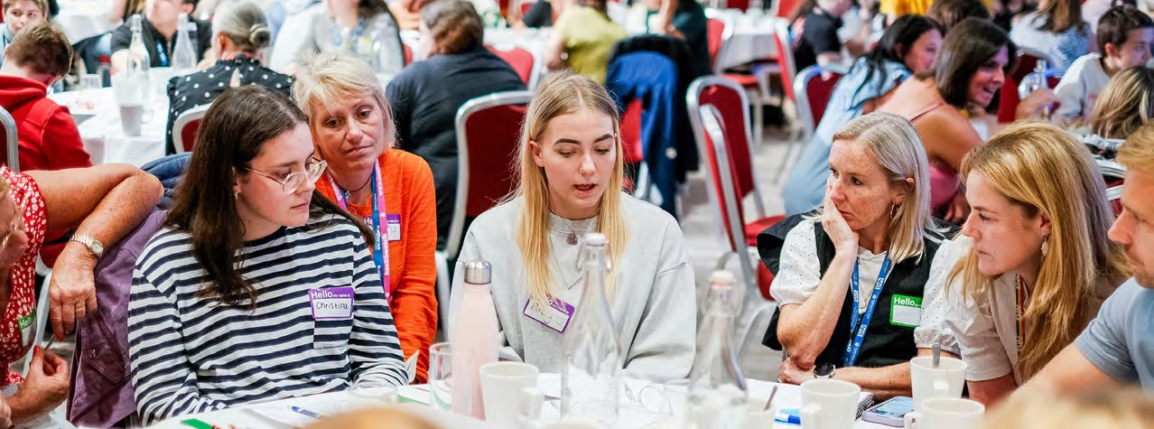
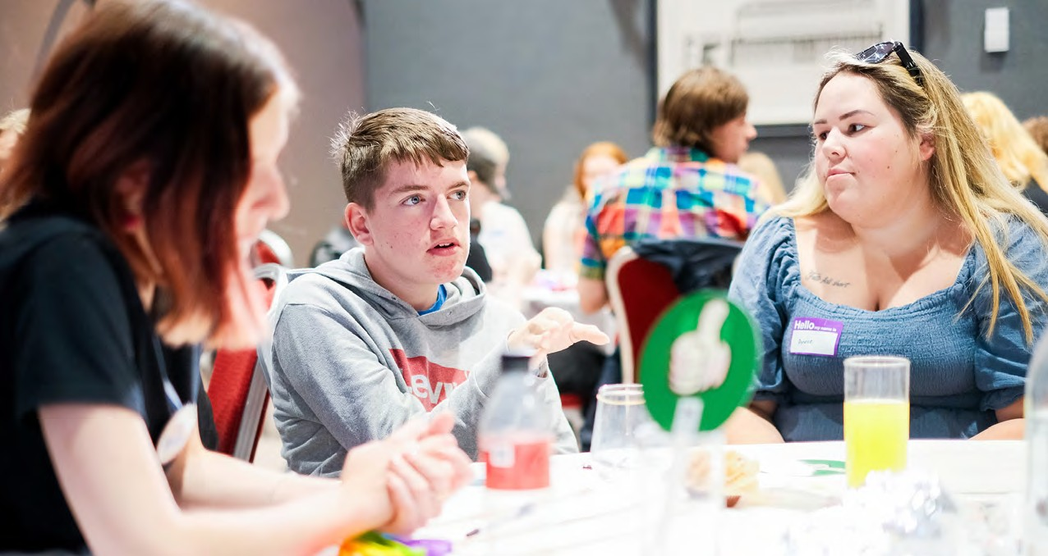
9

Priorities 2023/24
- Refresh our workplan to build on successes delivered in 22/23 and address ongoing and newly emerging challenges.
- Work to review current CYP MH provision across the Thrive Framework including Need, Activity, Outcomes, Finance and Workforce to ensure we maximise access and impact for CYP across HNY
- Research into disordered eating/ARFID
- Improved reporting of outcomes
- Delivery of CYP Core 20 plus 5, and focus on addressing health inequalities.
More information on our programme, strategic workplan and priorities can be found on the Humber and North Yorkshire Health and Care Partnership website.

Children and Young People’s Trauma Informed Care Programme

Aim of the Programme
The model of the Programme has two main aspects. One is delivering system change across the Partnership to develop and embed a consistent Trauma Informed approach across all partners working with vulnerable Children and Young People at risk of offending. The other is to test new interventions (known as Test and Learn sites) which divert young people from becoming first time entrants into the Youth Justice System’.
In order to meet the objectives of the framework, our phased implementation will focus and build on the following four key areas:
ICS wide scoping:
trauma informed initiatives, data and service provision
1
2
Building a trauma informed integrated care system
Strengthen multi agency relationships and improving
co-ordination of existing services
3

Successes 2022/23
4
Implementation of place based models of intervention as test and learn pilots
  - We have set up 3 Test and Learn pilot sites, with each following an individual model to address needs at Place level.
  - In Hull there were 238 appropriate referrals, and 230 new young people who accessed the VCS led Flipside service delivered by The Warren and Cornerhouse, which aims to prevent first time entrants to the youth justice system by delivering a range of 1-1 and group trauma informed interventions.
  - In North East Lincolnshire there were 91 referrals and 76 new young people who accessed the JEFF (Journey to Enrichment, Fulfilment, and Friendship) project, which aims to engage hard to reach Children and Young People and support them in accessing key local services such as The Young and Safe team, Compass Go, and We Are With You.
  - In North Yorkshire there were 158 referrals and 158 new young people who accessed the service, which is delivered in partnership with North Yorkshire Council, North Yorkshire Youth, and Tees, Esk and Wear Valley NHS Foundation Trust. The service targets areas of high need across the county, applying a shared model of systemic, relational, and Trauma Informed practice.

- We now have several Communities of Practice up and running: Leadership, Practitioner, Group Leads and Volunteers, ARC Champions and a Test and Learn Pilot Community of Practice.
- An Organisational Toolkit has been introduced to services across all six places. We have worked collaboratively with partners to support organisations to move from being Trauma Aware through to being fully Trauma Informed. This work has begun to build, embed and work to sustain a Trauma Informed Integrated Care System and develop a consistent joint approach and common language across the ICS.
- To date we have trained 238 professionals across the partnership in Trauma Informed Care using the ARC Model, and 21 people have attended the ARC leadership training.

ARC Framework

Attachment, Regulation and Competency (ARC)
A set of clinical interventions used to address complex trauma, and a framework for building Trauma Informed organisations/systems, is being developed to organisations within the partnership to enable them to become Trauma Informed.

Competency
Executive Functions | Self- Development & Identity |  | Relational Connection
Identification |  | Modulation
Caregiver Affect Management | Attunement |  | Effective Response
Engagement | Education |  | Routines & Rhythms

Regulation Attachment
Trauma Experience Integration

Priorities 2023/24
- Work with the partners in the non Test and Learn site areas to build relationships and support them on their Trauma Informed journey.
- Further develop the training offer to provide training models for different roles and responsibilities (including both ARC and AMBIT).
- Work in partnership with VCS organisations to provide Trauma Informed training to the education sector and schools.
- Develop a Trusted Adult Campaign and Training in partnership with the Humberside Violence Reduction Unit (VRU)/Police and Crime Commissioner.
- Establish a fourth Test and Learn site for the Programme.
- Expand and multiply Communities of Practice so they will be accessible to all areas.
- Hold the first annual Trauma Informed conference in March 2024.
- Establish external independent programme evaluation by CORC (Child Outcomes Research Consortium).
- Continue to work with the Children and Young People’s Mental Health Advisory group to ensure our work is informed by children and young people with lived experience.

- Developing a new IPS strategy and evolution of the approach to Fidelity Reviews and the IPS Grow Quality Mark.
- E-learning courses will be further developed and available on our Learn Worlds platform and accessible to IPS workers across all sectors.
- Further collaboration with the community mental health transformation.
12

Individual Placement Support
Individual Placement and Support (IPS) is a structured programme to support people with severe and enduring mental health issues into employment.
Most people accessing mental health services report that they see gaining employment as key to their recovery, wellbeing and life opportunities. In addition, being out of work can lead to a variety of negative health effects and socio-economic issues for individuals and their families. Yet unemployment rates remain high for people with mental health conditions.
By educating clinicians about the purpose and benefits of IPS, clinical teams can refer service users who are interested in sourcing employment. Links with the DWP, ICBs and Senior Executives in NHS Trusts are also important for delivering an effective and integrated IPS service.

Successes 2022/23
- This year The Centre for Mental Health and Social Finance have been given the opportunity to create new training courses for IPS. The e-learning courses are open only to those working in the NHS and in mental health teams.
- We continue to build on the work of the Fidelity Reviews and maintain alignment with the IPS Grow model.
- Our recruitment hub offers features such as job alerts for prospective IPS workers, insight events into IPS and a section for services to advertise their new IPS roles.
- IPS have been a key workstream in the community mental health transformation programme and emerging primary care networks to ensure pathways are joined up and people are supported for as long as they need support.

Priorities 2023/24

Humber and North Yorkshire Health and Care Partnership Mental Health, Learning Disabilities and Autism Collaborative Programme Annual Report 2022-23

Community Mental Health Transformation

The national requirements for Community Mental Health in the NHS Long-Term Plan are to expand and transform community services. The national goal is to ensure that in 2022/23, at least 257,000 adults and older adults with Severe Mental Illness (SMI) can access new integrated models of primary and community mental health services. By 2023/24, this number is expected to further increase to 370,000 adults and older adults per year, including adults with eating disorders, personality disorders, and rehabilitation pathways.
The transformation of community mental health services programme is now in its 3rd year across Humber and North Yorkshire. Reflecting on the last year, this programme has continued to develop and deliver much needed new services across the region.
Through strong partnership working and an inclusive and co-produced approach we have successfully progressed the transformation of community mental health services; this includes the development of new models of care, and providing more and better options for people within their own communities.
We have developed and matured a place-based approach to planning and mobilisation, involving stakeholders from across the whole system, including people with lived experience, carers and voluntary organisations.
This year we have focussed on stronger integration between Primary Care and mental health organisations. Each Place has dedicated mental health models based in Primary Care. We also wish to celebrate the success of the recruitment of new mental health practitioner roles (via the Additional Roles Reimbursement Schemes – ARRs) into most Primary Care Networks within Humber and North Yorkshire. These new roles have strengthened links across services, improved relationships with primary care colleagues and increased access to mental health services, reducing waiting times and improving outcomes.

13

Successes 2022/23
- We have achieved the target for the key access core indicators for transformed services including the number of adults and older adults receiving two+ contacts in the new integrated model across the core and dedicated service provision in the last 12 months.
- Investing in the Voluntary, Community and Social Enterprise Sector (VCSE): new investment to create VCSE Alliances and new community supporting roles including Peer Support, Involvement Workers, Social Prescribers, and Mental Health Coaches.
- York has launched a new Community Mental Health Hub based on a prototype model – this will offer a new way to provide and access mental health services in the community. This is a new partnership between York Mental Health Partnership and
the Connecting our Cities Partnership, who have a joint vision to support adults across the city and help change the way people are able to access mental health services.
This new model of mental health care will promote citizenship, enabling local places, neighbourhoods, and systems to support change. The Hub has received excellent feedback from service users and partner services.
- Workforce re-design including recruitment to new roles within psychological professions to offer much needed psychological interventions.
- The Mental Health Wellbeing Practitioner (MWHP) roles support service users between primary care (GPs), secondary care (Community Mental Health Teams) and NHS Talking Therapy services, improving access to psychological interventions, and reducing waiting times whilst giving the person the best quality care.
Here are some examples of the impact of the Mental Health Wellbeing Practitioner role, and some feedback.
North Lincolnshire Primary Care Mental Health Team
Paul’s presenting problems included paranoia, anxiety and not being able to regulate his emotions. He has had no previous/formal diagnosis. He is suspicious and untrustworthy of people which increases his anxiety when he is in a public place or around people
and is unable to cope with it. This has been affecting his relationships (personal and professional) begetting social isolation and withdrawal from his social support network. Paul also reported being on edge the majority of the time and experiences symptoms of anxiety such as increased heartrate, sweating and stomach-ache when in public.
Additionally, he struggles to recognise and manage his emotions resulting in avoidance of social situations and reduced activity levels.
Paul has attended a total of 11 appointments over a 3-month period. The treatment focused upon psychoeducation on emotions, anxiety management techniques and ‘the vicious cycle of reduced activity’ alongside developing specific and person-centred coping skills.

East Riding Primary Care Mental Health Network
“I suffer with depression, and I was going through a tough time at work. The doctor had written me off sick and she thought a referral to counselling to talk it through and to get it off my chest would be helpful. I had a call from a member of staff from the Primary Care Mental Health Network and he referred me to a Mental Health and Wellbeing Practitioner. She offered me 12 sessions and I saw her every week. I was expecting a long wait, but I saw her within a few weeks, I was quite impressed. She taught me to think about things in a different way. The problem-solving work was helpful, I was trying to work everything out in my head and writing it down helped much more than I thought it would. It created space in my head to be able to think. She helped me to see that I am in control and it’s not someone else telling me what to do, I’m in charge of that. She taught me about self-care and that looking after me is
something I need to do. The support has made a massive difference. From where I was 3-4 months ago to where I am now is a massive positive change. She’s helped me to see the place I was working wasn’t healthy and I was worth more than that. I’ve got myself a new job and I am feeling an awful lot better. She’s managed to help me stop self- harming and now I am able to open up to my family about how I was feeling and what it led to. It’s one of those things you never think will change in 12 sessions, feels not long what will you get out of it but I did get a lot –she helped fill up my tool box.”

Priorities 2023/24
As we are coming to the end of the 3 year programme it is important to start to evaluate the changes. We will be working with the NHSE national team to review progress and support our Places with evaluation.
We are using the ‘roadmap’ tool which sets out the key milestones and deliverables that underpin the transformation of community mental health. It is used as a guide for our system as to what needs to be delivered by the end of 2023/24 and is tailored according to our place plans.
- The Community Mental Health Framework for Adults and Older Adults will replace the Care Programme Approach (CPA) with person centred care planning. As part of this transformation programme person centred planning has developed as an alternative method which will improve a person’s experience of mental health services, maximise the best potential for recovery and create a review that is a true collaboration between service users, families, health, and social care, and which is inclusive of both a mental health service and Care Act (2014) duties.
- As local approaches evolve and implementation accelerates, we aim to share some practical examples of what the changes mean for people receiving mental health support and for staff working in mental health. We will be launching resources and initiatives to promote person centred care planning between mental health providers and our partners.
- The continued development of new Community Mental Health Hubs and primary care mental health teams across all areas.
- Building capacity and capability across the workforce to prevent mental health problems and promote good mental health within their everyday practice. Further workforce development is a priority across the whole system with links to the psychological model.
- To start to tackle the challenge of lack of interoperability of information systems across the whole system.
- Establish a Lived Experience Parliament to further support the involvement of people with lived experience and their Carers.

By 2023/24 – Priorities for Community Mental Health transformation
Model development
Care provision
Workforce
Data & outcomes

“Must have” services ³ commissioned at PCN level tailored for SMI 7
Recruitment in line with indicative 23/24 MH workforce profile
Record access data from new model (inc. primary, secondary & VCS orgs)

Commissioning and partnership working with range of VCSE services
Integration with Local Authority services
100% PCN coverage for transformed model
Shift away from CPA towards personalised care

Improve access to evidence-based psychological therapies
No wrong door approach means no rejected referrals recorded
Integration with primary care with access to the model at PCN level ²
Tailored offer for young adults and older adults
Principles for advancing equalities embedded in care provision
Support for co-occurring physical needs & substance use
Alignment of model with IAPT, CYP & perinatal
Trauma-informed & personalised care approaches

Staff accessing national training to deliver psychological therapies
Joint governance with ICB oversight ¹
Model design coproduced with service users, carers & communities
Multi-disciplinary place- based model 5 in place
“Additional” services 4 commissioned at PCN level tailored for SMI 7
Staff retention and wellbeing initiatives
Dedicated resource to support full range of lived experience input
Staff-caseload ratios to deliver high quality care
Place-based co-location approaches
Interoperable standards for personalized and co- produced care planning
Routine collection of PROMs using nationally recommended tools
Expand MHP ARRS roles in primary care
Waiting time measured for CMH services (core & dedicated focus areas)
Interoperability for activity from primary, secondary & VCSE services
Impact on advancing equalities monitored in routine data collection

Dedicated focus 6
CEN/’personality disorder’ Community rehab Eating disorders
Dedicated function linked to core model: increased access to dedicated function and consultation, support, supervision, and training to core model
Embed experts by experience in service development and delivery

Development of trauma-specific support, drawing on VCSE provision
Co-produced model of care in place to support a diverse group of users
Ensure a strong MDT approach 5
Clear milestones are in place to reduce reliance on inpatient provision
Co-produced care and support planning is undertaken
Supported housing strategy delivered in partnership with LAs
No barriers to access e.g. BMI or weight thresholds
Early intervention model (e.g.
FREED) embedded
Clear arrangements in place with primary care for medical monitoring
Support across spectrum of severity and type of ED diagnoses
Joint working with CYP ED services including transitions
Accept self-referrals, VCS referrals and Primary Care referrals
- In place by end of year

- Governance to include commissioners, primary care (inc. PCN leadership), mental and physical health services, local authorities, VCSE, service users and carers.
- “PNC level” defined as a footprint of typically 30,000 and 50,000 people (this can also be thought of as “sub-place”, “localities”, or “clusters of wards”). Most targeted, intensive and long-term input for people with more complex needs can be provided at the wider community or “place” level of around 250,000 – 500,000 people (this can also be thought of as a “PNC-cluster”)
- Must-have: physical health checks, EIP, employment support, psychological therapies, social prescribing, personalized care planning, care coordination, peer support, outreach for inequalities
- Additional: advocacy services, care support, community assets, culturally competent services, financial advice, housing, social care, support groups, volunteering & education
- Should include clinical psychologists; MH pharmacists; occupational therapists; primary care staff; psychological therapists; social workers; community connectors; paid peer support workers
- Systems should have commenced work on 2 of 3 dedicated focus areas in 2021/22, meeting relevant expectations. Where appropriate, aspects of core transformation model should be applied to dedicated focus areas
- In this context ‘SMI’ covers a range of needs and diagnoses, including but not limited to; psychosis, bipolar disorder, ‘personality disorder’ diagnosis, eating disorder, severe depression and mental health rehabilitation needs – some of which may be co-existing with other conditions such as frailty, cognitive impairment, neurodevelopment conditions or substance use

17

NHS Talking Therapies
As we enter the 15th Anniversary year of these services, Improving Access to Psychological Therapy (IAPT) services have been renamed as NHS Talking Therapies, for anxiety and depression.
This new name gives us an opportunity to raise the profile of the services, and to help people better understand what the services offer, so we can reach and help even more people.
Talking Therapies have a set of targets to achieve as part to the NHS Long Term Plan, mostly centred around access to the services, waiting times and outcome of the treatment to support a person’s recovery.

Successes 2022/23
  - In Humber and North Yorkshire all services are achieving the initial NHS Long Term Plan access target.
  - The transformation of community mental health services has a direct interdependence with Talking Therapies. Community Mental Health (CMH) services can jointly work with Primary Care Networks (PCNs) to ensure adults and older adults seeking mental health treatment through either service are able to access the most appropriate service to meet their needs.
  - NHSE have produced helpful guidance to support clinicians from community mental health providers to understand referral pathways.

Provision of a spectrum of support for people with mental

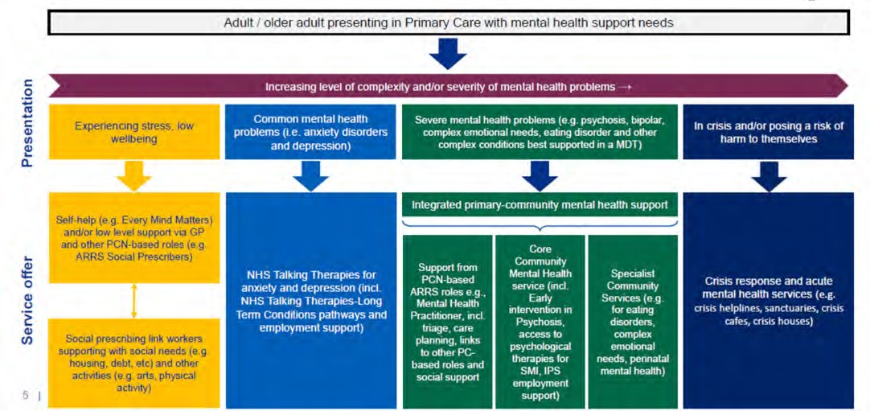
health problems presenting to primary care services
NHS England

Priorities 2023/24
  - The waiting list for treatment is longer than anyone would be happy with so we will continue to focus to reduce this wait time.
  - Continued implementation support for expansion of psychological therapies, including refreshed service guides.
  - Development of PT-SMHP metric in mental health services dataset (MHSDS) to measure increased availability of psychological therapies.
  - Continue to develop joint working pathways with PCNs and mental health providers.
  - Development of guidance on accessibility and acceptability of psychological therapies for autistic adults

Severe Mental Illness Physical Health Care
In 2022/23, the SMI Physical Health Care Programme built on the success of the 2021/22 performance towards the national target for Annual Physical Heath Check (APHC) delivery. All 6 places across the ICS have developed models to improve access and uptake of the APHC, together with ongoing interventions and management (e.g. weight management, smoking cessation work, and medical interventions where necessary).
Although each Place operates with a slightly different model they all share a vision with 10 key principles which guide delivery.
In 22/23 the ICS took part in the NHSE Remote Monitoring Scaling Programme. A digital task and finish group was established, with a focus of (1) increasing the uptake of the APHC through use of remote monitoring devices that can be used in the home, GP surgery, or any other community facility, (2) resolving data quality issues between primary and secondary care and (3) the establishment of an ICS dashboard for SMI data.
As part of the programme we shared lessons learnt with other ICSs in our region and the Remote Monitoring Scaling programme team, to support development of this national workstream.

Successes 2022/23
  - Achieved 7,505 Annual Physical Health Checks (57.7% of those on the SMI register), up from the previous year’s uptake of 46.6%
  - North East Lincolnshire improved from the lowest performing Place in our ICS to the best performing by the end of 22/23
  - Strengthened relationships with primary care and PCNs
  - Better delivery of follow up interventions for individuals identified as at risk
  - Faster and improved access to VCSE and community services

  - East Riding have coproduced a care plan and information pack for patients to support in their understanding around what a health check is and the importance of having one.
  - North Lincolnshire procured NL Mind to undertake a piece of engagement work, to support uptake of the health checks and reduce DNAs.
  - In North Yorkshire increased funding has enabled clinics to be held outside of routine hours, and in community venues, creating more opportunities for individuals to access their health check.
  - Vale of York funded health coaching, targeting individuals with high BMI and smokers, and have increased training and awareness on these topics to support staff awareness and ability to signpost.
  - Hull have similarly increased training opportunities for clinical staff across PCNs and practices, and focussed on engagement in primary care to support delivery of quality health checks.
  - In North East Lincolnshire, the Wellbeing Health Improvement Service follow a successful outreach based model, and worked closely with their data quality team, primary care and PCNs to improve working relationships and support delivery.
Through the SMI digital programme:
  - Employed 5 project support officers to support with resolving issues around SNOMED coding discrepancies and understanding
  - Rolled out 31 point of care testing devices across North and North East Lincolnshire, and Vale of York to support completion of HbA1c and blood lipids elements of the annual health check
  - Continued development of the SMI RAIDR dashboard, which will be used as a tool to monitor performance, support activity planning and delivery, and assist in the understanding of the health inequalities faced by people with SMI.

Priorities 2023/24
  - Continue working to achieve the national target of 9,715 checks (71.4% of the SMI register)
  - Focus on improving uptake of post-health check interventions, such as smoking cessation and weight management
  - Deliver 2 bespoke smoking cessation training sessions to staff in Primary Care, CMHTs, and local authority and voluntary sector organisations across Humber and North Yorkshire
  - Go Live of ICS wide SMI RAIDR data dashboard.
  - To work with digital colleagues to improve data flow between primary and secondary care and vice versa.
  - Increase service user and carer engagement with the programme

SMI PHCs 21/22 and 22/23 by %
70.00%

60.00%

50.00%

40.00%

30.00%

20.00%

10.00%
0.00%
Q1 21/22
Hull
Q2 21/22
East Riding
Q3 21/22
Q4 21/22 Q1 22/23
Q2 22/23
Q3 22/23 Q4 22/23
North Lincs
North East Lincs
North Yorkshire
York (inc. Vale)
Q1 23/24
Total
The below graphs demonstrate the progress that has been made in delivering Annual Physical Health Checks since the beginning of the steering group.

SMI PHCS 21/22 and 22/23 By Volume 8000
7000

6000

5000

4000

3000

2000

1000

0
Q1 21/22
Hull
Q2 21/22
East Riding
Q3 21/22
Q4 21/22 Q1 22/23
Q2 22/23
Q3 22/23 Q4 22/23
North Lincs
North East Lincs
North Yorkshire
York (inc. Vale)
Q1 23/24
Total

Resilience Hub
The Humber and North Yorkshire Resilience Hub continues to successfully support health, care and emergency service staff and their families who live or work in the Humber and North Yorkshire region. The hub offers a range of psychological advice and support by trained mental health professionals who have extensive experience of working with people who have experienced traumatic and distressing events. The team works with individuals as well as teams to develop and promote personal resilience in a kind and supportive way, recognising the impact of prolonged periods of stress. The hub delivers:

Trauma informed care (TIC) pathway inc stabilisation and resourcing group, 1:1 individual trauma therapy, team debrief modelling (CISM)

Person - centred psychological assessments within 5 days of referral

1:1 Psychological support - range of evidence based therapies

Long covid and long term health condition support

Individual, group & neuro Assessment
Organisational consultation framework, supporting teams and leaders and specific training including burnout

Medication advice and reviews and liaison with GP and other services

Bereavement support

Relationship support (Relate)

Liaison and support with occupational health and human resources

Signposting and trusted assessor pathways
with multiple organisations and therapeutic offers
Evidence based resilience training for individuals, teams and leaders

The following diagram illustrates the most common reasons for referral in 2022/2023:

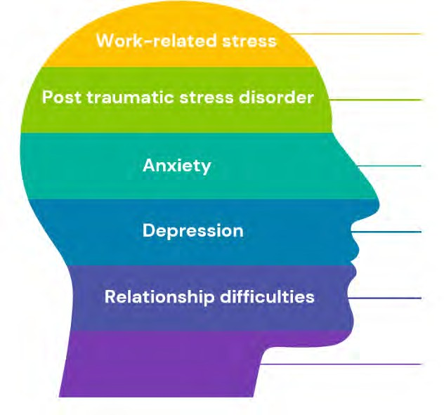

Humber and North Yorkshire Health and Care Partnership Mental Health, Learning Disabilities and Autism Collaborative Programme Annual Report 2022-23

Successes 2022/23
  - In 2022/2023, the team have provided individual treatment for over 818 staff, as well as supporting over 153 teams through team-based support and training.
  - 99% of respondents who have used the service would recommend the resilience hub to colleagues or family, and the service is rated an average of 4.9 stars out of 5 from service user experience feedback.
  - Continued development of Long Covid support for staff – through peer support programme and Long Covid Neuro care through cognitive rehabilitation
  - The Hub team have presented findings and outcomes from the Long Covid support programme at several national conferences (such as ‘Mental Health: Supporting NHS Workforce Resilience’).
  - Expansion of Trauma Informed Care workstream, furthering collaborations across the region and increasing availability of trauma specific support for staff and their families. This has been in accordance with NHSE guidance to provide critical incident response and coordination for psychological care.
  - Launched the Resilience Hub Staff Wellbeing Fund for the voluntary, community and social enterprise sector, enabling further collaboration across the region
  - Referral to assessment wait was on average 5.25 days and access to treatment within 30 working days of referral means those who require support and treatment are being seen promptly.
  - Shortlisted for The National Positive Practice in Mental Health Awards 2022
The HNY Our People App, developed by the hub in collaboration with the HNY Health and Wellbeing Team as part of the Integrated Care Partnership, continues to maintain and improve the physical and mental health of staff by providing a range of self-help materials, podcasts and weekly feeds.
HNY Our People has seen 1336 registrations in 2022/2023 following its launch in May 2022 HNY Our People has an app store rating of 5 out of 5
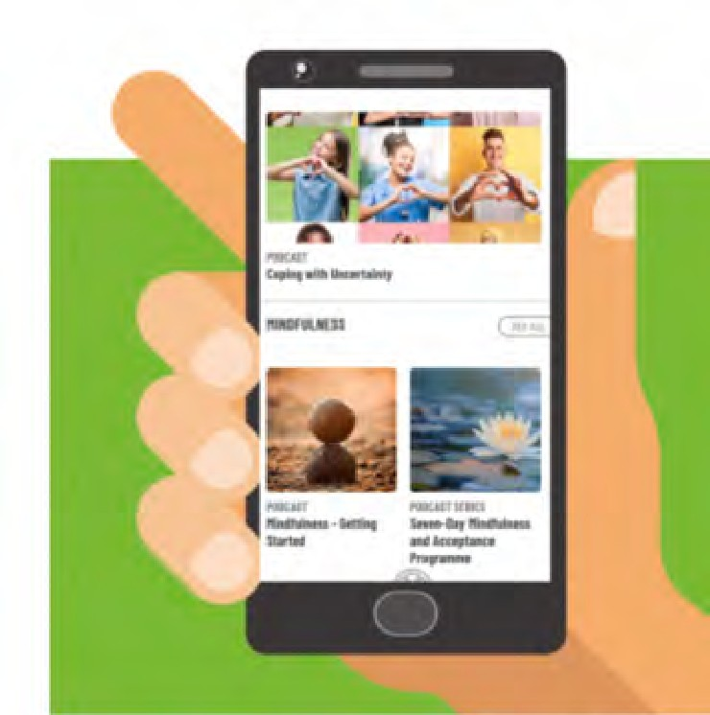

“The virtual consultations and group work enabled me to attend and was probably safer as I was not having to drive after a session when I
might be feeling emotional, drained or distracted.
I could access when working from home.”

Service User Feedback
“I had 1:1 and group work. This has been the BEST support I have ever received with any counselling I’ve ever had. The resilience group work was great as I got to hear others who had similar symptoms and experiences as I do. The compassion therapy has literally been a life changer!!! I can’t thank and praise this service enough.”
“It’s been a fabulous and truly valuable all round experience. The counselling with X was second to none. She listened and
also help me exists my view and gave me permission and confidence to grow. Best ever. The long covid hub was excellent, the team are just lovely and everybody is so professional. We have our own WhatsApp group now and so will continue.
Thank you.”

Priorities 2023/24
“I have already recommended the Resilience Hub to staff that I support. The support I have received has been fantastic, the people I have had contact with have been friendly, caring and compassionate and I have learnt a lot of skills that I can take away and use in the future.”
“They understand the stress involved with caring for others and the effects of long covid on essential workers”
“Excellent all round care. You have saved my life”
“…I don’t think I could of got through the last 2 years without the help I received”
“Kept my sick leave to short spell, got me going again, helped overall mood towards fixing some work problems.”
    - To award funding to successful bids from across the HNY system, following the launch of the Resilience Hub Staff Wellbeing Fund.
    - Continue to expand Long Covid support provided by the Hub and expanded this pathway to include all staff impacted by/diagnosed with long term conditions.
    - To present at a Health Education England conference on Trauma-Informed Care. The Hub will also work with organisations across the HNY system to implement postvention guidance following staff suicide incidents, and pilot collaborative approaches to Critical Incident Stress Management across several providers in HNY.

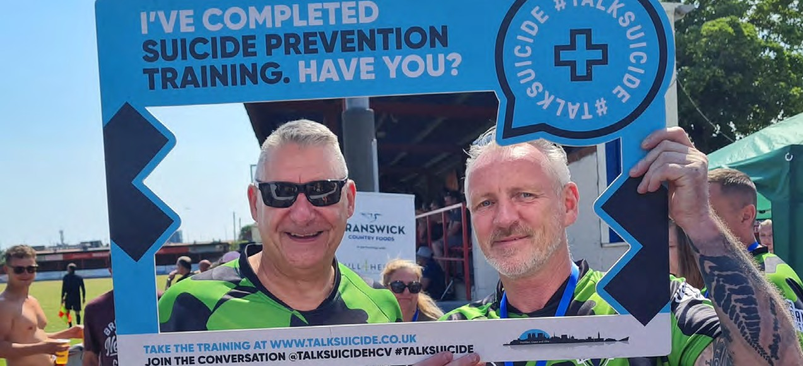

Suicide Prevention

Successes 2022/23
  - Growth of the Emotional Wellbeing hub which was set up by the Humber Bridge Board on the country park site in response to a series of suicides and the temporary closure of the bridge footpaths
  - Continuing to deliver the #TalkSuicide training. Since January 2019, we are delighted to have trained over 19,000 people and the number of people accessing the training continues to grow.
  - Continued delivery of the ‘Together’ postvention service supporting those who have been bereaved or affected by a suicide. This important work could not take place without the support of the Voluntary, Community and Social Enterprise sector, especially Hull and East Yorkshire Mind, and North East Lincolnshire Mind, who deliver the ‘Together’ service.

Priorities 2023/24
  - The number of children and young people either reported to have attempted to, or who have, taken their own life is sadly increasing across the country. Therefore, there will be an increased focus on reducing the risk of suicides of children and young people in HNY.
  - Increasing the number of professionals working in Mental Health trained in suicide prevention.
  - Create a Lived Expertise panel, comprised of service users, family, carers and peers.
  - Realign the HNY Suicide Prevention strategy to the new national Suicide Prevention Strategy 2023-2028 for England.
  - Develop a Suicide Prevention Communication and Engagement Strategy.
  - Embed Suicide prevention training for Community businesses within:
    - Barbers • Tattooists • Aesthetic clinics
    - Gyms • Pubs

25

Humber and North Yorkshire Health and Care Partnership Mental Health, Learning Disabilities and Autism Collaborative Programme Annual Report 2022-23

Perinatal Mental Health and Maternal Mental Health

Successes 2022/23
  - Continued to deliver high quality care to women and families, with access rates increasing. Evaluation of the outcome measures used have demonstrated that typically women who enter the service with severe psychological distress, and receive evidence based interventions, see their symptoms reduce to mild psychological distress by discharge.
  - Increased offer of psychological interventions which includes infant mental health.
  - Co-designed and delivered Perinatal Mental Health Module with Hull University
  - Introduced peer support workers into the perinatal mental health service which covers the Humber Four region. Peer support workers have been in place for some time in North Yorkshire and York.
  - Commissioned a charitable organisation in Hull called Bora Shabaa who support refugees to offer peer support for women from black and ethnic minority backgrounds who are experiencing baby loss.
  - North Yorkshire and York’s Perinatal Mental Health service has worked hard to bring the team up to a full complement of staff, including the introduction of new roles, such as a pharmacist.
  - A health inequalities lead has been recruited jointly to work across the specialist mental health services and the local maternity and neonatal system to improve access to services and improve outcomes for women. In particular they are focussing on women under 25 and women from black, Asian and other ethnic minority backgrounds who we know are at an increased risk of poor birth outcomes, mental health problems and risk of suicide (MBRRACE, Nov 2022).
  - Supported Local Authorities in the development of the Best Start for Life programme in three of our six Places where funding was received (Hull, North Lincolnshire
and North East Lincolnshire) to increase the support for parents who have a mild to moderate mental health need as well as infant mental health, training for the workforce and much more.
  - Designed and implemented a Maternal Mental Health Service (MMHS) for women experiencing moderate to severe and/or complex mental health problems related to loss in the maternity context (fertility difficulties, miscarriage, ectopic pregnancy, termination for medical reasons or stillbirth). The service went live on 4th July 2022
and was delivered by Hull and East Yorkshire Teaching Hospitals on behalf of the full Humber and North Yorkshire geography.
  - Launched the Maternal Separation Support Service (MSSS) in North East Lincolnshire. This service supports women who are at risk of separation, or who have been separated, from their baby at birth due to safeguarding concerns.
  - The MMHS and the MSSS both evaluated well, with high improved outcomes for women. Unfortunately, these services ceased being operational in March 2023.

26

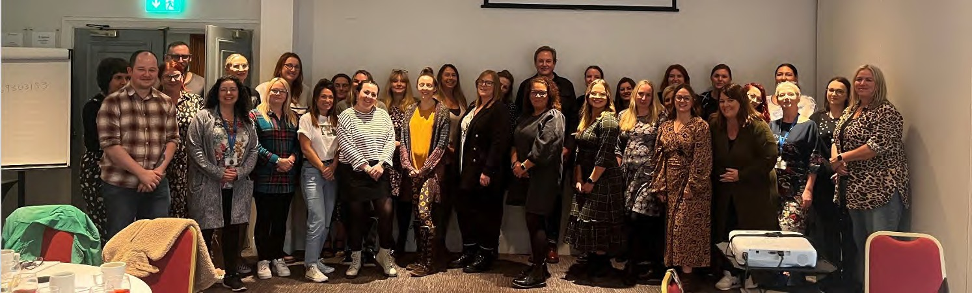

Priorities 2023/24
- To increase the number of women receiving a service from the specialist perinatal mental health services and continue to ensure that outcomes and experience for women continue to be high.
- To increase the number of women with a Severe Mental Illness (SMI) who access pre- conception advice through the specialist perinatal mental health services.
- To re-establish maternal mental health services across the patch.
- To expand the peer support offer across services and communities.
- To improve the health inequalities faced by women from black, Asian and ethnic minority backgrounds, and women under 25.
- To continue to support Local Authorities in the delivery of the Best Start for Life programme and services for mild to moderate perinatal mental health issues and parent-infant relationships.
- To support the implementation of the Women's Health Hubs in response to the National 10 year strategy for Women's Health for England.

“It's a year on since I had my little girl and I wanted to check in and say how we are doing. Things have been great. She is the happiest little baby and full of smiles apart from when she's teething (she's got 9 now!). I have put to bed a lot of grief and anxiety that overshadowed my daily life. Still on my happy pills and I have no intention of coming off them anytime soon. I've attached a picture of her from yesterday, her 1st birthday. I'll never forget the kindness and support you gave me. Being pregnant took me to hell and back, and without your clinical expertise and honest conversations, I dread to think how I would have coped. The future’s bright once again”.

“I’d like to thank you for all your continuous support throughout a very difficult, life changing time but also an amazing time in my life. You have been the first person in 10 years to help me in a way I needed for so long.”

27

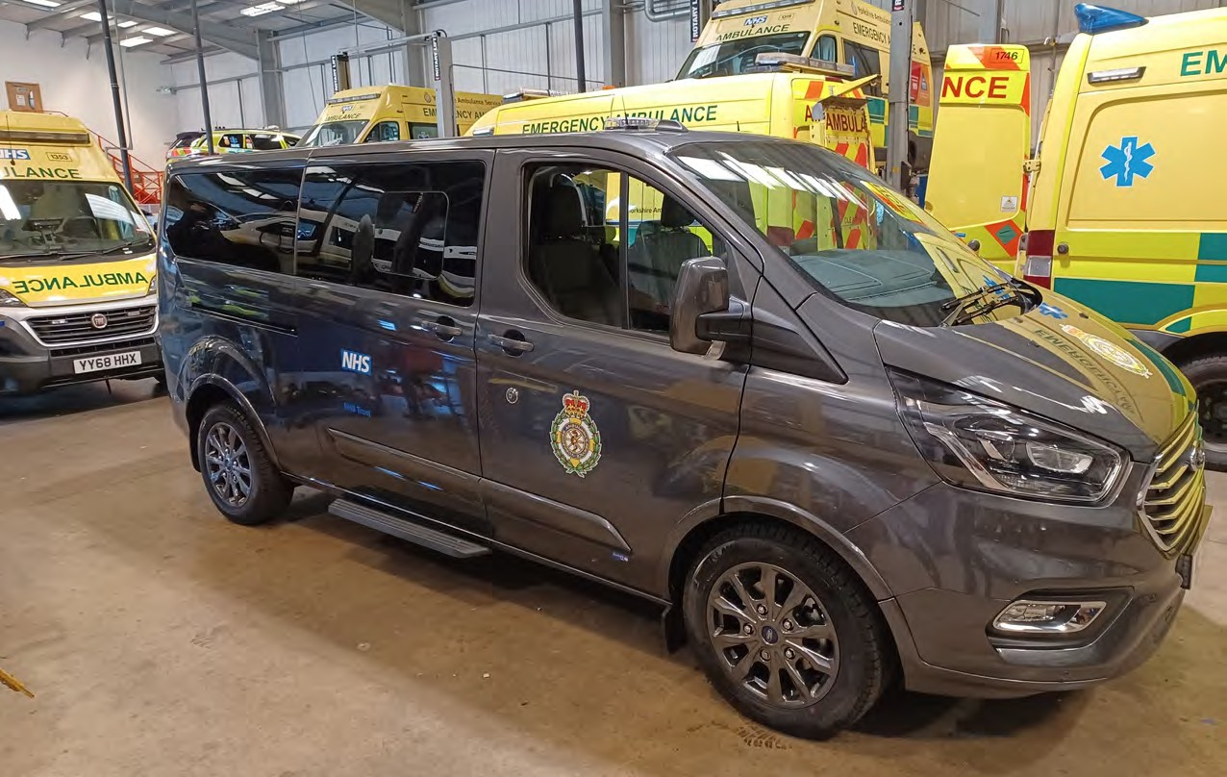
28

Urgent and Emergency Care Mental Health

Successes 2022/23
  - The 6 weekly Crisis Coproduction group developed an improved communications offer around accessing crisis support including via NHS 111 in 2024; lived experience recommendations were shared with the Urgent and Emergency Mental Health Steering group to help inform service planning and delivery; and priorities were developed for the Yorkshire and Humber Shared Care Record to support the safe delivery of 111 access to mental health crisis support.
  - We established a Frequent Use Network with a range of system partners to identify challenges, share learning and best practice, and develop proposals for an improved and more coordinated approach to ensuring people’s needs can be met more effectively.
  - Humber and North Yorkshire System partners were selected as pilot sites for the implementation of the NHS 111 ‘Select Mental Health Option’ ahead of the national ‘Go Live’ date of April 2024.
  - We have been part of an Expert Reference Group with NHS England to develop guidance for the NHS and other health services which seeks to share good practice about what helps to reduce unwarranted police involvement in mental health care, and improve access to the right mental health support, in response to the National roll out of Right Care Right Person (RCRP)
  - Presented on Right Care Right Person at the Policing and Mental Health national best practice webinar and supported NHSE, DHSC and the Home Office with the national roll-out.

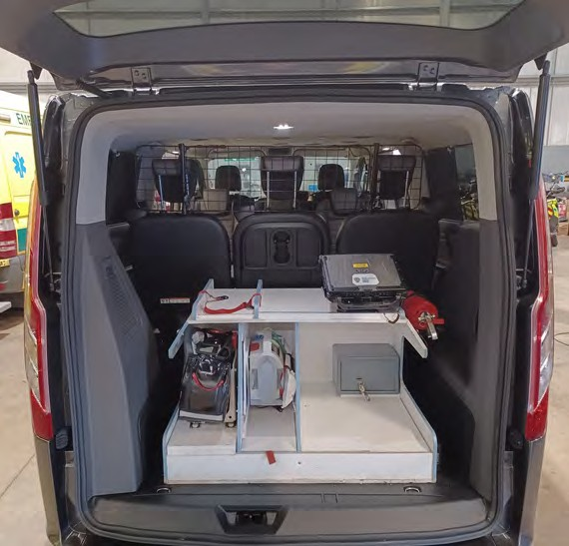

Priorities for 2023/24
  - Continue to develop the HNY crisis coproduction group, expand membership and progress with plans to coproduce an accessible crisis card and codesign and deliver improved communications that offer practical and emotional support to prevent and manage crisis.
  - We are working closely with other sector collaboratives to progress proposals to create a more equitable approach to supporting people who use services frequently and address unmet need more effectively and efficiently.
  - Develop a Memorandum of Understanding with system partners to agree pathways for people accessing Mental Health Crisis services via NHS 111.
  - Development of a shared mutual aid and escalation protocol for all age mental health across Humber and North Yorkshire.
  - Working with experts by lived experience and system partners to improve access to timely support in a crisis from the right service.

Dementia

Successes 2022/23
  - We were successful in securing funding to support education and training linked to improving dementia diagnosis rates.
  - We were successful in securing funding to enable more Memory Assessment Service (MAS) Clinicians to be able to undertake dementia assessments and increase diagnostic capacity.
  - We have built up a large network of interested stakeholders from a range of organisations to support the dementia programme, and we are working with partners to strengthen the voice of people with lived experience of dementia at a more strategic level.
  - We have coproduced an action plan to support the recovery of the dementia diagnosis rates across HNY and improve dementia diagnosis pathways.

Priorities 2023/24
  - Face to face workshops are planned throughout 23/24 to coproduce action plans and pathways across all stages of the dementia journey from first recognition of symptoms through to post diagnostic support and living well with dementia.
  - All of the Memory Assessment Services across HNY will be accredited or affiliated with the Memory Assessment Services National Accreditation Programme (MSNAP).
  - We will develop a HNY Memory Assessment Service peer review network and establish a community of practice to share learning and best practice.
  - We will explore the feasibility of developing separate Young Onset Dementia Services across HNY based on best practice from other areas.
  - Improve access to assessment by ensuring people are aware of how to access assessment, their rights and options in where they access assessment, how to access financial support for travel costs for appointments, improved referral processes to prevent delays in referrals being processed, and more accessible resources using plain English.
  - Work with partners to identify people at higher risk of developing dementia and ensuring they have timely access to assessment, diagnosis and post diagnostic support.

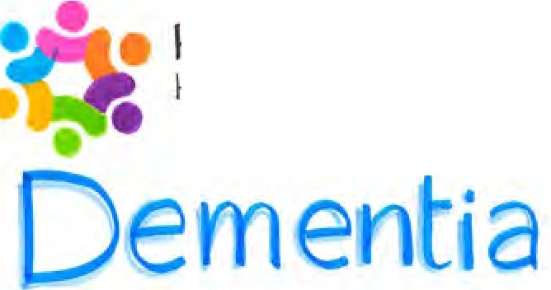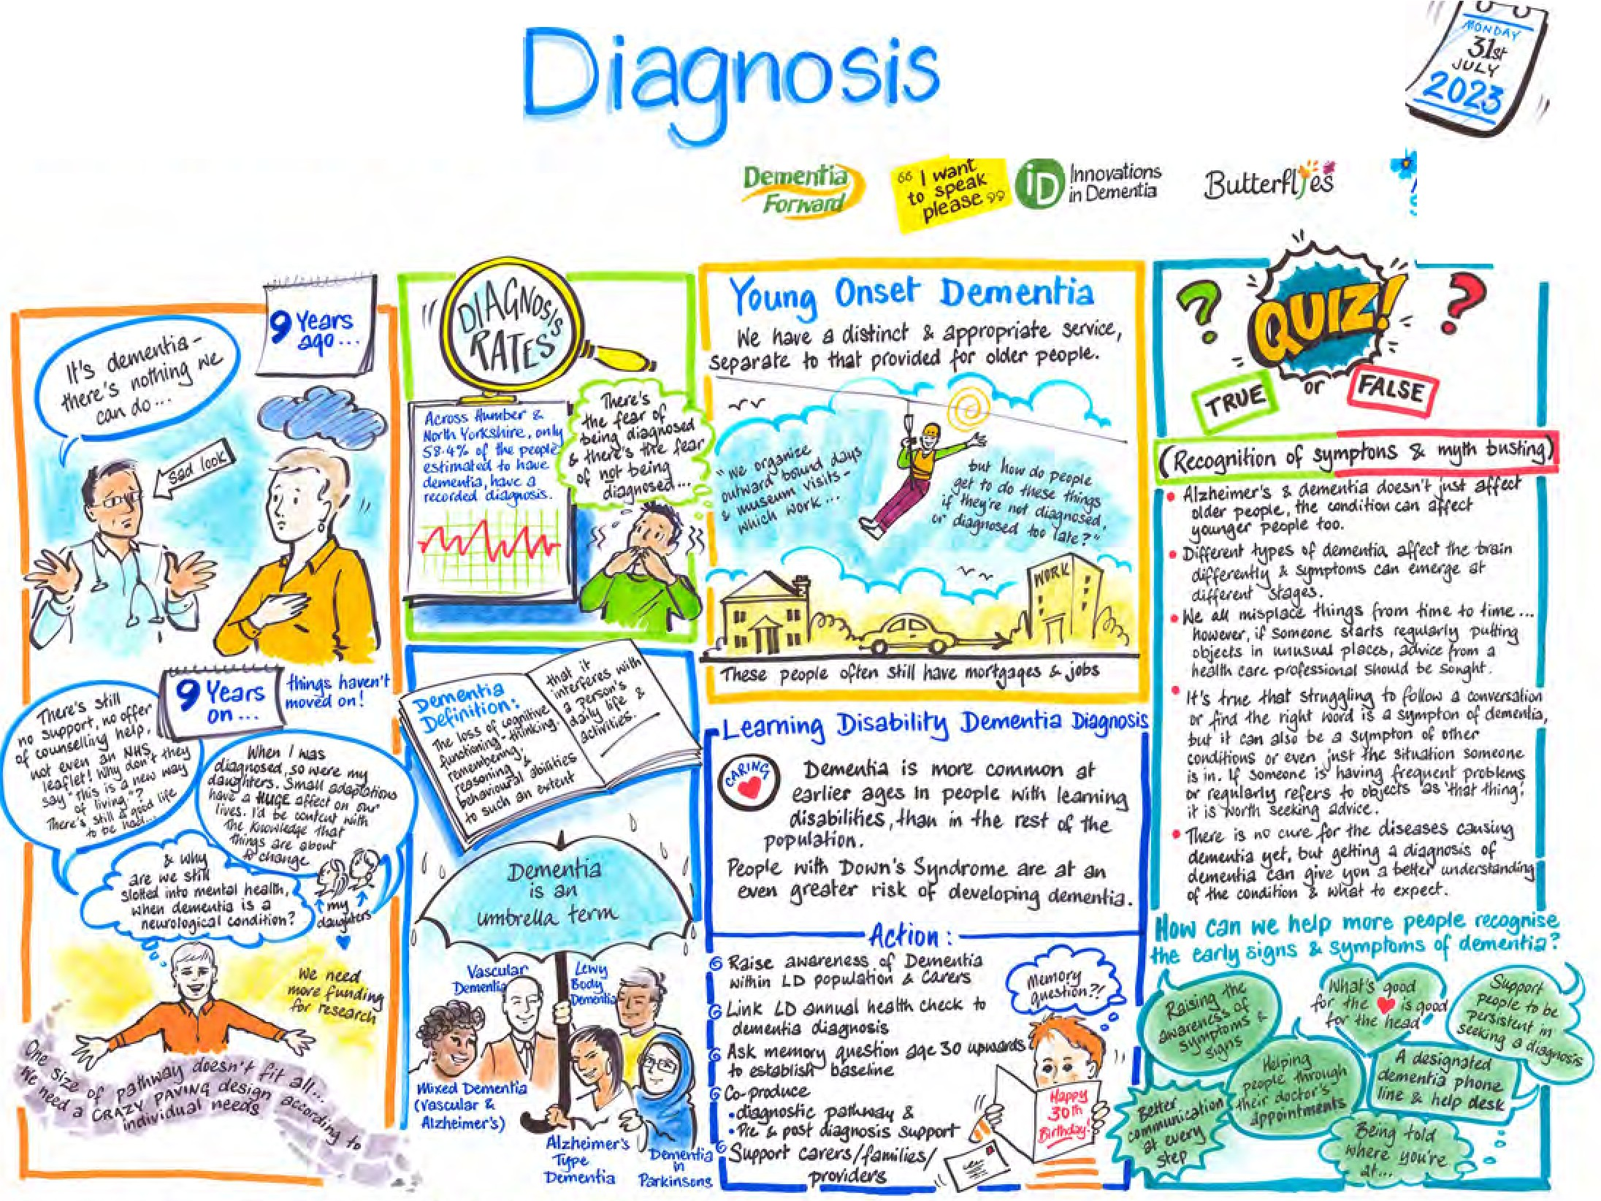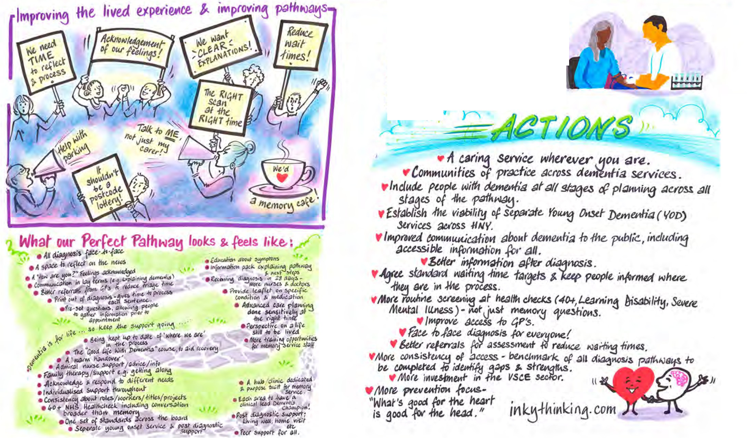Humber and North Yorkshire
Heallh and C3re Parlne ip ICS

;\lzheimers
Soc.iet

Bloo -vased ! io,narKers Pr blood -test is ot1 the. horizon -ttlat _{ff} help
di _4110.se Al.zheimers e,ar1Ttt' help -lo infc('m frwfrtint ecisiorts.
<

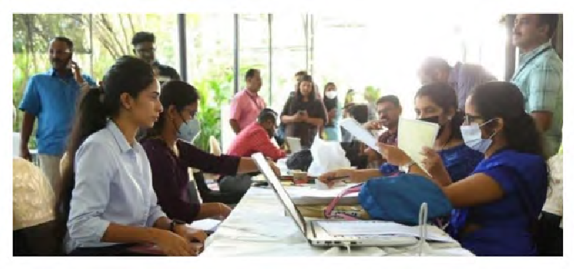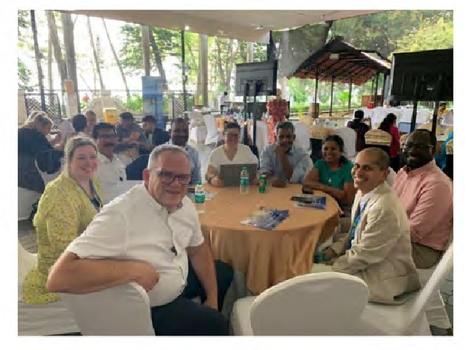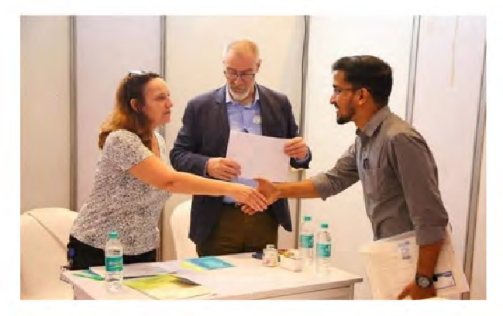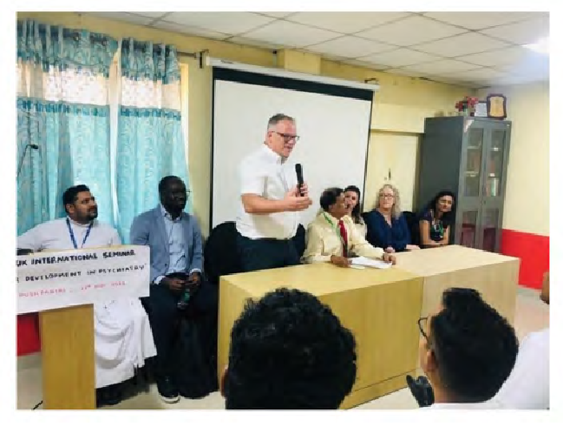

Workforce and Culture

Successes 2022/23
We have been working with all providers and the ICB People Directorate building relationships and exploring what we can do differently to ensure our workforce are supported to be at their best, enabling them to deliver the best care possible to those within our populations.
Psychiatry vacancies have been difficult to recruit roles for a number of years. Following a successful international recruitment project, Navigo (North Lincolnshire Mental Health
provider) joined up with Rotherham, Doncaster and South Humber NHS Foundation Trust; Tees, Esk and Wear Valleys NHS Foundation Trust; and Humber Teaching NHS Foundation Trust to carry out a programme of joint recruitment.
As part of a wider system partnership initiative, our mental health, learning disability and autism providers visited Kerala in India to interview pre-selected candidates. Those interviewed were exceptional, with many years of clinical experience as psychiatrists
in India, and we were able to recruit to over 20 psychiatry vacancies. Each successful candidate will undertake a GMC approved training programme to become a Consultant Psychiatrist in the UK. Our partnership work has continued in the development of the training programme, supporting new candidates during the recruitment process and new employees once they have started in post. Working in this way, collaboratively, continues into 2024 with more joint initiatives planned.

Priorities for 2023 – 2025
In line with the NHS Long Term Workforce Plan, NHS Workforce Priorities and our local Integrated Care System People Strategy, we have identified key areas of transformational work. This transformation work will be led by the established Mental Health, Learning Disabilities and Autism Sector Collaborate Culture and Workforce Steering Group with key stakeholder membership and supported through those working within the system, and in some cases through successful financial ‘bids’.
Psychological Professions
Expand and retrain this crucial workforce, identifying how we can work differently, together, across the system.

System Wide Psychiatrist

Psychiatry Support Role

Job Centre Recruitment

LD&A
Workforce Plan
A role developed to comprise of assigned caseload, rotation, multi-organisational network and peer support, recruited as a collaboration between our mental health providers.

Identifying work that can be undertaken by a different role, rather than the psychiatrist (currently being piloted within provider collaborative

Create links with local Job Centres to reach local population, increase awareness and provided dedication support to provide information, signpost, support application form completion, and interview preparation.

Ensure our data system accurately record the workforce within learning disabilities and autism to enable a baseline beyond the national work to be created and a plan for the future.

Learning Disability Nursing
Retaining and developing this workforce from point of entry including increased levels of awareness and engagement.

Social Workers in MH Settings

Utilising AHP Roles

Supervision Capacity

Collaborative Job Evaluation Panels
Oliver McGowan Mandatory Training
Learn from current project within Tees Esk and Wear Valleys NHS Foundation Trust and Lincolnshire Partnership NHS Foundation Trust, where social workers form part of the core team within mental health settings. Look to expand across our services.

Gain a collective understanding of the benefit Allied Health Professionals bring working within the sector. Create multi-disciplinary teams through new opportunities and applying best practice.

Understand our current and future needs of clinical supervision to support the nationally planned increase in university places and apprenticeships. Work across system where possible, with innovative and effective solutions.

Bring trained individuals from providers within Humber and North Yorkshire to band job descriptions together and promote the use of system wide job descriptions.

Lead the roll-out nationally approved and recommended learning disability and autism training across our integrated care system, to bring regulated health organisations in line with the newly approved legal requirement.

Peer Mentor System Roles
Develop and expand peer mentors throughout our sector, led from an occupational therapy lens.

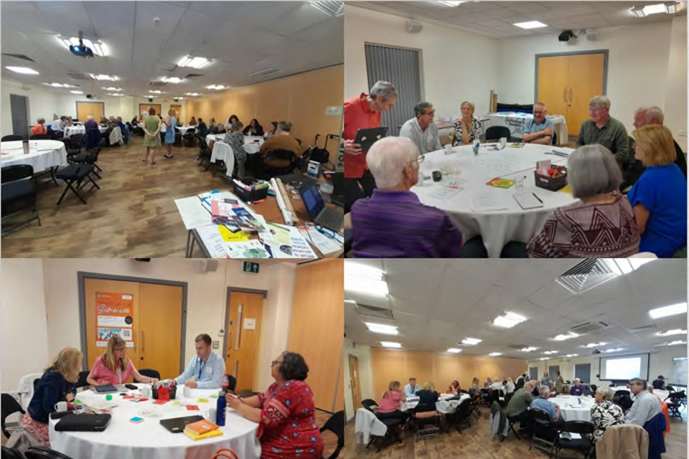
34

Engagement and Co-production

Adult
We have a strong commitment to prioritising engagement and coproduction as an important part of the way we lead on each of our workstreams. Families and carers are our ‘experts by experience’, and we value their input across all of our workstreams and at every stage influencing decision making, pathway development and service implementation.
We are proud to have a proven track record of engagement and coproduction throughout our workstreams, and this is carried out in a variety of ways. From recruitment stakeholder panels, to workshops, local engagement events, and involvement with our steering groups, the input of individuals with lived experience, families and carers is highly valued. This helps to ensure strategic decisions are well-informed, reflect the needs of our population, and that models of care are co-produced.
There are numerous examples throughout the report which demonstrate our commitment to coproduction throughout our programme. For example, in our Community Mental Health Transformation workstream, a Lived Experience Director for North Yorkshire and York will work to consolidate the co- production agenda across the ICS and ensure that people with lived experience are at the centre of transforming services.
We believe it is vital to continue to work with people who have first-hand experience of both using and delivering mental health, learning disabilities and autism services to co- produce the solutions that will support people in our area for years to come.

Children and Young People
Coproduction is one of our 6 ICB priorities for Children and Young People’s Mental Health, and a key aspect of the Children and Young People’s Trauma Informed Care Programme.

Successes 2022/23
  - Over the last year we have worked with Young Minds (the national Children and Young People Mental Health Charity) to map existing engagement and coproduction activity with Children and Young People across our six Places.
  - Creation of communities of practice with place-based engagement and coproduction leads across the ICS partners, to ensure consistency of approach, and peer to peer support and learning between services and partners. The network includes over 170 staff members involved in engagement and coproduction.
  - We have provided consultancy, advice, and guidance to a wide range of place- based services and partners, to support organisations to embed evidence-based practice
to enable sustainability of delivery. This included developing and sharing resources, skills, and knowledge across the ICS, working with places and partners support and empower them to embed coproduction within their own work and organisations.
  - Recruited, trained and supported a team of young volunteers with lived experience from across the ICS geography, who will act as advisory groups to relevant steering groups and boards. In December 2022, 24 Children and Young People from across Humber and North Yorkshire attended the “Nothing About Us Without Us” Children and Young People’s Mental Health engagement event to coproduce the development of a Humber and North Yorkshire wide Children and Young People’s advisory group.

Quotes from Young People

I had such a great time on Monday at the event and am pleased to say I was part of the start of this important project. It was so refreshing to see professionals and young people working together to start to make a change to ensure that decisions about youth mental health are made with us. Looking forward to seeing this opportunity progress.
Young Person

I learned that many opinions may be different, but you can still join together as a community to make something work.
Young Person

We got to meet new people from
different places who want to also have our voices heard and all worked together to try and change it.
Young Person

It was an amazing experience not only as a young person, but to see so many professionals listening to a group of young people.
YounYgouPnergsoPnerson

What I liked about this was that young people were included from the very beginning because that doesn’t usually happen. I’m involved in different groups, and we only ever get invited to be involved once the professionals have already decided what they want. It’s exciting to be involved like this and I look forward to ouYronuenxgt mPeeerstoinng.
Young Person

I would like to say Clair is one of the most amazing people I’ve met in a long time. She is so passionate about her job and is there for young people every step of the way throughout. Since volunteering with Clair, she has really changed my life and has
given me so many opportunities to be part of things I never thought I’d be a part of. She makes young people feel valued and that we are important.
She has changed my life for the better and has had an influence in what I want to do as a career.
Young Person

I know what it’s like to not feel like I have a voice and to not be listened to by services for my mental health. I have had my journey, and now I want to help other young people with theirs by helping these services improve so Children and Young People can get the help they need. It’s taken me years to get where I am today and if someone had said that I’d be a part of this group helping make services better I wouldn’t have believed them. I see all my friends moving on with their lives and I think to myself ‘What am I doing?’ but now I look at myself and see that I am actually doing so so well, and I am making such a positive difference on the other people and how much I have grown in confidence.
I’ve had my down times and there’ll be more, but I know that no matter what I am still making a difference and I’m getting somewhere in life. Young Person

36

The advisory group of young people with an interest in or lived experience of mental health challenges will meet frequently in their local area, and twice a year across Humber and North Yorkshire, to influence mental health strategy, policy, and practice. The group’s agreed aims are:
- To inform decision making about young people’s mental health services
- To make a change
- To hold services accountable
- To improve awareness and understanding of mental health
- To ensure that young people’s experiences and opinions are embedded in decision making processes from start to finish.

Humber and North Yorkshire’s Young People’s Mental Health Advisory Group’s Top Priorities for Improving the Mental Health of Children and Young People
across Humber and North Yorkshire: -

1 | Young people led awareness-raising and training, on the signs and symptoms of mental health problems, and issues impacting young people’s mental health, including LGBTQ+, racism, etc.
2 | Easier access to services
3 | Young people leading on work and courses about children and young people’s mental health, to ensure their voices are heard, their lived experience is valued, and they are not ‘shrugged off’ by professionals
4 | Listen to us more

The young people’s advisory group will also inform decision making of relevant steering groups such as the Humber and North Yorkshire Health and Care Partnership Children and Young People’s Mental Health Steering Group and the Strategic Alliance and Operational Steering Group.
We have also undertaken system wide consultation and engagement exercises to inform service improvements and developments to improve access to digital mental health support for CYP.

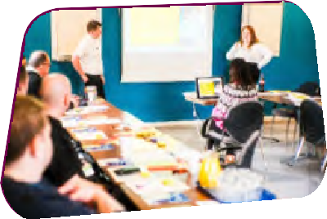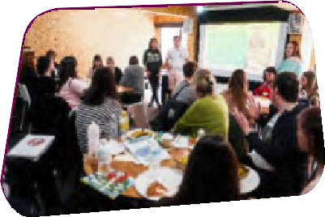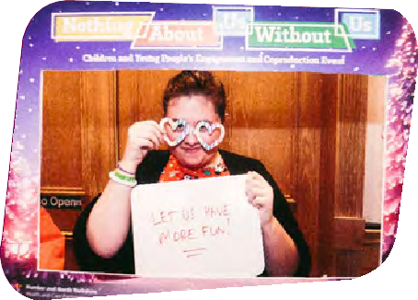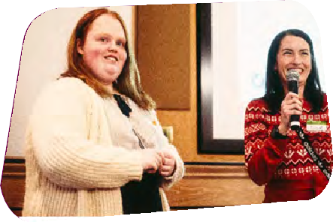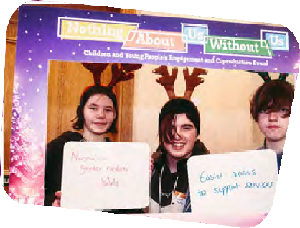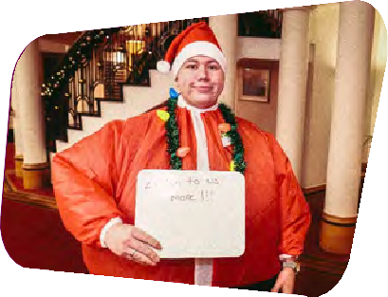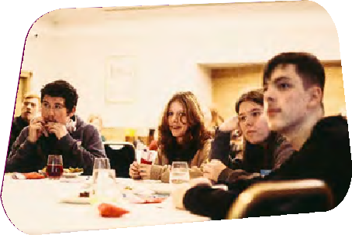

Priorities 2023/24
- Finalise, disseminate, and embed the HNY CYP Engagement and Coproduction strategy.
- Grow the CYP Advisory Group to include individuals from a diverse range of backgrounds and experiences.
- To map and produce a report on the gaps in participation, and identify opportunities to uplift the voices of children and young people.
- Consultation with CYP presenting at A&E and in acute paediatric wards with poor mental health.
- CYP led peer consultation on improving access to mental health services.
- Developing short films/animations on key issues to improve training for multi- agency staff working with CYP e.g., LGBTQ+
- Communities of practice on improving engagement and coproduction.

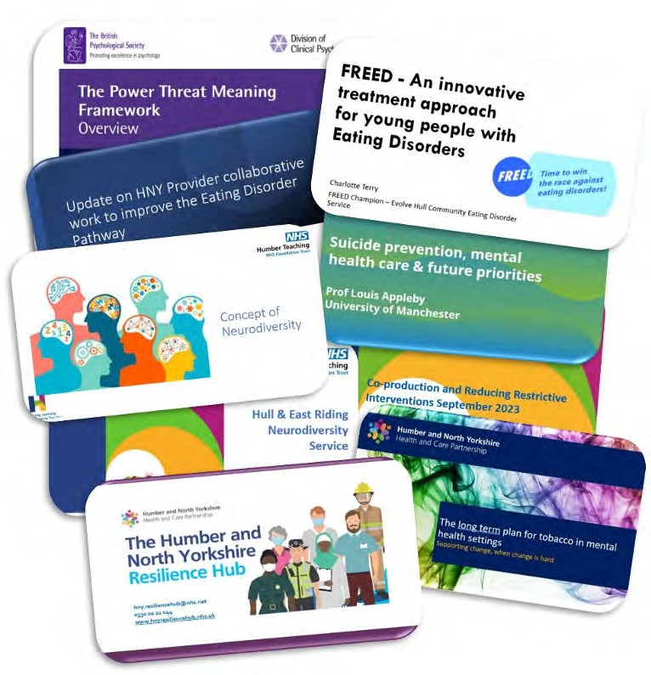

Clinical Engagement

Mental Health, Learning Disabilities and Autism Clinical Assembly
The Humber and North Yorkshire Health and Care Partnership Mental Health, Learning Disabilities and Autism Clinical Assembly is now well into its third year and continues to be very well attended.
The primary aim of the assembly is to promote clinical engagement across the collaborative between clinicians and professionals of all disciplines and from all partner organisations (including NHS providers,
primary care, local authority, and voluntary organisations).
We have consistently sought feedback from those attending, both to ensure that the content is relevant and to guide future content. A key acknowledgement from the outset was that the clinical voice needs to be heard, considered, and responded to. We recognise
that demonstrating evidence of its impact on the direction
of the collaborative and the ICS is an important requisite in sustaining the high levels of attendance that the assemblies attract. The clinical voice is far from the only voice of course, but the assembly has a responsibility to be both meaningful and accountable for the contributions of its members.
Increasingly, the assemblies are focussing on system-wide approaches to health and care, and we see this trend continuing, supporting directly the goals and ambitions of the ICS and the opportunities to improve outcomes at both personal and population levels. For all assemblies we have once again welcomed experts in the field from within and outside our ICS, showcased innovative models of care, and have used question and answer sessions to encourage rich and vibrant dialogue.
One recent change, in response to direct requests and specific (and unanimous) feedback is for the assemblies to be recorded and uploaded on the HNY ICS You Tube channel. It
is encouraging that the assemblies are particularly regarded as a forum for learning and sharing practice and facilitating cross-sector collaboration.
The following clinical assemblies were held in 2023:
23rd January - Update about the ongoing work within the ICS to improve the physical health of people with Severe Mental Illness with a focus on smoking cessation. The assembly included an update about smoking cessation in the light of the SCIMITAR study from Prof. Simon Gilbody (Director of the York Mental Health and Addictions Research Group).

22nd February - System wide approach to Neurodiversity: what should services look like? This assembly included presentations from services within the non-statutory sector about their work.
15th March - Update on the National Suicide Prevention Strategy. Main speaker Prof. Louis Appleby (Director of the National Confidential Inquiry into Suicide and Safety in Mental Health). This assembly included an update about the suicide prevention work ongoing within the ICS.
19th April - The regional clinical network held a live one-day celebration event in York to showcase Community Mental Health Transformation across Yorkshire and the Humber, with both Humber and North Yorkshire represented. This was an opportunity to
look at whole-community integrated mental health care as it is developing across the ICS. Assembly members were encouraged to participate in this regional event and an assembly on this topic was not held for fear of duplication.
12th May - Mental Health Question Time with system leaders. System leaders on the panel included Stephen Eames (CEO, Humber and North Yorkshire Health and Care Partnership), Zoe Campbell (Managing Director - North Yorkshire, York and Selby, Tees, Esk and Wear Valley NHS Foundation Trust), Dr Nigel Wells (Executive Director of Clinical and Professional, Humber and North Yorkshire Health and Care Partnership), Helen Kenyon (Place Director, North East Lincolnshire), Jason Stamp (Chair and Senior Responsible Officer – VCSE Collaborative and Senior Responsible Officer – Workforce,
Humber and North Yorkshire Health and Care Partnership) and Alison Flack (Programme Director, Humber and North Yorkshire Mental Health, Learning Disabilities and Autism Collaborative Programme).
14th June – Children and Young People Eating Disorders update, with a focus on Avoidant Restrictive Food Intake Disorder (ARFID), early intervention and First Episode Rapid Early Intervention for Eating Disorders (FREED) workers, and prevention of nasogastric feeding in young people.
1st August – Power Threat Meaning Framework: Compassionate Care and Cultural Values. The Power Threat Meaning Framework is a model which moves away from the traditional ‘medicalisation’ of mental health, from ‘What is wrong with you?’ to ‘What has happened to you?’ It looks at how power operates for the individual (patient) but also within organisations, and of the latter, those who understand these conflicts tend to be better organisations for both patients and staff.
6th and 13th September – linked meetings, Safety and Quality of Inpatient services and Alternatives to admission/inpatient care. These “twin” meetings were organised to coincide with the emerging national focus on inpatient settings and care and the development of our own inpatient transformation workstream. We heard from national speakers and the HNY collaborative programme lead, thus enabling meaningful clinical engagement at an early stage. It was attended by a range of clinicians from across the system and this is certainly something that we would aim to replicate in future assembly programmes.
27th October – Dementia diagnosis and clinical pathway update and Annual Review of Clinical Assemblies (using Mentimeter to collect feedback).
We are looking forward to planning the 2024 programme together with feedback from assembly members.

All staff members from partners across the ICS are encouraged to attend and can email hnf-tr.hnymhpmo@nhs.net to join the clinical assembly mailing list.

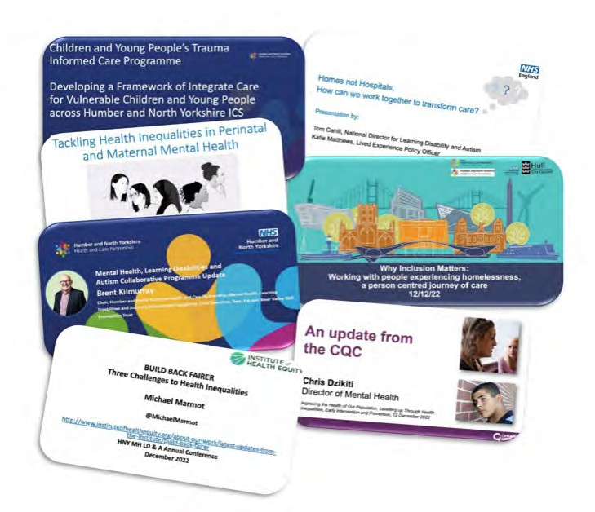The Humber and North Yorkshire Mental Health, Learning Disabilities and Autism International Conference 2022/23
Humber and North Yorkshire Health and Care Partnership Mental Health, Learning Disabilities and Autism Collaborative Programme Annual Report 2022-23
On Monday 12th December 2022, over 300 colleagues joined our fourth annual, international Mental Health, Learning Disabilities and Autism Collaborative conference via MS Teams. The conference was titled: Improving the Health of our Population: Levelling up through Health Equalities, Early Intervention and Prevention.
The main theme of the conference was health inequalities, early intervention and prevention, with guest speakers presenting on a range of issues from local to national level.
The following keynote speakers were featured:
- Professor Sir Michael Marmot MBBS, MPH, PhD, FRCP, FFPHM, FMedSci, FBA; Director of the Institute of Health Equity (UCL Department of Epidemiology and Public Health) on Build Back Fairer: Three Challenges to Health Inequalities
- Tom Cahill, National Learning Disability and Autism Director, NHS, on Homes not Hospitals, How can we work together to transform care
- Chris Dzikiti, Director of Mental Health, Hospitals, CQC, giving an update from the CQC
- Katy Morley, Service Development Manager, Humber 4 Specialist Perinatal Mental Health Service and Elizabeth Adekeye, Clinical Psychologist, HNY Maternal Mental Health Service on Reducing Perinatal and Maternal mental health inequalities

  - Gail Teasdale, Children and Young People’s Mental Health Programme Lead and Kati Taunt, National Trauma Informed Care Training Lead on Reducing inequalities and improving outcomes for vulnerable CYP through a system wide trauma informed approach
  - Dr Lucy Chiddick, Hull and HNY HCP Clinical Lead, Inclusion Health, NHSE/I NEY region Clinical Lead, Inclusion Health (Mental Health) and Paula Ashton, Clinical Lead, Homeless Mental Health Team, Humber Teaching NHS Foundation Trust on Working with people experiencing homelessness. A person centred journey of care: why inclusion matters
Other speakers included: Professor Stephen Eames CBE, System Lead and Independent Chair for the Humber and North Yorkshire Integrated Care Board; and Brent Kilmurray, Chair, Humber and North Yorkshire Health and Care Partnership Mental Health, Learning Disabilities and Autism Collaborative Programme and Chief Executive, Tees, Esk and Wear Valley NHS Foundation Trust.
Brent Kilmurray shared on the successes and priority areas for the Mental Health, Learning Disabilities and Autism Collaborative in the last year, which included:
  - Being selected as one of two pilot sites in the region to develop mental health support for rough sleepers in East Riding and work collaboratively with social care and community services.
  - Building on the success of our Community Mental Health vanguard site in Hull and East Riding by now expanding CMHT transformation across our ICB.
  - Being selected as one of two pilot sites in our region for a new service for people with Type 1 diabetes and an eating disorder, with a planned launch later in the year in Hull and East Riding.
  - A successful bid for funding from NHS Digital which has allowed us to rapidly improve support for comprehensive annual health checks for people with Severe Mental Illness (SMI) through use of remote monitoring and improved data quality
  - Expansion and implementation of Mental Health Support Teams for Children and Young People in schools
  - Ensuring the ICS meets waiting time standards for eating disorder referrals
  - Developing and embedding the CYP Trauma Informed Care Programme
  - Reducing out of area placements, and ensuring that when they do it is supported by a clear rationale of assessment and treatment, and desired outcomes, and services are as close to home as possible.
  - Expanding mental health crisis teams and liaison services
  - Rollout of Right Care, Right Person programme
  - Developing an ambulance response for Mental Health
  - Increasing the number of Learning Disabilities health checks in line with the Long Term Plan
  - Delivery of the Oliver McGowan training across the ICB

Performance
In 2022/23, delivery of mental health, learning disabilities and autism performance targets continued to be a challenge as we deal with the long term effects of the COVID-19 pandemic and increasing pressures on health and care services. Below you can see Humber and North Yorkshire’s performance against some of NHS England’s core indicators.

Indicator | Target | March
 | March 2023 | 2023
Children and Young People
Children and Young People’s Access (1+ contact) | 22,407 | 17,765
Children and Young People’s Eating Disorder Waiting Time – routine | 95% | 81.5%
Children and Young People’s Eating Disorder Waiting Time – urgent | 95% | 53.8%
Adult Mental Health
Dementia Diagnosis rate | 66.7% | 58.1%
IAPT Access | 4,465 | 2,820
IAPT Recovery rate | 50% | 55%
Individual Placement Support | 544 | 835
Perinatal Access | 574 | 550
SMI Physical Health Checks | 8,893 | 7,505
OAP Bed Days (Inappropriate Only) | n/a | 1,175
Community Mental Health Access (2+ Contacts) | 17,267 | 16,300
EIP Waiting Times | 60% | 58%
Discharges Followed Up Within 72 Hours | 80% | 85%
Patients on the Learning Disability Register who received an Annual Physical Health Check | 75% | 82.6%

We have some areas where we are performing well against these indicators, such as:
  - Significantly increasing delivery of physical health checks for people with serious mental illness.
  - Increasing access to community mental health services
  - Increasing numbers of people with serious mental illness supported into employment (individual placements support services – IPS)
  - Exceeding the national target for delivery of physical health checks for people with learning disabilities and autism.

  - The quality of our IAPT services and supporting people through recovery from common mental health problems.
However, we also have some significant challenges to address including:
  - Increasing the rate of dementia diagnosis
  - Reducing waiting times for children and young people requiring support with eating disorders.
  - Increasing access to children and young people’s mental health services
  - Reducing inappropriate out of area placements
We have plans in place to address these areas, and are working hard with our partners to achieve them through collaborative and innovative work.

Finance
The Mental Health Collaborative successfully delivered against £21.9m of SDF investment through the 2022/23 financial period, the majority of which was continuation or growth of existing funding streams.
As in previous years the funding was used across the full Humber and North Yorkshire footprint and utilised to deliver on either ICS wide programmes of work or prioritised on local need dependent upon the nature of the funding stream.
A summary of the funding is below:

Scheme Type Value £m
Community Mental Health 8.0

CYP Mental Health Support Teams 4.2

CYP Community and Crisis 1.9
Adult Crisis
1.7

Health and Justice - Trauma Informed Care 1.5
Staff Support
1.0

Young Adults 0.9
Other Smaller Schemes*
Total Investment HNY MH
2.6
21.9
*Schemes with value of less than £0.5m
During 2022/23, the collaborative was also successful in securing Capital investment for Mental Health Urgent and Emergency schemes. The level of funding secured
for Humber and North Yorkshire amounted to £2.0m with three key schemes being funded. All schemes were completed in year with specific focus on increasing local
alternatives to admission in order to relieve pressure on the UEC MH pathways and/or reducing the need for out of area placement of patients.

What Next
We will continue to work in collaboration with our partners to implement the NHS Long Term Plan priorities identified throughout this report. In addition, we will also work to:
- Improve access to mental health support for children and young people in line with the national ambition for 345,000 additional individuals aged 0-25 accessing NHS funded services (compared to 2019)
- Increase the number of adults and older adults accessing NHS Talking Therapies, and improve treatment
- Achieve a 5% year on year increase in the number of adults and older adults supported by community mental health services.
- Work towards eliminating inappropriate adult acute out of area placements.
- Recover the dementia diagnosis rate to 66.7%
- Improve access to perinatal mental health services.
- Ensure 75% of people aged over 14 on GP learning disability registers receive an annual health check and health action plan by March 2024
- Reduce reliance on inpatient care, while improving the quality of care when admission is necessary, for adults and children with a learning disability and/ or who are autistic.

We will also:
- Build on the great clinical engagement work that has been led by the Clinical Assembly, promoting clinical engagement across the collaborative, welcoming experts in their field to present on new and innovative models of care, and encouraging rich dialogue and discussion amongst professionals and clinicians. Future topics under consideration include: Community pharmacy and Mental health pharmacy and their place in integrated care; Services for young people aged 16-25 including transition; Early onset dementia; CMHT Transformation and PCNs
- Prioritise refreshing our collaborative strategy, working with partners to identify the key areas of focus for the coming years post-LTP.
- Have an increased focus on transformational workforce programmes. Identifying and innovating ways to support our current workforce, as well as grow and develop the future workforce of our Integrated Care System, and appointing to new posts to lead and support with this work.
ICS 5 year Jo Forward Pla
National Priorities 2023-24
Children and Young People
Think person
- Increase access to community mental health services, including IAPT and EIP
- Recover dementia diagnosis rate to 66.7%
- Reduce out of area placements
- Increase access to children and young people’s mental health services
- Increase access to perinatal mental health services
- Deliver annual health checks to 75% of those aged over 14 on the LD register
- Reduce reliance on inpatient care and improve quality
- Address health inequalities and deliver on the Core20PLUS5 approach
ICS 2 year Operational Plan
Dementia
Community Mental Health
Think family
Perinatal and Maternal Mental Health
Think community
our delivery workstreams
Health Inequalities
Suicide Prevention
Learning
Disabilities and
- Experts by lived experience
- Co-production and partnerships
- Data and governance
- Focus on quality and efficiency
Start Well
Live Well
Age Well
Die Well
Autism • Culture development
- Resource triangulation
- Clinical leadership
Adult and Older Inpatient
People Mental Quality Health Transformation
Enablers
int n
Improve outcomes in All Age Autism Assessment and Pathways
Improve health and wellbeing of vulnerable children through Health and Justice Framework for Integrated Care
Improve quality and safety through Inpatient Quality Transformation
National Programmes
Deliver Expand early comprehensive, quality intervention and
care and treatment prevention
Ensure equal access and outcomes for all ages
Reduce reliance on hospital care and Transform community services
NHS Long Term Plan Ambitions
ICS Strategy
Mental Health, Learning Disabilities and Autism Sector Collaborative
Our Vision: We want people of all ages who experience mental health problems, have learning disabilities and/or autism to live healthy lives, be able to achieve their goals and be accepted and supported in the communities they live in
Responsibilities: Deliver key targets; Act between provider members, place, and other delivery partners to deliver
transformation at scale, as part of the ICS strategy; Provider and service strategic transformation
ICB Purpose: improve the lives of the people who live and work in Humber and North Yorkshire
Improving outcomes │ Tackling inequalities │ Enhancing quality and productivity │Supporting social and economic recovery

Meet the Team

Michele Moran,
Senior Responsible Officer

Alison Flack,
Programme Director

Michele is a Nurse, Midwife and Health Visitor by background and has more than 35 years’ experience of front-line roles in NHS management and care. Michele was appointed to the role of Chief Executive at Humber on a permanent basis in February 2017. Prior to this Michele was Chief Executive in Manchester for four years. Michele served as Deputy Chief Executive/Chief Operating Officer/ Chief Nurse at Leeds and York Partnership NHS Foundation Trust for seven years.
Michele has extensive experience across all sectors in the NHS, with substantial experience in integrating systems and is an advocate for integrated care, speaking at many national conferences on collaboration in care. Michele
is Chair of the Yorkshire and Humber Clinical Research Network.
Michele is committed to putting patients at the heart of everything that we do and supporting staff health and wellbeing. A qualified nurse, mental health nurse and midwife, Michele also has a Master’s degree in Health Services Management from the University of Manchester.
Michele leads the Mental Health, Learning Disabilities and Autism Collaborative alongside leading the design of the collaboratives in Humber and North Yorkshire and is a partner representative on the Humber and North Yorkshire Integrated Care Board.

Alison plays a pivotal role in the Humber and North Yorkshire Health and Care Partnership Mental Health, Learning Disabilities and Autism Collaborative Programme as the Programme Director. She is passionate about ensuring our partners across the patch work together collaboratively to improve mental health outcomes for everyone in our area. Alison has a wealth of experience working at a senior level in health and care organisations and is proud to be part of a team transforming and improving mental health services for our communities.

Pete’s role as finance lead for the partnership sees him coordinate the sharing and reporting of financial
information across partners. This includes the coordination and monitoring of investments to support national planning priorities. Pete is passionate about directing investments
to the most beneficial areas to ensure people receive high quality treatment and support.

Pete Beckwith,
Chief Finance Officer

Doug Flockhart,
Head of Performance and Programme Delivery
Doug has worked in health and care organisations across the Humber and North Yorkshire patch since 2007. He became increasingly interested in the wider health and care system, particularly what can be achieved when partner organisations work collaboratively. Over the past few years, Doug has focused on integration and system development work, taking up a programme lead role in the Humber
and North Yorkshire Health and Care Partnership Mental Health, Learning Disabilities and Autism Collaborative Programme in 2018. Mental Health is now rightly receiving the focus and attention it deserves and, through the
work of our programme, Doug wants to ensure all of our residents have access to the support they need in a way that works for them and their families.

Trish Bailey,
Senior Clinical Lead for Learning Disabilities and Autism
Trish Bailey joined the team in October 2022 as the Senior Clinical Lead for the Learning Disability and Autism programme. Trish has 35 years of experience working in the NHS in various clinical and leadership roles working with both children and adults along with their families within Learning Disability services. In more recent years, Trish has expanded her role through developing support for individuals who are neurodiverse. Throughout her career Trish has engaged and worked in partnership
with experts by experience, families, carers, and external stakeholders and is looking forward to working as part of the team to help promote and deliver personalised care across a diverse range of health and social care services.

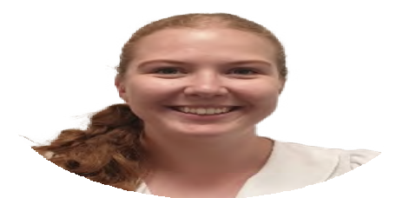Emily Davey, Programme and Performance Manager
Emily recently completed the General Management Training Scheme with the NHS Leadership Academy, during which she undertook placements within the Mental Health, Learning Disabilities and Autism Collaborative Programme, and Community and Primary Care. Emily is passionate about improving mental health services for people across the region, and in particular is focussed on working with partners to improve the physical health of people with a severe mental illness.

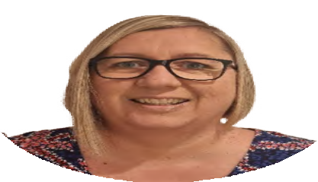Lisa is a new member of the team, providing administration support to the Children and Young People’s Trauma Informed Care Programme and the wider team. She
has previously worked in a strategic Children and Young People’s Mental Health Programme and is looking forward to continuing to work with those who are passionate about improving the mental health of children and young people.

Lisa Hudson,
Senior Administration Assistant, Children and Young People’s Trauma Informed Care Programme

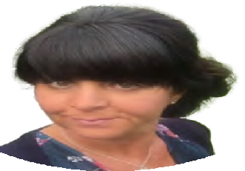

Cat Jones,
Programme Partnership Manager, Children and Young People’s Trauma Informed Care Programme
Cat recently joined the team from outside the NHS, with a background in education and more recently working
on a strategic Children and Young People’s Mental Health Programme within a Local Authority. Cat has extensive experience in driving initiatives within schools during
her time as a Senior Leader and Headteacher, and also implementing national policy and practice change across the schools in a city. Cat has taken on the role as Programme Partnership Manager of the Children and Young People’s Trauma Informed Care Programme. Cat and the Core
Team will focus on working collaboratively to ensure that all professionals working across the system with children and young people who have experienced trauma, can be supported to respond appropriately, consistently, and compassionately, so that the support these children and young people receive helps them to thrive.

Jo is passionate about working within our communities to reduce the stigma around suicide, and to support individuals and organisations to prevent suicides from occurring.
Favourite quote: “Never doubt that a small group of citizens can change the world; indeed, it’s the only thing that ever has.” - Steve Jobs.

Jo Kent, Suicide
Prevention Programme Lead
Katy Marshall, Strategic Workforce and Cultural Lead

With a background of engagement and organisational development, Katy joined the team to provide strategic direction on workforce and culture. She is passionate about working collaboratively and believes this is the best way
to shape how we move forward as one workforce. Being part of the ICS enables her to support positive change on a wide scale, work with lots of great organisations and support amazing people that look after the needs of our local populations.

Stella is a consultant psychiatrist with over 30 years’ experience of working in mental health services. In collaboration with Dr Steve Wright, she is focusing on improving clinicians’ engagement with the work of the ICS and has established the Mental Health, Learning Disability and Autism Clinical Assembly. In addition, she contributes to the wider programme and strategic work.

Dr Stella Morris,
Clinical Lead

Lynnette Robinson, Mental Health Programme Lead

Gail Teasdale, Children and Young People’s Mental Health Programme Lead
Lynnette leads on the Community Mental Health transformation, including the specialist area of developing the annual physical health check for patients with Severe Mental Illness (SMI).
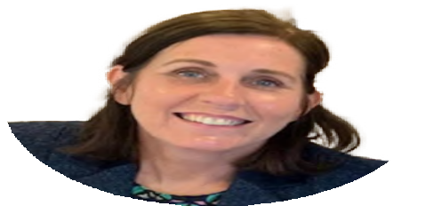Lynnette set up and supports the Humber and North Yorkshire Resilience Hub which centres on Covid-19, our regional mental health response which support key
workers who have experienced distress related to Covid-19 pandemic by providing early help, and intensive evidence- based therapeutic interventions in a timely way.

Gail joined the collaborative in November 2021 after 20 years leading on system change and commissioning services for Children and Young People’s health at place across
local authority children’s services, public health and CCGs. Her work to improve outcomes for Children and Young People has been recognised as national best practice by the Department of Health, Department for Education, Local Government Association and the National Children’s Bureau. Gail leads the Children and Young People’s Mental Health Programme, working with a wide range of partners at
place including VCSEs, Local Authorities, and Health commissioners and providers. The programme has developed and is delivering the strategic plan for Children and Young People’s Mental Health to improve prevention and early intervention, improve access to services and outcomes and reduce inequalities. Gail is passionate about ensuring that the voice and influence of children and young people with lived experience is embedded throughout our work. With effective engagement and coproduction we can ensure all children and young people can access the right support, in the right place at the right time.

Georgie Thrippleton, Perinatal Mental Health Programme Lead
Georgie is passionate about improving mental health support for mothers and families in the perinatal period. By ensuring mother’s mental health needs are met early, this greatly improves outcomes for babies and improves relationships. Georgie wants to work with women, families and all partners to reduce the stigma surrounding mental health as new parents as mental illness at this time is very common and with the right support outcomes for families are positive.

Kelly provides administrative support to the programme. She feels lucky to be part of a passionate team and to have the opportunity to support the various workstreams. Kelly enjoys being able to assist the programme leads and help contribute to improving the mental health care for the local community.

Kelly Toes-Smith,
Administration Team Lead

Gemma Willingham-Storr, Programme Lead for Urgent and Emergency Mental Health and Dementia

Katy Winfield, Community of Practice Manager, Children and Young People’s Trauma Informed Care Programme

Gemma is a Learning Disability Nurse and DBT Therapist by background and has worked in the NHS for 14 years. Gemma is very passionate about making sure that everyone is able
to access help and support when they need it and without barriers. Having worked in clinical practice across Mental Health and Learning Disability Services for the last 14 years, Gemma has seen first hand some of the challenges faced by our population. Gemma is keen to make sure that people are at the heart of all that we do and that their voices truly contribute to the way in which our services work. Gemma also wants to fully support our workforce and embrace their
experiences and contributions to transformational change. We are all in it together.

With over 20 years’ experience of working within health service settings, supporting vulnerable and socially isolated individuals, Katy has a broad understanding of their needs and a passion to make a positive impact. Katy thrives when engaging with communities and services that work to make a positive difference. Katy brings an extensive amount of knowledge and experience working within a clinical setting
and supporting staff to achieve positive outcomes, with service user groups experiencing health inequalities. She has managed services and contracts, and implemented service change, over several years, which will support her future success within her role of Community of Practice Manager of the Children and Young People’s Trauma Informed Care Programme.

Debbie provides support to the Humber and North Yorkshire Partnership (Mental Health, Learning Disabilities and Autism) Senior Management Team. She enjoys the variation in her role, and the opportunities to play a part in helping to shape the future of mental health, learning disabilities and autism services across the Humber and North Yorkshire.

Debbie Wilson, Senior Administration Officer

Nicola Wood,
Finance and Performance Manager
Nicola enjoys supporting the programme with the monitoring and reporting of the funding coming into the system. She enjoys working with partners across the system to ensure funding is invested to achieve the best outcomes for our population.
Mental Health and Learning Disabilities are subjects close to her heart after seeing the impact that the challenges surrounding accessing the right services, not only in the NHS but in the wider social care and local authority sector, has placed on her loved ones over her lifetime. She believes that good Mental Health is a priority for all and rightly deserves de-stigmatisation.
Nicola is looking forward to the continued success of the programme as it begins its next chapter within the ICB.

Dr Steve Wright,
Clinical Lead
Steve is a psychiatrist with Tees, Esk and Wear Valleys (TEWV) NHS Foundation Trust and the medical lead for early intervention services.
Alongside his role as a clinical lead for mental health in Humber and North Yorkshire, he is clinical lead for Adult Mental Health with Yorkshire & Humber Clinical Networks, chairing the community mental health transformation regional collaborative.
He has worked in early intervention services since their introduction, supporting their increasingly preventive role. In recent years he has also been working with international collaborators to promote a “whole person, whole life, whole community” approach to mental health including developing a system-wide learning partnership with Trieste in Italy.

If you would like to find out more about the work of the Humber and North Yorkshire Health and Care Partnership,
please get in touch.

Write to us: Humber and North Yorkshire Health and Care Partnership,
c/o NHS Hull CCG,
2nd Floor, Wilberforce Court, Alfred Gelder Street, Hull, HU1 1UY.
Email: hullccg.stpcontactus@nhs.net
website: humberandnorthyorkshire.org.uk

