Appendix 2 –
Humber & North Yorkshire Integrated Care Board Risk Assessment
(Item Description) RISK ASSESSMENT

- Pre-Risk Assessment Score

Severity of risk | Likelihood of risk | Overall Risk Score
(Number from chart below here) | (Number from chart below here) | (Total Number totaling matrix score)
- Hazard  (i.e., Burn, Electric Shock, Trip etc.) | Who may be harmed  (i.e., Staff, Visitor, Contractor etc.) | Control measures  (i.e., Policy/ Procedure, Servicing, Signage, PAT tested, Incident reporting etc.) | Name of and responsibility of completion and annual review of the risk assessment
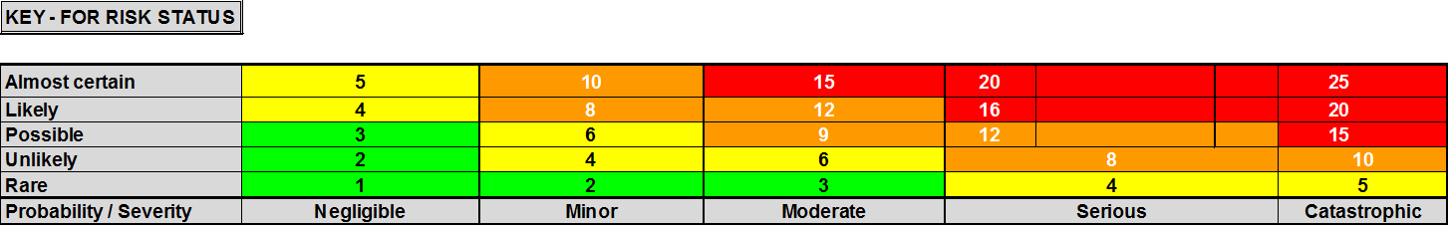

3. Residual Risk Score
Severity of risk | Likelihood of risk | Overall Risk Score
(Number from Chart below here) | (Number from Chart below here) | (Total Number totaling matrix score)
- Name of person completing risk assessment: | Appointed person sign off: | Date: | Review Date:
(NAME) | (NAME)
Signatures to confirm that this is a suitable and sufficient risk assessment and that stated control measures are in place. This assessment will be reviewed annually.

