Manual Handling Policy
November 2023

Authorship: | Risk Assurance and Safety Lead - HNY ICB
Committee Approved: | Executive Director of Corporate Affairs
Approved date: | 18 January 2024
Equality Impact Assessment: | November 23
Target Audience: | ICB and its Committees and Sub-Committees, ICB Staff, agency, and temporary staff & third parties under contract
Policy Number: | HNY ICB 67
Version Number: | 1.2

The on-line version is the only version that is maintained. Any printed copies should, therefore, be viewed as ‘uncontrolled’ and as such may not necessarily contain the latest updates and amendments.

AMENDMENTS
Amendments to the policy may be issued from time to time. A new amendment history will be issued with each change.

New Version Number | Issued by | Nature of Amendment | Approving body | Approval date | Date published on website
1.0 | Risk Assurance and Safety Lead | New Policy for comment and approval of sharing with SPF | ICB Executive Director Corporate Affairs | 30/11/2023 | N/A
1.1 | Risk Assurance and Safety Lead | Comments and approval by SPF | SPF | 04/01/2024 | N/A
1.2 | Risk Assurance and Safety Lead | Approval by HNY ICB H&S Group | HNY ICB H&S Group | 18/01/2024 | January 2024

Contents Page

1 | Introduction | 4
2 | Purpose | 4
3 | Scope | 4
4 | Implementation | 5
5 | ICB Responsibilities | 5
5.1 | Management responsibilities | 5
5.2 | Employee responsibilities | 6
6 | Training | 7
7 | Occupational Health Arrangements | 7
8 | Arrangements for review | 8
9 | Dissemination | 8
10 | Associated Documentation | 8
11 | References | 8
12 | Appendices | 8
13 | Impact Assessments | 9
13.1 | Equality | 9
13.2 | Bribery Act 2010 | 9
13.3 | General Data Protection Regulations (GDPR) | 9
 | Appendix 1 - Guidelines on the manual handling of loads | 10
 | Appendix 2 - HNY ICB Risk Assessment form | 12

Introduction

For the purposes of this policy Humber and North Yorkshire Integrated Care Board (ICB) will be referred to as 'the ICB'.
The ICB is committed to providing a safe working environment for all employees. This will include the provision of safe management systems, equipment and any information, training and supervision that is necessary to enable its employees to carry out their duties in a safe manner.

Manual Handling is defined as “any transporting or supporting of a load (including the lifting, putting down, pushing, pulling, carrying or moving) by hand or bodily force”. Regulation 2(1) Manual Handling Operations Regulations 1992 (as amended) 2002.

Statistics show that manual handling of hazardous loads is one of the most common causes of absence due to injury in the workplace. This policy outlines the measures that must be taken by both managers and employees to reduce the risk of injuries being incurred and sets out guidance for the moving and handling of loads.

The aim of the policy is to eliminate the need for employees to undertake any hazardous manual handling tasks “so far as is reasonably practicable”, in accordance with current legislation and to promote best practice regarding manual handling tasks.

The ICB reminds all its employees of their duties under the Manual Handling Operations Regulations 1992 to make full and proper use of service aids provided and will take all reasonable steps to ensure that this Manual Handling Policy is communicated and available to all appropriate persons who have cause to work within the organisation.

Guidelines on the Manual Handling of Loads can be found attached at (Appendix 1)

General Manual Handling Risk Assessments should be recorded using the standard ICB Risk Assessment Form (attached as Appendix 2).

Specialist risk assessments for a specific individual or for complicated lifting equipment may be carried out by the Occupational Health provider on their own paperwork.

Purpose

The purpose of this document is to provide guidance to staff on Manual Handling. The ICB is committed to providing a safe environment for all Staff, visitors and everyone based at its premises.

This will be achieved by ensuring ICB premises and activities are free from unnecessary manual handling tasks wherever possible, and that those tasks which remain necessary are carried out in a safe and appropriate way.

Scope

This policy applies to all employees of the ICB, any staff who are seconded to the ICB, contracted and agency staff and any other individual working on ICB premises.

This policy applies to all ICB premises whether owned or leased, and forms part of the overall risk management strategy.

To this end, this policy will be available and or circulated to representatives of tenant and contractor organisations as necessary.

Implementation

This policy will be available to all staff for use via the ICB Internet.

All managers are responsible for ensuring that relevant staff within the ICB have read and understood this document and are competent to perform their duties in accordance with the procedures described.

ICB Responsibilities

The ICB recognises and accepts its statutory responsibilities as an employer to avoid hazardous manual handling so far as is reasonably practicable.

Where hazardous handling tasks cannot be avoided a suitable and sufficient risk assessment should be made considering:

• The nature of the task
• The nature of the load
• The capabilities of the individuals involved in the task
• The working environment
• Provision, maintenance and suitability of equipment
The risk assessment should be used to implement measures that eliminate or, where this is not possible, to reduce the risk of injury to the lowest level reasonably practicable.
Any assessment should be completed using an ICB template and reviewed annually, or sooner if changes in the task, load, working environment or individual capability occur.
All individuals who may be at risk, including non-employees must be informed of the risks associated with hazardous manual handling tasks so far as is reasonably practicable.
Employees who do not carry out safe manual handling techniques, as identified within the ICB Policies, but carry out unsafe techniques which increases the risk of injury to themselves and others, may be subject to disciplinary action in line with ICB Disciplinary Policy.

Management Responsibilities

Managers must ensure that all manual handling incidents are reported immediately in compliance with the ICB Incident Reporting Procedures and that appropriate investigations are undertaken.

Any employee with back pain or any other physical condition which may affect their required manual handling capability, whether or not as a result of injury, must be referred to the Occupational Health provider for a specialised assessment.

Managers must ensure that staff are instructed in the use and maintenance of specialised manual handling equipment were provided in the workplace following manual handling induction training. Any such training should be recorded in the Staff member’s personnel file.

Employees Responsibilities

All staff shall be reminded of their obligations under the Health and Safety at Work Act etc:
1974, as set out in Section 7, as follows:

“It shall be the duty of every employee while at work to take reasonable care of the health and safety of himself and other persons who may be affected by his acts and omissions at work”.

and that:

“As regards any duty or requirements imposed on his employer or any other persons by or under any of the statutory provisions, to co-operate with him so far as is necessary to enable that duty or requirement to be performed or complied with”.

Employees are reminded of their duties under the Management of Health and Safety at Work Regulations 1992, as set out in Regulation 5:

“Each employee while at work shall make full and proper use of any system of work provided for his use by his employer”.

Employees are also reminded of their duties under the Manual Handling Operations regulations 1992, as set out in regulation 12:

“To make use of appropriate equipment provided for them. Such equipment will include machinery and other aids provided for the safe handling of loads."

All employees are responsible for ensuring that they have read the Manual Handling Policy and that they are familiar with the principles outlined. Compliance with safe systems of work is mandatory. Any breach of this policy observed must be reported to the line manager.

Employees are required to participate in and comply with the undertaking and review of both generic and individual assessments of manual handling risk and to follow the guidance given where specific risks have been identified.

Accidents and incidents must be reported immediately in compliance with ICB Incident Reporting, and treatment/advice sought in the case of injury.

Any employee aware of a health problem or condition, whether or not due to injury which may affect their required manual handling capabilities must report this directly to their manager or refer to the Occupational Health provider if further advice or support is required.

Training

- Manual handling instruction is regarded by the ICB as mandatory training and the ICB considers it to be an integral part of the Health and Safety process and all staff must complete on-line training when required to do so. Compliance will therefore be monitored through the Performance and Individual Development process and through the electronic staff records.

- Mandatory E-learning training is provided through ESR, any subsequent face to face training requirements will be commissioned by the ICB.

All new employees must receive any training requirements at the first opportunity following appointment if they are unable to provide a record and details of previous training which satisfy the requirements of the ICB. Staff will receive refresher training as necessary. Staff may also be asked to attend further training if new risks are identified or if there are significant changes to the manual handling requirements of their specific role.
.

Occupational Health Arrangements

- The Occupational Health provider, in conjunction with the line manager, will provide health screening for all prospective new employees and where appropriate, health checks for those returning to work to assess their fitness for the work to be undertaken. Occupational Health will provide guidance to managers regarding specific elements of an individual’s job to advise people who may be at risk from manual handling operations.

- The Occupational Health provider’s responsibility will be to assess the health of prospective candidates against the physical requirements of the job, including manual handling.

- In response to management concerns, The Occupational Health provider will advise on how to ensure the environment does not adversely affect health.

- Any employee who may have been identified as having a work-related health concern may be referred for advice, information and assessment, or may make a self-referral to the Occupational Health Provider.

Arrangements for Review
No policy or procedure will remain operational for a period exceeding three years without a review taking place or as required legislative changes or following incidents.

Dissemination
The Accountable Officer will ensure through the ICB’s line management arrangements, that manual handling Policy considerations are included in any future business planning.
Directors will ensure appropriate cascading of Manual Handling procedures throughout their area of responsibility to ensure that the needs of the organisation are identified, prioritised and that any appropriate resources are allocated.

Associated Documentation
Health and Safety Policy
Incident Reporting Guidance

References
- Health and Safety at Work etc: Act 1974
- The Manual Handling Operations Regulations 1992 (MHOR)
- The Lifting Operations and Lifting Equipment Regulations 1998 (LOLER)
- Provision and Use of Work Equipment Regulations 1998 (PUWER)
- The Management of Health and Safety Regulations 1999 (MOHASR)
- Reporting Injury, Disease, Dangerous Occurrences Regulations 1998 (RIDDOR)

Appendices

Appendix 1 - Guidelines on the manual handling of loads

Appendix 2 – HNY ICB Risk Assessment form

Impact Assessments

Equality

NHS Humber and North Yorkshire ICB is committed to creating an environment where everyone is treated equitably and the potential for discrimination is identified and mitigated. It aims to design and implement services, policies and measures that meet the diverse needs of our service, population and workforce, ensuring that none are placed at a disadvantage over others.

It is required that a Quality and Equality Impact Assessment (QEIA) be carried out on a new policy that is likely to impact on patients, carers, communities, or staff.

The QEIA toolkit can be found on the HNY ICB Internet.

Potential adverse impact on any protected group identified through the QEIA will be monitored as part of the routine work to monitor compliance with the policy.

Bribery Act 2010
Due consideration has been given to the Bribery Act 2010 in the development (or review, as appropriate) of this policy document, further details can be found below.

The ICB follows good NHS business practice as outlined in the Business Conduct Policy and the Conflicts of Interest Policy and has robust controls in place to prevent fraud, bribery, and corruption. Under the Bribery Act 2010 there are four criminal offences:
• Bribing or offering to bribe another person (Section 1)
• Requesting, agreeing to receive, or accepting a bribe (Section 2).
• Bribing, or offering to bribe, a foreign public official (Section 6).
• Failing to prevent bribery (Section 7).

General Data Protection Regulations (GDPR)
The UK General Data Protection Regulation (GDPR)/ Data Protection Act 2018 includes the requirement to complete a Data Protection Impact Assessment for any processing that is likely to result in a high risk to individuals. Consideration should be given to any impact the policy may have on individual privacy; please consult NHS Humber and North Yorkshire ICB Data Protection Impact Assessment Policy. If you are commissioning a project or undertaking work that requires the processing of personal data, you must complete a Data Protection Impact Assessment.

The ICB is committed to ensuring that all personal information is managed in accordance with current data protection legislation, professional codes of practice and records management and confidentiality guidance. More detailed information can be found in the Data Protection & Confidentiality Policy and related policies and procedures.

Appendix 1 -

Guidelines on the manual handling of loads

- Where reasonably practicable all hazardous manual handling must be avoided

- Managers are responsible for ensuring the systematic recorded assessment of all potentially hazardous movement of loads and implementation of safe systems of work

- Where assessment indicates that the load needs physical assistance to move it, methods that avoid manual lifting must be used, e.g., hoists, belts, trolleys, sack trucks, rollers etc

- The Health & Safety weight guidelines below serve as an indication for suitable assessment. These guidelines should be adjusted when working as a team and according to an assessment of characteristics of the load, nature of the task, working environment and individual capability. Where assessment indicates no option but to exceed these guidelines, a more detailed risk assessment must be undertaken, and the task carried out by suitably trained staff

- Lifting and lowering: When seated or standing for any manual handling task, select the lowest weight zone through which the hand passes during the task

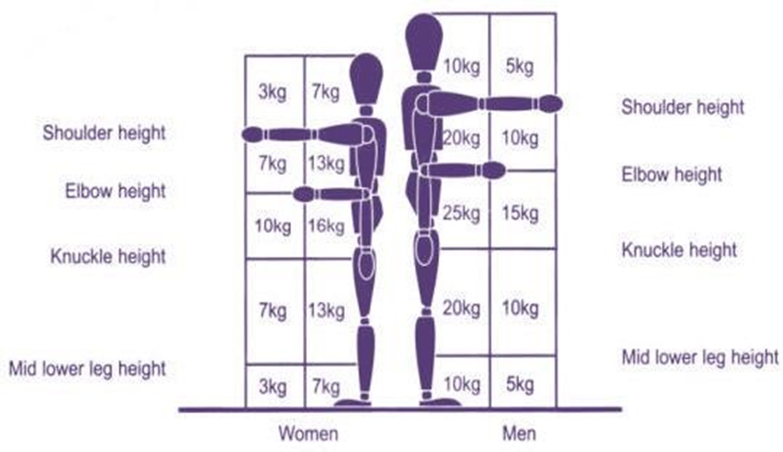

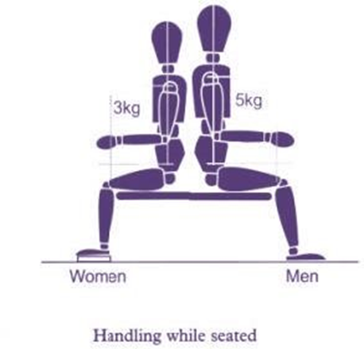

Pushing and pulling

For Information:
For women, a force of 16.6 kg is the maximum force that should normally be required to start a load moving. 6.6 kg is the maximum force that should normally be required to keep it moving.

For men, the maximum force for starting a load moving should normally be 25 kg. While the maximum force required for keeping it moving should be 10 kg.

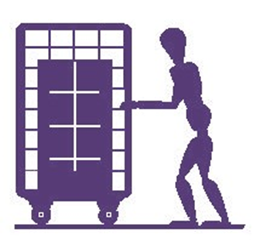
Hand position when pushing / pulling.

Appendix 2 –
Humber & North Yorkshire Integrated Care Board Risk Assessment
(Item Description) RISK ASEESSMENT

- Pre-Risk Assessment Score

Severity of risk | Likelihood of risk | Overall Risk Score
(Number from chart below here) | (Number from chart below here) | (Total Number totaling matrix score)
- Hazard  (i.e., Burn, Electric Shock, Trip etc.) | Who may be harmed  (i.e., Staff, Visitor, Contractor etc.) | Control measures  (i.e., Policy/ Procedure, Servicing, Signage, PAT tested, Incident reporting etc.) | Name of and responsibility of completion and annual review of the risk assessment
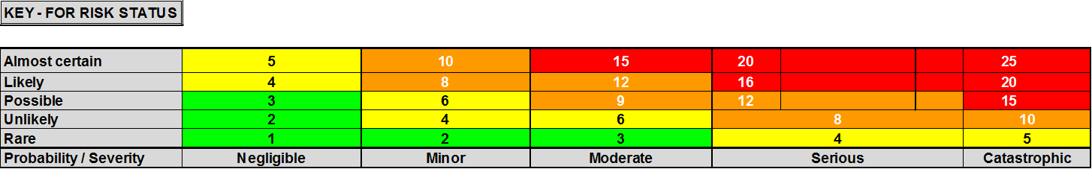

3. Residual Risk Score
Severity of risk | Likelihood of risk | Overall Risk Score
(Number from Chart below here) | (Number from Chart below here) | (Total Number totaling matrix score)
- Name of person completing risk assessment: | Appointed person sign off: | Date: | Review Date:
(NAME) | (NAME)
Signatures to confirm that this is a suitable and sufficient risk assessment and that stated control measures are in place. This assessment will be reviewed annually.

