
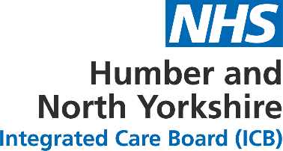

HNY ICB Committee Assurance and Escalation Report
Report to: HNY Integrated Care Board
Report from: Workforce Board
Date of meeting: Monday 18 November 2024
Committee Chair: Jason Stamp, Senior Responsible Officer for Workforce
Director Sponsor: Jayne Adamson, Executive Director of People
Author: Carly McIntyre, Senior Officer: Workforce Transformation

Key agenda items covered by the meeting
(A bulleted list of the key agenda items discussed at the meeting)
- ICB Blueprint update

- Humber and North Yorkshire Health and Care Partnership update
  - ICB Board

- Breakthrough 2024/25 programme update
  - Breakthrough update
  - Communications proposal

- Portability update

- People Promise exemplar site and retention conference update

- North Yorkshire and York Workforce Group update

- Skills for Care Workforce Strategy update

- Committee updates:

  - Paybill and Agency Management
  - People Story Committee
    - Action plan

- Items for information only
  - HNY Workforce Transformation – NHS Futures

- Any other business
  - Hull & East Yorkshire Combined Authority draft Skills Framework and draft Adult Skills Commissioning Framework formal consultation
  - HNY Talent Programme
ALERT
(BY EXCEPTION ONLY - key matters and / or risks to alert or escalate to the ICB Board)
Nil
ADVISE AND / OR ASSURE
(BY EXCEPTION ONLY - Key decisions and any updates to advise the ICB Board on the matters the Committee was able to take assurance on or where additional information was required)
END.

