Appendix B – HNYICB Core Standards Self-Assessment 24/25 Executive Summary
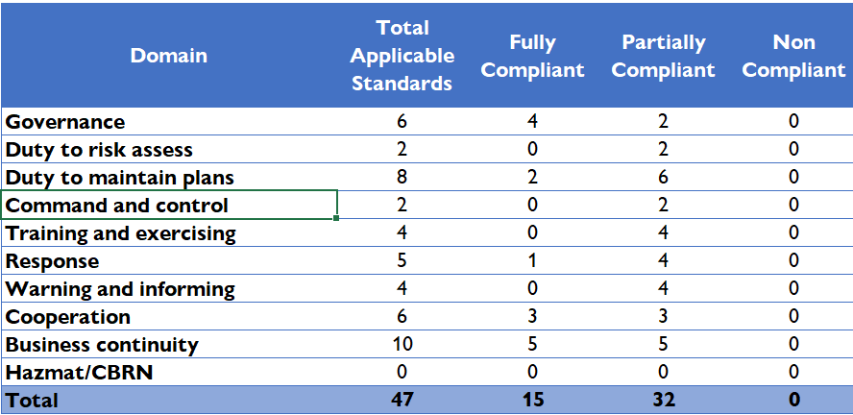
2023/24
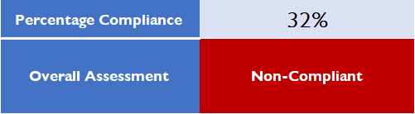

2024/25
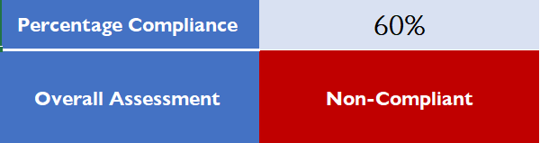
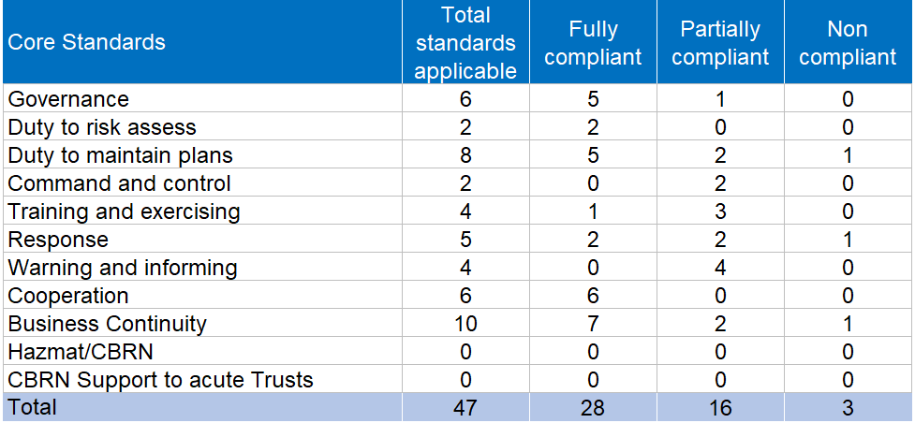

As can be see from above, the ICB has increased by 13 fully compliant standards this year. There are 3 standards that have become non-compliant, as for various reasons it might not be possible to achieve finalisation of work on these within 12 months. These are:

- Core Standard 13: Plans on new and emerging pandemics – the ICB is a member of the newly established North East Yorkshire and Humber Strategic Pandemic Oversight Group which met for the first time in March 2024. It has produced a strategy for ensuring the pandemic preparedness of the NHS organisations in NEYH which includes
  - Aiming for a draft plan to be in place by the end of March 2025
  - System training
  - Large scale exercise in April/September 2025 across NEYH
  - Tier 1 Pandemic Exercise (National – Pegasus) in Autumn 2025
  - Debriefing and updating of the plan
  - Final plan production – Spring 2026.

The ICB is also engaging with Local Resilience Forums on the outputs of the Covid-19 Inquiry.

- Core Standard 20: Loggists – The ICB has struggled to recruit loggists following the formation of the organisation and previously has only 2 trained loggists (the two staff in the EPRR team). Previous CCG loggists confirmed they not longer wanted to continue in this role. The role has often been held by administrative staff and the organisation’s admin review is ongoing. This being said, the EPRR Team have discussed approaching all ICB staff for loggist recruitment with the Executive Director of Corporate Affairs. Once this is approved an all staff email will be sent out but it may take time to train up new loggists to be added to the rota.

- Core Standard 53: Assurance of Commissioned Providers/Suppliers BCPs – The ICB are required to confirm they are assured of the business continuity plans of providers and suppliers. For the acute trusts and large CIC’s, this is done through the core standards process. There are other organisations who do not submit core standards, most notably primary care. The EPRR Team will need to work with the Corporate Affairs Team who hold Business Continuity in their portfolio to agree the best process to gain this assurance, using a risk assessment based approach to focus efforts on where the biggest risk in the system sits. The ICB has undertaken considerable work on business continuity since its formation and is in a strong position, so this standard may be completed within a year pending the outcome of the risk assessment discussions.

The ICB EPRR Team have had to respond to a multitude of incidents within the last 12 months and have done so for the majority of the year with just two staff members. Responses have been delivered conjunction with improvement work which has resulted a difference of 28% in compliance. All submitting NHS organisations in HNY have seen an uplift in compliance percentages as well; which is reflective of not just the hard work taking place within individual teams but also the system wide co-operation taking place through both Local Resilience Forums, the LHRP and its 4 subgroups.

The ICB’s EPRR Team have just successfully appointed a new Senior EPRR Manager, who will be joining the team on the 6th January 2025 boosting its numbers to 3. A Band 4 post in the Planning and Performance Team that would have a pivotal role in supporting the EPRR Team is currently frozen.

An action plan has been generated which if achieved will move the ICB into the substantially compliant bracket by 2025/26. Achievement of the action plan as always will depend on the level of response required in the coming 12 months, and any further capacity challenges that might emerge.

