**North East & Yorkshire Emergency Preparedness, Resilience and Response (EPRR) assurance 2024-25**

**STATEMENT OF COMPLIANCE**

Humber and North Yorkshire ICB has undertaken a self-assessment against required areas of the EPRR Core standards self-assessment tool.

Where areas require further action, Humber and North Yorkshire ICB will meet with the LHRP and RHRP to review the attached core standards, associated improvement plan and to agree a process ensuring non-compliant standards are regularly monitored until an agreed level of compliance is reached.

Following self-assessment, the organisation has been assigned as an EPRR assurance rating of Non-compliant (from the four options in the table below) against the core standards.

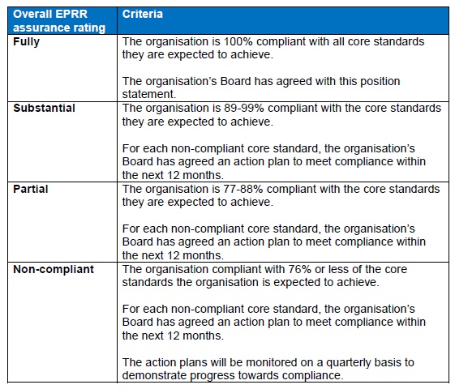

I confirm that the above level of compliance with the core standards has been agreed by the organisation’s board/governing body along with the enclosed action plan and governance deep dive responses.

Signed by the organisation’s Accountable Emergency Officer

|  |
| --- |
|  |
|  |

|  |  |  |
| --- | --- | --- |
| 11/12/2024 | 11/12/2024 | 04/08/2025 |
| Date of Board/governing body meeting | Date presented at Public Board | Date published in organisations Annual Report |