NHS Humber and North Yorkshire Integrated Care Board

Finance, Performance and Delivery Committee

Terms of Reference

Terms of Reference: | Finance, Performance & Delivery Committee
Authorship: | Executive Director of Finance and Investment
Board / Committee Responsible for Ratifying: | Integrated Care Board
Agreed Date: | March 2024
Approved Date: | May 2024
Review Date: | March 2025
Version Number: | 3.0
The online version is the only version that is maintained. Any printed copies should, therefore, be viewed as ‘uncontrolled’ and as such may not necessarily contain the latest updates and amendments.

- Governance

The Finance, Performance & Delivery Committee (FPD) is established by the Integrated Care Board (the Board or ICB) as a Committee of the Board in accordance with its Constitution and Standing Orders.

These Terms of Reference (ToR), which must be published on the ICB website, set out the membership, the remit, responsibilities, and reporting arrangements of the Committee and may only be changed with the approval of the ICB who it is accountable to.

The Committee of the Board and its members, including those who are not members of the Board, are bound by the Standing Orders and other policies of the ICB.
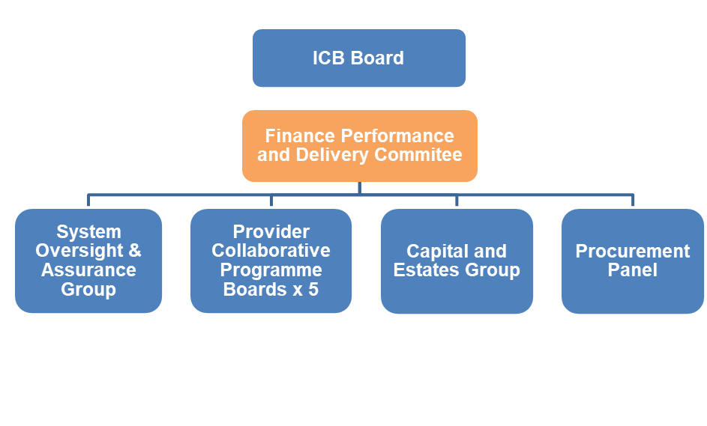
Authority

The Finance, Performance and Delivery Committee is authorised by the Board to:
- Investigate any activity within its terms of reference.
- Seek any information it requires within its remit, from any employee or member of the ICB who are directed to co-operate with any request made by the committee within its remit as outlined in these terms of reference.
- Commission any reports it deems necessary to help fulfil its obligations.
- Obtain legal or other independent professional advice and secure the attendance of advisors with relevant expertise if it considers this is necessary to fulfil its functions. In doing so the committee must follow any procedures put in place by the ICB for obtaining legal or professional advice.
- Create task and finish sub-groups in order to take forward specific programmes of work as considered necessary by the committee members. The committee shall determine the membership and terms of reference of any such task and finish sub- groups in accordance with the ICB’s Constitution & Standing Orders and Scheme of Reservation and Delegation (SoRD) but may/ not delegate any decisions to such groups.

The Committee has no executive powers, other than those delegated in the SoRD and Operational Scheme of Delegation (OSD) to individual members of the committee and specified in these terms of reference.

For the avoidance of doubt, the committee will comply with, the ICB Standing Orders, Standing Financial Instructions (SFIs), Operational Scheme Delegation (OSD) and the SoRD.

Groups of the Finance, Performance and Delivery Committee
- System Oversight and Assurance Group
- Provider Collaborative Programme Boards x 5
- Capital and Estates Group
- Procurement Panel

Procurement Panel

The Procurement Panel has a delegated responsibility from the Executive Director of Finance and Investment of the ICB to undertake the activities described in the purpose of its Terms of Reference. Procurement Decision Registers which record contract award decisions taken by the ICB will be reported to the Finance, Performance and Delivery Committee on a quarterly basis.

- Purpose

The purpose of the Finance, Performance and Delivery Committee is to contribute to the overall delivery of the ICB objectives by providing oversight and assurance to the ICB Board in the development and delivery of a robust, viable and sustainable system plans.

The Committee is responsible for overseeing, monitoring, and reviewing the stewardship of the finances, investments and sustainability of the ICB, including planning, financial performance, capital expenditure and the delivery of the informatics and estates, facilities and capital development annual plans.

The duties of the Committee will be driven by the organisation’s objectives and the associated risks. An annual programme of business will be agreed before the start of the financial year; however, this will be flexible to new and emerging priorities and risks.

- Responsibilities of the Finance, Performance & Delivery Executive Committee

The Finance, Performance & Delivery Committee duties can be categorised as follows:

Financial Strategy
- To develop a medium and long-term financial plan which demonstrated ongoing value and recovery to develop an understanding of where costs sit across a system, system cost drivers and the impacts of service change on costs.
- To develop an effective resource allocation approach
- To develop an approach to transformation and efficiency for the Integrated Care Board (ICB) and Integrated Care System (ICS)
- To advise the ICB on any changes to NHS and non-NHS funding regimes and consider how the funding available to the ICB can be best used within the system to achieve the best outcomes for the local population.

Resource allocations (revenue and capital)

- To develop an approach to distribute the resource allocation fairly and equitably, enabling the delivery of the ICB strategy. To ensure health and social inequalities are taken into account in financial decision-making.
- To advise on and oversee the process regarding the deployment of system-wide transformation funding.
- To work with ICS partners to identify and allocate resources where appropriate to address finance and performance related issues that may arise.
- To work with ICS partners to consider major investment/disinvestment outlined in business cases for material service change or efficiency schemes and to agree a process for sign off.

Financial monitoring information

- To ensure that ICB expenditure is kept within the resources allocated to it identifying where the NHS system (ICB and partner trusts) might exceed the resource limits set by NHSE to achieve system financial balance every year.
- To develop a reporting framework for the Integrated Care System (ICS) and agree common approaches across the system such as financial reporting, estimates and judgements.
- To monitor and report to the ICB Board overall financial performance against national and local metrics, highlighting areas of concern.
- To agree financial recovery plans (of the ICB and partner trusts) where necessary
- Work with ICS partners to seek assurance over the financial reports from system bodies and provide feedback to them.

System financial management framework

- To set the strategic financial framework of the ICB and monitor performance against it.
- To develop the ICB financial information systems and processes to be used to make recommendations to the Board on financial planning in line with the strategy and national guidance.
- To approve ICB financial and procurement policies.

System efficiencies and transformation

- To understand the financial and performance impact of transformation changes on individual organisations and the wider system
- To ensure system efficiencies are identified and monitored across the ICB, in particular opportunities at system level where the scale of the ICS partners together and the ability to work across organisations’ can be leveraged.
- To ensure financial resources are used in an efficient way to deliver the objectives of the ICB.
- To review exception reports on any material breaches of the delivery of agreed efficiency improvement plan including the adequacy of proposed remedial action plans.

Other financial duties

- To ensure that suitable policies and procedures are in place to comply with relevant regulatory, legal and code of conduct requirements.
- To develop the Procurement strategy (both in relation to the ICB and any agreed system-wide arrangements) operational service performance, enabling expenditure on individual service areas to be reviewed in line with performance and finance staff development.
- To approve arrangements for complying with the NHS Provider Selection Regime
- To receive and note the ICB procurement decision log on at least a quarterly basis.

Performance

- To assure the ICB Board as to the governance arrangements to support collective accountability between partner organisations for whole-system delivery and performance, underpinned by the statutory and contractual accountabilities of individual organisations.
- To review performance against the delivery of the ICB plan and key performance metrics as set out in the NHS System Oversight Framework for the ICB and ICS.
- To take an overview of performance and transformation at whole system, place, and organisation levels in relation to ICS objectives and priorities.
- To oversee a framework for mutual accountability and peer review and support for the partnership.

Risk Management

- To be responsible for the oversight, monitoring, and implementation of remedial actions in relation to any risks which are aligned to the Committee on the Board Assurance Framework (BAF) and on the risk registers.

- Chair, Membership and Attendance

Chair and Vice Chair

The Finance, Performance & Delivery Committee will be chaired by an Independent Non-Executive Member of the Board appointed on account of their specific knowledge skills and experience making them suitable to chair the executive committee.

The Vice Chair will be the Executive Director of Finance and Investment. In the event of the Chair of the Finance, Performance & Delivery Executive Committee being unable to attend all or part of the meeting, the Vice Chair will be appointed to Chair the meeting.

The Chair will be responsible for agreeing the agenda and ensuring matters discussed meet the objectives as set out in these ToR.

Membership

The Finance, Performance & Delivery Committee members shall be appointed by the Board in accordance with the ICB Constitution.

Core Membership
- Independent Member (Chair)
- Executive Director of Finance and Investment (Vice Chair)
- Chief Operating Officer / Deputy Chief Executive
- Executive Director of Clinical and Professional
- Executive Director of Corporate Affairs
- Place Finance Directors
- Director of Planning and Performance Deputy Director of Finance
- Director of Primary Care and Commissioning (COO Office)
- Director of Commissioning Strategy (COO Office)
- Place Directors

Attendees
- Executive Officers may request or be requested to attend the meeting when matters concerning their responsibilities are to be discussed or they are presenting a paper.
- Other individuals may be requested to attend the meeting when matters concerning their responsibilities are to be discussed or they are presenting a paper.
- Nominated deputies may be present if agreed in advance and will count towards the quorum with the agreement of the Chair.

- Meeting Frequency, Quoracy and Decisions Frequency

The Finance, Performance & Delivery Committee will meet no less than 11 times per year and arrangements and notice for calling meetings are set out in the Standing Orders. Additional meetings may take place as required.

The Board, Chair or Chief Executive may ask the committee to convene further meetings to discuss particular issues on which they want the committee’s advice.

In accordance with the Standing Orders, the Committee may meet virtually when necessary and members attending using electronic means will be counted towards the quorum.

Quorum

The Finance, Performance & Delivery Executive Committee will be quorate when at least the following members of the executive committee are present:

- Chair or Vice Chair
- 1 Executive Member
- 1 of each of the following Representatives:
  - Place Director or Place Finance Director for Hull or East Riding
  - Place Director or Place Finance Director for York or North Yorkshire
  - Place Director or Place Finance Director for North Lincolnshire or North East Lincolnshire

If any member of the committee has been disqualified from participating in an item on the agenda, by reason of a declaration of conflicts of interest, then that individual shall no longer count towards the quorum.

If the quorum has not been reached, then the meeting may proceed if those attending agree, but no decisions may be taken.

Decision Making and Voting

The Finance, Performance & Delivery Committee will ordinarily reach conclusions by consensus. When this is not possible the Chair may call a vote.

Only members of the Committee may vote. Each member is allowed one vote and a majority will be conclusive on any matter.

Where there is a split vote, with no clear majority, the Chair of the Finance, Performance & Delivery Committee will hold the casting vote.

If a decision is needed which cannot wait for the next scheduled meeting, the Chair may conduct business on a ‘virtual’ basis by telephone, email, or other electronic communication.

- Virtual Meetings / Recording of Meetings

Before starting a recording, the Chair is legally required to inform attendees if the meeting is being recorded and / that the purpose of the recording is as an administrative tool to support the provision of clear and accurate minutes. The recording is only retained for the period of drafting the minutes and then subsequently deleted from all systems. No person admitted to a meeting of the Committee will be permitted to record the proceedings in any manner without written approval from the Chair.

- Behaviours and Conduct ICB values.

Members will be expected to conduct business in line with the ICB values and objectives.

Members of, and those attending, the Committee shall behave in accordance with the ICB’s Constitution, Standing Orders, and Code of Conduct and Behaviours.

Equality and diversity
Members must demonstrably consider the equality and diversity implications of decisions they make.

- Accountability and Reporting

The committee is accountable to the Board and shall report to the Board on how it discharges its responsibilities.
The minutes of the meetings shall be formally recorded by the secretariat and the Chair will provide the agreed key messages of each of its meetings, for information, to the ICB Board at each meeting and shall draw to the attention of the Board any issues that require disclosure to the Board or require action.

Groups of the FPD

To provide a consistent approach in receiving assurance back to the Committee, all groups accountable to the Committee will complete a standardised form that will include key messages and shall draw the attention of any issues that require disclosure or require action. These forms will be managed by the secretariat and submitted to the Committee.

- Declarations of Interests, Conflicts and Potential Conflicts

Conflicts of interest will be managed in accordance with the ICBs policies and procedures. All committee members and attendees must adhere to the ICB’s Constitution and Conflicts of Interest policies.

Where the Chair or a member, or attendee, of the committee believes that they have any actual or perceived conflicts of interest in relation to one or more agenda items, they must declare this at the beginning of the meeting wherever possible, and always in advance of the agenda item being discussed. It will be responsibility of the Chair to decide how to manage the conflict and the appropriate course of action.

Any interests which are declared at a meeting must be included within the minutes of the meeting, the individual with the conflict must ensure that the interest is added (if not already the case) to their declaration as soon as is practicable following the meeting.

- Secretariat and Administration

The Finance, Performance & Delivery Committee shall be supported with a secretariat function which will include ensuring that:
- The agenda and papers are prepared and distributed in accordance with the Standing Orders having been agreed by the Chair with the support of the relevant executive lead.
- Attendance of those invited to each meeting is monitored by the Secretariat. Those that do not meet a minimum of 75% attendance in a 12 month period are highlighted to the Chair.
- Records of members’ appointments and renewal dates are maintained and the Board is prompted to renew membership and identify new members where necessary.
- Good quality minutes are taken in accordance with the standing orders and agreed with the chair and that a record of matters arising, action points and issues to be carried forward are kept.
- The Chair is supported to prepare and deliver reports to the Board.
- Action points are taken forward between meetings and progress against those actions is monitored.
- The secretariat is responsible for ensuring that the annual programme of business is regularly updated according to the Committees objectives and associated risks.

- Review

The Finance, Performance & Delivery Committee will review its effectiveness at least annually.

These terms of reference will be reviewed at least annually and more frequently if required. Any proposed amendments to the terms of reference will be submitted to the Board for approval.

END

