NHS Humber and North Yorkshire Integrated Care Board
Population Health and Prevention Committee

Terms of Reference

Terms of Reference: | Population Health and Prevention Committee
Authorship: | Deputy Chief Executive / Chief Operating Officer
Board / Committee Responsible for Ratifying: | Integrated Care Board
Approved Date: | February 2024
Ratified Date: | May 2024
Review Date: | February 2025
Version Number: | 3.0
The online version is the only version that is maintained. Any printed copies should, therefore, be viewed as ‘uncontrolled’ and as such may not necessarily contain the latest updates and amendments.

Governance

The Population Health and Prevention Committee is established by the Integrated Care Board (the Board or ICB) as an Committee of the Board in accordance with its Constitution and Standing Orders.

These Terms of Reference (ToR), which must be published on the ICB website, set out the membership, the remit, responsibilities and reporting arrangements of the Committee and may only be changed with the approval of the Board who it is accountable to.

The Population Health and Prevention Committee and its members, including those who are not members of the ICB Board, are bound by the Standing Orders and policies of the ICB.

Authority

The Population Health and Prevention Committee is authorised by the Board to:
- Investigate any activity within its terms of reference;
- Seek any information it requires within its remit, from any employee or member of the ICB who are directed to co-operate with any request made by the Committee within its remit as outlined in these terms of reference;
- Commission any reports it deems necessary to help fulfil its obligations;
- Obtain legal or other independent professional advice and secure the attendance of advisors with relevant expertise if it considers this is necessary to fulfil its functions. In doing so the Committee must follow any procedures put in place by the ICB for obtaining legal or professional advice;
- Create task and finish sub-groups in order to take forward specific programmes of work as considered necessary by the Committee members. The Committee shall determine the membership and terms of reference of any such task and finish sub-groups in accordance with the ICB’s Constitution, Standing Orders and Scheme of Reservation and Delegation (SoRD) but may/ not delegate any decisions to such groups.

The Population Health and Prevention Committee has no executive powers, other than those delegated in the Scheme of Reservation and Delegation (SoRD) and Operational Scheme of Delegation (OSD) to individual members of the committee and specified in these terms of reference.

For the avoidance of doubt, the Committee will comply with, the ICB Standing Orders, Standing Financial Instructions, OSD and the SoRD.

Groups of the Population Health and Prevention Committee

Current sub-groups of the Population Health and Prevention Committee are:
- Population Health and Prevention Programme Board
- HNY Vaccination and Immunisation Board
- Oral Health Steering Group

Purpose

The ICB Board has identified a key ambition to improve outcomes in population health and healthcare. The purpose of the Committee will be to oversee the partnership approach to delivering this ambition by:

- Providing population health and prevention leadership and oversight to support the vision of helping the population to ‘start well, live well, age well and end life well.’
- Influencing decision-making, at-scale, and support place-based delivery to improve population health, tackle health inequalities and prevention.
- Ensuring the approach to population health management is front and centre of the work of HNY Health and Care Partnership and is embedded within existing HNY programmes and workstreams and ensure the effective delivery of several key programmes to reduce and address health inequalities across the HNY Health and Care Partnership.
- Focusing on the four pillars of prevention, population health management, health inequalities, and vaccinations.

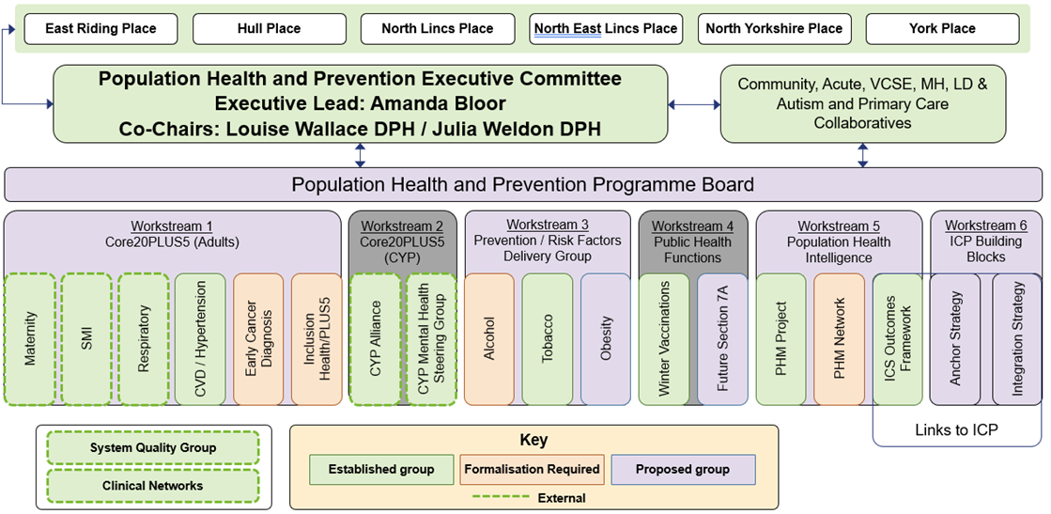

Responsibilities of the Committee

The Committee will:
- Oversee the HCP approach to Core20Plus5:
  - Maternity
  - Severe mental illness
  - Chronic respiratory disease
  - Early cancer diagnosis
  - Hypertension

- Develop a strategy that enables all people in Humber and North Yorkshire to live longer and healthier lives.
- Respond to local and national priorities aligned to improving outcomes in population health and healthcare, prevention, and tacking health inequalities.
- Address health disparities in coastal and port communities, through development of a strategy, where we have some of our most significant health inequalities within Humber and North Yorkshire and developing a plan for delivery of the strategy during 2024/25.
- Strengthen our engagement and participation so that the voices of people with lived experience influence all our population health strategies and plans.
- Deliver the three Regional Prevention Programmes – Tobacco, Alcohol and Obesity/Digital Weight Management Programme (DWMP).
- The duties of the Committee will be driven by the organisation’s strategic objectives and the associated risks. An annual programme of business will be agreed before the start of the financial year; however, this will be flexible to new and emerging priorities and risks.
- To be responsible for the oversight, monitoring and implementation of remedial actions in relation to any risks which are aligned to the Committee on the Board Assurance Framework (BAF) and on the risk registers.

Chair, Membership and Attendance

Chair and Vice Chair
The Population Health and Prevention Committee will be co-chaired by the Director of Public Health from North Yorkshire County Council and the Director of Public Health from Hull City Council.

The Chair will be responsible for agreeing the agenda and ensuring matters discussed meet the objectives as set out in these ToR.

Membership
The Committee members shall be appointed by the Board in accordance with the ICB Constitution.

The membership of the Committee will include ICB Directors, Public Health, Provider Collaboratives and Place leads.

Core Membership

Job Title | Organisation
HNY ICB Chief Executive | HNY ICB, Executive Member ICB Board
HNY ICB Chief Operating Officer / Deputy Chief Executive | HNY ICB, Executive Member ICB Board
HNY ICB Executive Director of Clinical and Professional | HNY ICB, Executive Member ICB Board
HNY Cancer Alliance Representative | HNY ICB
HNY Mental Health Director | HNY ICB
HNY Executive Director of Communications, Marketing and PR | HNY ICB
Mental Health Representative | Tees, Esk and Wear Valley NHS Foundation Trust
Acute Collaborative SRO and/or Director | HNY Health and Care Partnership
Mental Health Collaborative SRO and/or Director | HNY Health and Care Partnership
Community Health Collaborative SRO and/or Director | HNY Health and Care Partnership
VCSE Collaborative SRO and or Director | HNY Health and Care Partnership
Primary Care Collaborative SRO and or Director | HNY Health and Care Partnership
ICB Place Directors (6 x Place) | HNY ICB
Directors of Public Health (or their nominated deputy) per Place  - Co-Chairs (2 Representatives) | Local Authorities
Representatives from UKSHA and OHID | UKSHA and OHID
HNY Place Clinical Director  (East Riding of Yorkshire & Hull) | HNY ICB
HNY Consultant in Public Health | HNY ICB
HNY Finance Representative | HNY ICB
Regional Health Inequalities Lead | NHS England
Associate Director of Population Health and Prevention Analytics | HNY ICB
Local Dental Network Chair | HNY ICB
Executive Director of Corporate Affairs | HNY ICB
Executive Director of People | HNY ICB
Executive Director of Nursing and Quality | HNY ICB

Attendees
- Executive Officers may request or be requested to attend the meeting when matters concerning their responsibilities are to be discussed or they are presenting a paper.
- Other individuals may be requested to attend the meeting when matters concerning their responsibilities are to be discussed or they are presenting a paper.
- Nominated deputies may be present if agreed in advance with the Chair.

Meeting Quoracy and Decisions

The Committee will meet no less than 6 times per year and arrangements and notice for calling meetings are set out in the Standing Orders. Additional meetings may take place as required.

The Board, Chair or Chief Executive may ask the Committee to convene further meetings to discuss particular issues on which they want the Committee advice.

In accordance with the Standing Orders, the Committee may meet virtually when necessary and members attending using electronic means will be counted towards the quorum.

Quorum
The Committee will be quorate when a third of members are present, but must include the following members of the Committee present:

- One of the Co-Chairs
- At least one Executive Member of the ICB Board

If any member of the Committee has been disqualified from participating in an item on the agenda, by reason of a declaration of conflicts of interest, then that individual shall no longer count towards the quorum.

If the quorum has not been reached, then the meeting may proceed if those attending agree, but no decisions may be taken.

Decision Making and Voting
Decisions will be taken in accordance with the Standing Orders. The Committee ordinarily reach conclusions by consensus. When this is not possible the Chair may call a vote.

Only members of the Committee may vote.

Where there is a split vote, with no clear majority, the Chair of the Committee will hold the casting vote.

If a decision is needed which cannot wait for the next scheduled meeting, the Chair may conduct business on a ‘virtual’ basis through the use of telephone, email or other electronic communication.

- Declarations of Interests, Conflicts and Potential Conflicts

Conflicts of interest will be managed in accordance with the ICB’s policies and procedures. All committee members and attendees must adhere to the ICB’s Constitution and Conflicts of Interest policies.

Where the Chair or a member, or attendee, of the committee believes that they have any actual or perceived conflicts of interest in relation to one or more agenda items, they must declare this at the beginning of the meeting wherever possible, and always in advance of the agenda item being discussed. It will be responsibility of the Chair to decide how to manage the conflict and the appropriate course of action.

Any interests which are declared at a meeting must be included within the minutes of the meeting, the individual with the conflict must ensure that the interest is added (if not already the case) to their declaration as soon as is practicable following the meeting.

Behaviours and Conduct

ICB values
Members will be expected to conduct business in line with the ICB values and objectives.

Members of, and those attending, the Committee shall behave in accordance with the ICB’s Constitution, Standing Orders, and Code of Conduct and Behaviours.

Equality and diversity
Members must demonstrably consider the equality and diversity implications of decisions they make.

Virtual meetings/recordings

Before starting a recording, the Chair is legally required to inform attendees if the meeting is being recorded and / that the purpose of the recording is as an administrative tool to support the provision of clear and accurate minutes. The recording is only retained for the period of drafting the minutes and then subsequently deleted from all systems. No person admitted to a meeting of the Committee will be permitted to record the proceedings in any manner without written approval from the Chair.

Accountability and Reporting

The Committee is accountable to the Board and shall report to the Board on how it discharges its responsibilities.

The minutes of the meetings shall be formally recorded by the secretariat and the Chair will provide the agreed key messages of each of its meetings, for information, to the ICB Board.

The Chair will provide assurance reports to the Board at each meeting and shall draw to the attention of the Board any issues that require disclosure to the Board or require action.

Secretariat and Administration

The Population Health and Prevention Committee shall be supported with a secretariat function which will include ensuring that:
- The agenda and papers are prepared and distributed in accordance with the Standing Orders having been agreed by the Chair with the support of the relevant executive lead;
- Attendance of those invited to each meeting is monitored by the secretariat. Those that do not meet a minimum of 75% attendance in a 12 month period are highlighted to the Chair;
- Records of members’ appointments and renewal dates are maintained and the Committee is prompted to renew membership and identify new members where necessary;
- Good quality minutes are taken in accordance with the standing orders and agreed with the chair and that a record of matters arising, action points and issues to be carried forward are kept;
- The Chair is supported to prepare and deliver reports to the Board;
- The Committee is updated on pertinent issues / areas of interest / policy developments.
- Action points are taken forward between meetings and progress against those actions is monitored.

Review

The Committee will review its effectiveness at least annually.

These terms of reference will be reviewed at least annually and more frequently if required. Any proposed amendments to the terms of reference will be submitted to the Board for approval.

END

