Humber and North Yorkshire ICB

Complaints, Concerns, Comments and Compliments

Annual Report

1st April 2023 - 31st March 2024

Content

|  |  |  |
| --- | --- | --- |
| **1.0** | Introduction | Page 3 |
| **2.0** | Background | Page 4 |
| **3.0** | Executive Summary | Page 5 |
| **4.0** | Formal Complaints | Page 6 |
| **5.0** | MP Contact | Page 12 |
| **6.0** | Concerns, including Patient Advice and Liaison Service (PALS) | Page 13 |
| **7.0** | Enquiries | Page 15 |
| **8.0** | Comments | Page 17 |
| **9.0** | Compliments | Page 18 |
| **10.0** | Lessons Learnt and Actions taken | Page 20 |
| **11.0** | Reflections and Achievements | Page 21 |
| **12.0** | Future Ambitions | Page 22 |

1. Introduction

The ICB is committed to high quality care for all as a core principle of its vision and purpose. This includes the provision for any user of the organisation, their family, carers, or members of the public, to seek advice, raise concerns, make a complaint or log a compliment, about any of the services it commissions, provides or policies and procedures it has developed and implemented.

The delivery of the advice, concerns, complaints and compliments service is provided by the NHS Humber and North Yorkshire Integrated Care Board (HNYICB) ‘Experience Team’ and is referred to in this way throughout this report.

The Experience Team were one of this first within HNYICB to adopt a centralised, hub-based model bringing staff together from the previous six Place based Clinical Commissioning Groups (CCG’s). The Experience Team consist of Experience Support Officers who provide a proactive, professional, friendly ‘front door’ service for the organisation; listening, responding and signposting individuals according to their request. In cases of escalation, our Experience Officers support individuals with their formal complaints, guiding them through the statutory process.

This report, as the second of its kind, reflects this approach from both an aggregated and Place based perspective, inclusive of the following partnership areas:

|  |  |  |
| --- | --- | --- |
| * East Riding of Yorkshire (ERY) | * North Lincolnshire (NL) | * North Yorkshire |
| * Hull | * North East Lincolnshire (NEL) | * York |

.

2. 0 Background

All commissioners and providers of NHS and Adult Social Care services adhere to ‘*The Local Authority Social Services and National Health Service Complaints (England) Regulations 2009.’* Under these regulations, complainants can raise a complaint or concern to either the provider or the commissioner – The ICB - of the service. This report therefore relates to contact received and managed as the ‘commissioner.’ The same Regulations state that organisations have a statutory duty to record and report:

* The number of complaints received
* The number that were well founded
* The number referred to the Ombudsman (Parliamentary and Health Service Ombudsman (PHSO) and the Local Government and Social Care Ombudsman (LGSCO))
* The subject matter of complaints
* Matters of importance arising from the complaints or handling thereof
* Action taken, or being taken, to improve services as a result of complaints received

This report provides information in line with our statutory requirements but also aims to highlight the voice of our people that is gained through the Experience Team intelligence.

It should be noted that the data in this report is based on the contact received as the commissioner. Providers also have their own teams and processes for the public to access and therefore the numbers being presented will be small and should be considered proportionately.

1. Executive Summary

The key point to note from this report is the increase in contacts that have been supported by the Experience from the 1st April 2023 – 31st March 2024, in comparison to the previous year. Overall, there has been a 93% increase across the different contact types. The two contact types that have seen a decrease in numbers are compliments and MP contacts.

One fundamental change that has impacted on the increase has been the delegation of responsibility, from NHSE to ICB’s, of primary care services. From 1st July 2023, the responsibility to manage primary care complaints and contacts specifically was delegated to ICB’s and the Experience Team have therefore had this addition to their remit. 21% (822) of new contacts were in relation to Primary Care Services.

The below table shows the total number of new contacts the Experience Team have assisted with from 1st April 2023 – 31st March 2024

|  |  |  |  |  |  |  |  |  |
| --- | --- | --- | --- | --- | --- | --- | --- | --- |
| **Contact Type** | **North Yorkshire** | **York** | **Hull** | **East Riding of Yorkshire** | **North Lincolnshire** | **North East Lincolnshire** | **Total 23/34** | **Total 22/23** |
| Formal Complaint | 51 | 44 | 33 | 57 | 31 | 40* | **256** | **121** |  |
| Concern | 383 | 251 | 290 | 358 | 116 | 319* | **1717** | **1106** |  |
| Comment | 1 | 0 | 2 | 0 | 11 | 0 | **14** | **54** |  |
| Compliment | 7 | 5 | 4 | 5 | 1 | 24* | **46** | **82** |  |
| Enquiry | 464 | 264 | 350 | 198 | 137 | 158* | **1571** | **415** |  |
| MP | 31 | 9 | 29 | 29 | 35 | 2* | **135** | **162** |  |
| **Total** | **937** | **573** | **708** | **647** | **331** | **543** | **3739** | **1940** |  |

*Inclusive of both health care and Adult Social Care

Primary Care contacts is the most notable of differences in this year’s report, with concerns about General Practice being the highest across the HNYICB footprint. Themes remain like the previous year around access to treatment/ services and clinical/ quality of care. CHC remains one of the highest areas of complaint within the ICB.

1. Formal Complaints

4.1 Formal Complaints 4.2 Formal Complaints – Organisation

As can be seen from this graph, the majority of complaints managed directly by the Experience team relate to the services provided by the ICB or policies and procedures it has developed and implemented (22%).

From the 1st July 2023 the ICB are accountable for primary medical services, GP, Dental, Pharmacy and Optometry Services. As can be seen from the above graph primary care services combined account for 30% of the total complaints managed directly by the team.

The above complaints represent those that have been managed by the ICB experience team, either in capacity as the commissioner or because the complaint relates directly to an ICB function, policy or decision.

East Riding Place have received the highest proportion of complaints at 22%.

North East Lincolnshire have received 16% of the total complaints with 11 health related complaints, 18 relating to Focus Adult Social work and 11 in relation to the direct provision of adult social care services. The team support adult social care complaints as a result of the Section 75 agreement that is in place.

4.3 Formal Complaints – Top 3 Subject Areas

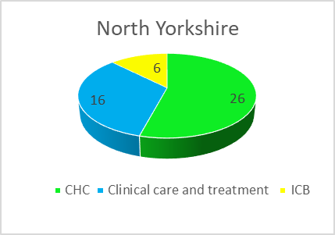 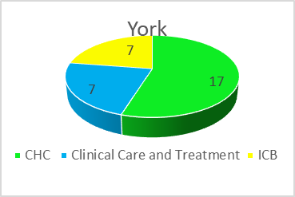 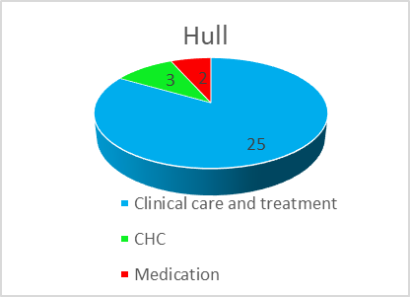

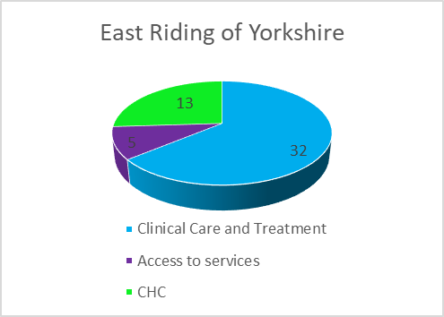 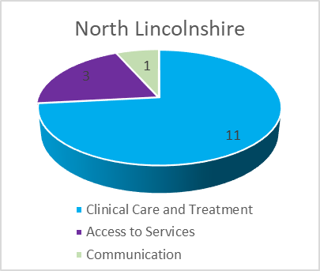 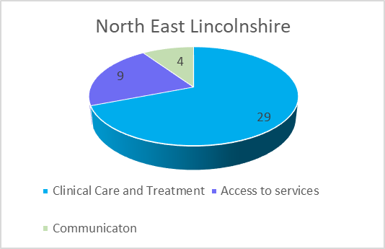

The top three subject areas have been identified for each Place. For 2023/24, the common themes across the ICS relate to:

* Clinical Care and Treatment (47%)
* CHC (23%)
* Access to Services (11%)

4.4 Formal Complaints – Open

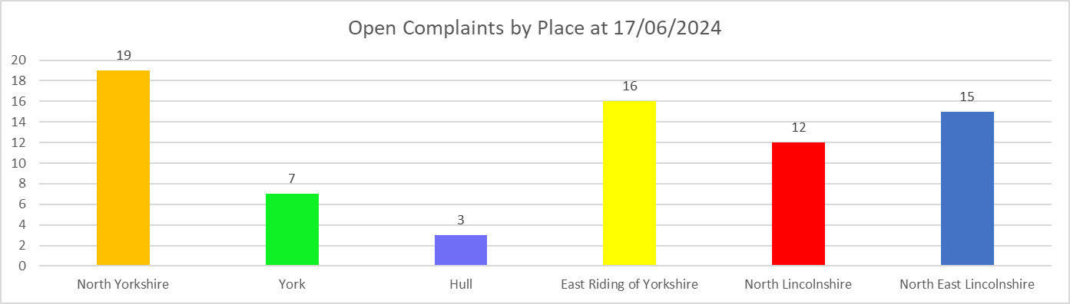

Open Complaints Timescales

|  |  |  |  |  |  |  |
| --- | --- | --- | --- | --- | --- | --- |
|  | North Yorkshire | York | Hull | East Riding of Yorkshire | North Lincolnshire | North East Lincolnshire |
| In Timescale | 8 (42%) | 2 (29%) | 1 (33%) | 7 (44%) | 2 (17%) | 11 (73%) |
| Out of Timescale | 11 (58%) | 5 (71%) | 2 (67%) | 9 (56%) | 10 (83%) | 4 (27%) |

As can be seen from the above graph four of the Places have a higher number of open complaints in comparison to Hull and York, with North Yorkshire having the highest at 26%.

Of the open complaints, a proportion of those being handled by the team are multi-agency and are therefore more complex in both nature and, coordination of response. For NEL, the complaints also include social care providers.

A number of those open are provider led complaints and timescale compliance is therefore dictated to, in part, by those of the Provider.

4.5 Formal Complaints – Closed

Closed Timescales

|  |  |  |  |  |  |  |
| --- | --- | --- | --- | --- | --- | --- |
| *Closed Timescales* | **North Yorkshire** | **York** | **Hull** | **East Riding of Yorkshire** | **North Lincolnshire** | **North East Lincolnshire** |
| *In Timescale* | 23 (77%) | 26 (70%) | 6 (60%) | 9 (67%) | 4 (31%) | 9 (45%) |
| *Out of Timescale* | 7 (23%) | 11 (30%) | 4 (40%) | 21 (33%) | 9 (69%) | 11 (55%) |

Outcome of Complaint

|  |  |  |  |  |  |  |
| --- | --- | --- | --- | --- | --- | --- |
|  | **North Yorkshire** | **York** | **Hull** | **East Riding of Yorkshire** | **North Lincolnshire** | **North East Lincolnshire** |
| *Upheld* | 5 (17%) | 3 (8%) | 1 (10%) | 13 (44%) | 2 (15) | 2 (10%) |
| *Partially Upheld* | 10 (33%) | 11 (30%) | 3 (30%) | 8 (26%) | 5 (39%) | 5 (25%) |
| *Not Upheld* | 1. (50% | 23 (62%) | 6 (60%) | 9 (30%) | 6 (46%) | 13 (65%) |

4.6 Re-opened Complaints

|  |  |  |  |  |  |  |
| --- | --- | --- | --- | --- | --- | --- |
| Re-Opened | **North Yorkshire** | **York** | **Hull** | **East Riding of Yorkshire** | **North Lincolnshire** | **North East Lincolnshire** |
| **Total** | **3** | **0** | **0** | **1** | **3** | **4** |

The team closed 41 more complaints this year in comparison to the 22/23 period, which is reflective of the general increase in complaints received. **56%** of those complaints were responded to and closed within timescale. This is a slight decrease of 4% compared to the previous year.

**51%** of the complaints closed were not upheld, suggesting that there were no elements of those complaints substantiated. **19%** of the complaints were fully upheld and thus well founded in the issues raised.

Re-opened complaints were low across the ICB with only 11 (8%) complainants raising further concerns upon receipt of their original response. Every effort to resolve complaints locally is encouraged and is in line with good practice.

4.7 Complaints referred to the Ombudsman’s

In line with the Complaints Regulations and as informed by the NHS Constitution, complainants have the right to take a complaint to the independent Parliamentary and Health Service Ombudsman (PHSO) or the Local Government and Social Care Ombudsman (LGSCO) if they are not satisfied with the outcome of their complaint or the way in which their complaint has been dealt with, locally. Each complainant is clearly informed of this right in their response letter.

The Ombudsmen’s investigate complaints made to them and decide whether the actions taken (by the provider or commissioner) have caused an injustice to the person affected and if the complaints process has taken any steps to remedy the injustice, if well founded.

In 2023/2024, there have been 16 complaints referred to either the Parliamentary and Health Service Ombudsman or the Local Government and Social Care Ombudsman as follows:

|  |  |  |  |  |  |  |
| --- | --- | --- | --- | --- | --- | --- |
|  | **North Yorkshire** | **York** | **Hull** | **East Riding of Yorkshire** | **North Lincolnshire** | **North East Lincolnshire** |
| PHSO | 4 | 1 | 0 | 1 | 3 | 0 |
| LGSCO | 0 | 0 | 0 | 0 | 0 | 1 |
| Closed with no further action | 4 | 1 | 0 | 0 | 1 | 0 |

One North East Lincolnshire case was via the Local Government and Social Care Ombudsman relating to social care needs rather than health needs. This case was not a complaint received or investigated by the HNY ICB Experience Team, however, as the ICB has a shared responsibility with the Local Authority for the commissioning of health services, the LGSCO contacted the ICB Experience Team as part of their investigations. However, due to the shared responsibility, the LGSCO upheld elements of the complaint against Focus and North Lincolnshire Council and financial remedy was recommended together with changes to the Local Authority and Provider websites to provider better signposting for the general population.

There has been an outcome letter in respect of a Continuing Health Care in ERY with the following high level learning:

* A process and policy should be developed in relation to Personal Health Budgets (PHB)
* System based tool developed to manage PHB’s
* Communication and Customer Care Training Plan developed and implemented

Of the other cases referred to the PHSO/LGO; these were closed without further investigation.

1. MP Contact

Dental related enquiries from MP’s accounted for **17%** of contact with Hull receiving most contacts in this regard.

**20%** relate to Access to treatment with representation from 5 of the 6 Place areas.

**31%** of MP contacts relate to Commissioning with representation from 5 of the 6 Places

|  |  |
| --- | --- |
| **North Yorkshire**    **9 ENQUIRIES**  **16 CONCERNS**  **6 Complaints** | Robert Goodwill MP User with solid fill  Rishi Sunak MP User with solid fillUser with solid fillUser with solid fillUser with solid fillUser with solid fillUser with solid fillUser with solid fill  Andrew Jones MP User with solid fillUser with solid fillUser with solid fillUser with solid fillUser with solid fillUser with solid fillUser with solid fillUser with solid fillUser with solid fill  Julian Smith MP User with solid fill  Kevin Hollinrake MP User with solid fillUser with solid fillUser with solid fill  Kier Mather MP |
| **York**  **1 FORMAL COMPLAINT**  **3 CONCERNS**  **5 ENQUIRIES** | Rachael Maskell MP User with solid fillUser with solid fillUser with solid fillUser with solid fillUser with solid fillUser with solid fillUser with solid fillUser with solid fillUser with solid fill |
| **Hull**  **5 ENQUIRIES**  **16 Concerns**  **8 COMPLAINTS** | Diana Johnson MP User with solid fillUser with solid fillUser with solid fillUser with solid fillUser with solid fillUser with solid fillUser with solid fillUser with solid fillUser with solid fillUser with solid fillUser with solid fillUser with solid fillUser with solid fillUser with solid fillUser with solid fillUser with solid fillUser with solid fill  Emma Hardy MP User with solid fillUser with solid fillUser with solid fillUser with solid fillUser with solid fillUser with solid fillUser with solid fillUser with solid fillUser with solid fill  Karl Turner MP User with solid fill |
| **East Riding of Yorkshire**  **22 CONCERNS**  **2 Enquiries**  **5 COMPLAINTS** | Greg Knight MP User with solid fillUser with solid fill  Graham Stuart MP User with solid fillUser with solid fillUser with solid fillUser with solid fillUser with solid fillUser with solid fillUser with solid fillUser with solid fillUser with solid fillUser with solid fillUser with solid fillUser with solid fillUser with solid fillUser with solid fillUser with solid fillUser with solid fillUser with solid fillUser with solid fill  David Davis MP User with solid fillUser with solid fillUser with solid fill  Stephen Dorrell MP |
| **North Lincolnshire**  **2 FORMAL COMPLAINTS**  **19 CONCERNS**  **14 ENQUIRIES** | Holly Mumby-Croft MP User with solid fillUser with solid fillUser with solid fillUser with solid fillUser with solid fillUser with solid fillUser with solid fillUser with solid fillUser with solid fillUser with solid fillUser with solid fillUser with solid fillUser with solid fillUser with solid fillUser with solid fillUser with solid fillUser with solid fillUser with solid fill  Andrew Percy MP User with solid fillUser with solid fillUser with solid fillUser with solid fillUser with solid fillUser with solid fillUser with solid fill  Martin Vickers MP User with solid fill  Cllr R Waltham User with solid fill |
| **North East Lincolnshire**  **2 – Enquiries** | Martin Vickers MP User with solid fillUser with solid fill |

1. Concerns; including Patient Advice and Liaison Service (PALS)

6.1 Concerns by Place

North Yorkshire have received the highest number of concerns across all 6 Places at 22%, with North Lincolnshire Place having the lowest number of contacts at 7%.

As can be seen from the below graph GP Services have the highest number of concerns at 535 (31%). Of the GP services concerns Hull have the highest levels at 8% and NY 7%.ull

Dental concerns rated second highest at 11% with most of these being in relation to access to NHS dental provision.

6.2 Concerns by Provider

* 1. Concerns by Subject Area – Top 3 Categories

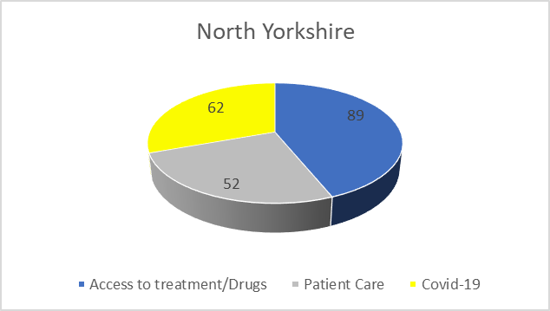 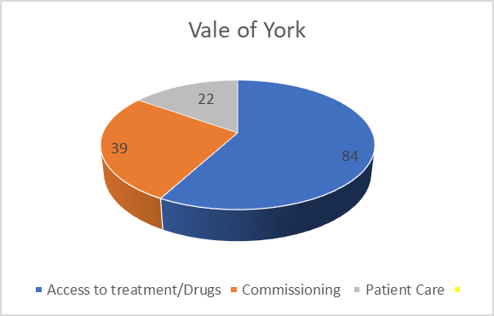 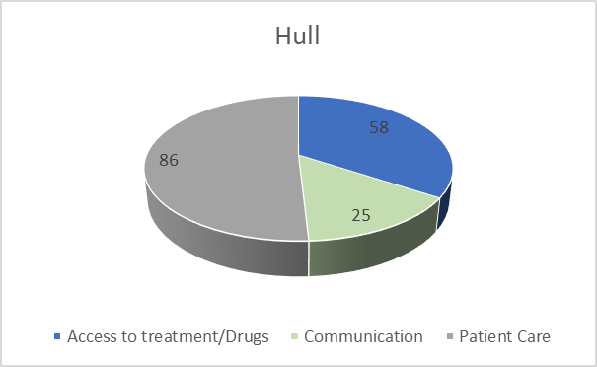

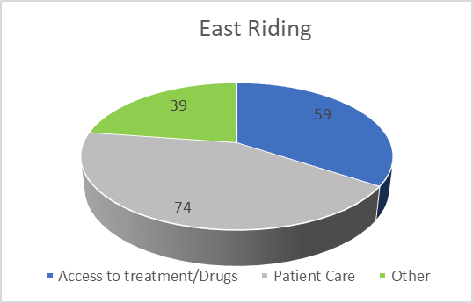 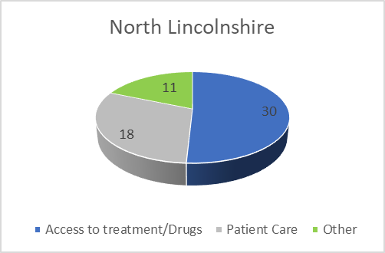 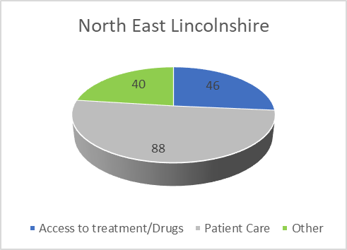

Concerns across all 6 Places relate to accessing treatment/drugs with an overall 21% representation of the contact made, also concerns across the 6 Health Places is patient care with an overall 20%.

1. Enquiries

7.1 Enquiries by Place

As can be seen from the numbers by Place, North Yorkshire have received and recorded the highest number of enquiries. 34% of these enquiries related to NY Place enquires and 30% related to GP enquiries.

Hull Place received the second highest number of enquiries. 37% of the Hull enquires related to GP enquiries, and 36% related to HUTH enquiries.

As can be seen from the numbers by provider, the overall top three providers are (i) GP enquires at 36%, (ii) NY Place at 10% and (iii) HUTH at 9%.

There were an additional number of 146 enquiries not included in the figures of the above graphs, which were received from outside of the Humber and North Yorkshire ICB area.

7.2 Enquiries by Provider

7.3 Enquiries by Subject – Top 3 Categories

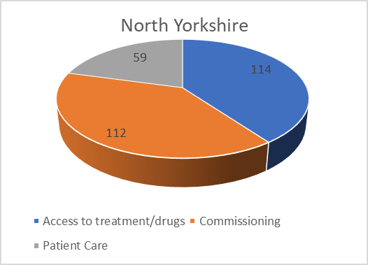 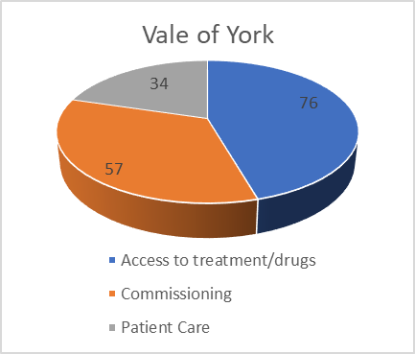 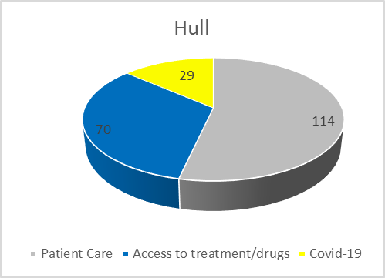

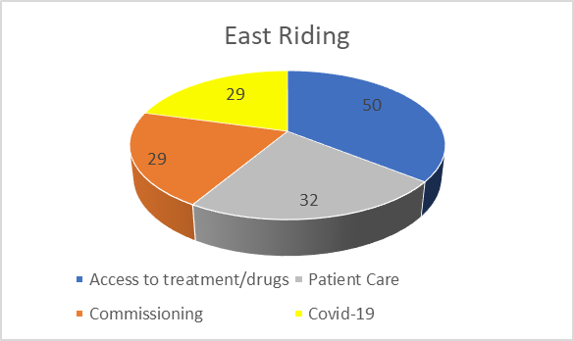 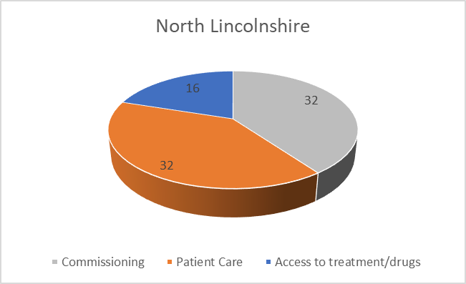 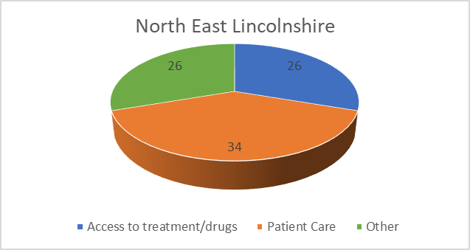

As can be seen the main top three enquiry themes predominately across the HNY ICB are Access to Treatment/drugs some 23%, Commissioning 16% and patient care (including quality of care) some 19%.

Covid-19 continues to be a theme at 11%.

1. Comments

8.1 Comments by Theme - Top 3 Categories

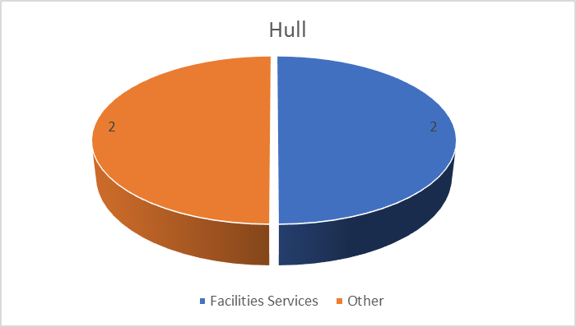 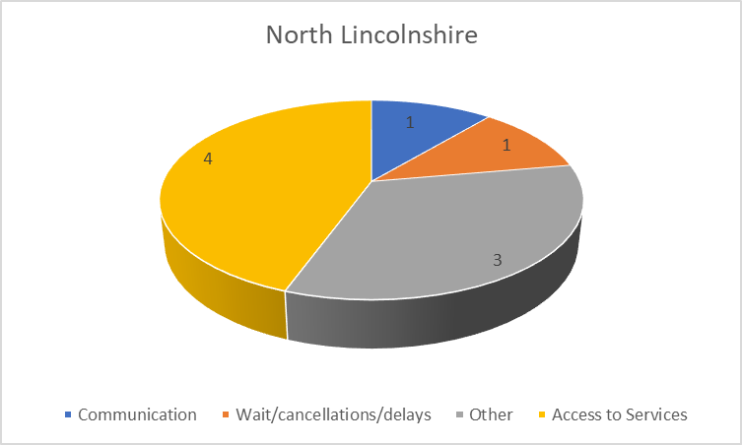

As can be seen from the above, there were no comments for East Riding of Yorkshire, Vale of York, or North East Lincolnshire Places.

North Lincolnshire had **64%** of the total comments, with **44%** being Access to Services

In relation to providers, **29%** of the comments were related to Primary Care (GP), with **14%** of the comments were in relation to North Yorkshire Place, HUTH, and Other respectively

1. Compliments

9.1 Compliments by Place

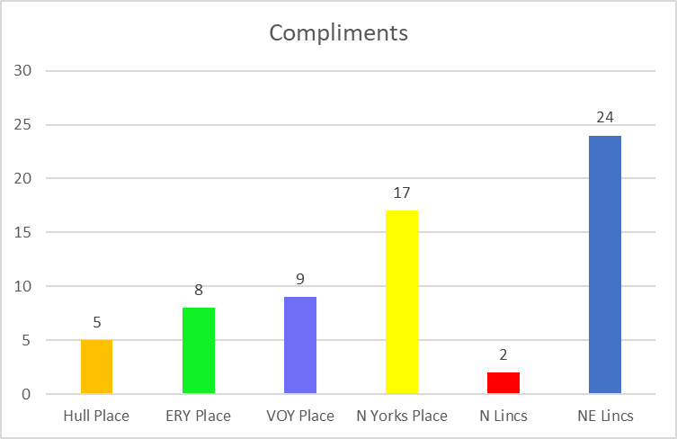

**45%** of the compliments recorded related to the HNY ICB Experience Team

**29%** were recorded across 6 Places in relation to positive values and behaviours of staff

**17%** of compliments related to the quality of care provided to the patient or service user.

"I would love to take this opportunity to thank all the staff who were on duty that day…….they were all very attentive, pleasant and very professional."

**Bridlington Hospital**

**“Please thank the medical staff on Ambulance XXXX for their remarkable professionalism. the staff were amazing people”**

**.Yorkshire Ambulance Service**

“Good afternoon, I have just spoken to a advisor over the phone and while the ICB cannot help me with the ongoing problem I have with local health services, your advisor listened carefully and took a lot of information to make sure she understood my situation. I feel I was really listened to and the situation was treated seriously and with professionalism. I would like to say I’m really impressed with your advisor, and she was a credit to the ICB. I cannot remember her name sadly though.”

**HNY ICB Experience Team**

thank you for helping me out with registering with a North Lincolnshire GP. I have been struggling to register with a GP for some time now, and you have sorted this for me with minimum fuss and very quickly too. I am so very grateful. Thanks

**HNY ICB Experience Team**

10.0 Lessons Learnt and Actions taken

**North East Lincolnshire**

Implementation of safety briefing to understand the impact of handing out family member’s prescriptions to other family members without being requested to by the patient

Colleagues to review the applicable standard operating procedures that involved the handing out of prescriptions to patients

Update patient records to note that patient does not wish to have medication collected by anyone other than the patient

Additional software has been obtained and provided to the worker which proofreads written activity. In addition to this, operational managers and supervisors have been reminded of the requirement to scrutinise any written activity. Since implementing the software, an improvement in the standard of documentation has been observed.

North East Lincolnshire Council website updated to include specific complaint information to aid in the direction and making of a complaint

**East Riding of Yorkshire**

New Personal Health Budget policy and system based tool have been developed and implemented to aid health and care worker involved in Continuing Health Care

Communication and Customer Care Training provided to Continuing Health Care staff

**North Lincolnshire**

Communication with service users within North Lincolnshire CHC team. Agreed to arrange customer service training for the CHC team.

1. Reflections and Achievements

During the 2023/2024 period, there have continued to be significant changes to the delivery of the Experience Function and on the team that deliver this. In 2022/23, as part of the formation of Integrated Care Boards, we established one of the first centralised teams, bringing together staff from 6 different Places, their expertise, knowledge, custom and practice. In 2023/24, the team have worked hard to align processes to ensure that the population of Humber and North Yorkshire are receiving a consistent, commissioner led, ‘experience’ offer.

Whilst enabling these changes, the team have continued to provide a professional, friendly, front facing service and have handled 93% more contacts than the previous year. This in itself is a real achievement. However, the specific achievements to note from the 2023/ 2024 year are:

* Positive recruitment of Experience Support Officers to provide the front facing service for the HNYICB
* Delegation of Primary Care contact management including concerns and complaints
* Consistent, positive leadership
* Function review with the team
* Standard Operating Procedure (SOP) developed to support the implementation of the Policy on a consistent basis
* Developed a suite of document templates for the team to utilise
* Implemented a new digital telephone system, with one front facing telephone number
* With internal system development colleagues, designed and implemented a bespoke experience system to enable consistent logging and recording of contacts
* Development of a monthly complaints and concerns dashboard
* The team have worked with Communications colleagues to update the HNYICB website to ensure information is clear on the services they offer
* The team supported an internal audit process for 2023/24 data and received an outcome of ‘Significant Assurance’ with 8 minor recommendations

1. Future Ambitions

|  |  |
| --- | --- |
| **2022/23 Ambitions** | **Progress** |
| 1. Agreeing a reporting structure that will provide useful intelligence to the Executive Team and Place leads | Complete |
| 1. Ensuring communication to the public is clear on the ICS website and on how best to access support for a concerns, complaints, and compliments | Complete |
| 1. Fully implement a single recording system/database at each Place to support a more uniformed approach to recording and reporting of contacts | Complete |
| 1. Develop effective systems and processes for responding to contacts, for the purpose of learning and improving. | To develop further (see below) |
| 1. York Place specifically have agreed to be a pilot for working with their local partners, via the Place Quality Group, to gain the experience intelligence held by them as the provider. | Developing with changes (see below) |
| 1. Over the next year, the Regulatory Team will conduct a focused piece of work, in partnership with the lead Place Director of Nursing with this portfolio, to understand the CHC complaints and the processes around Local Resolution Meetings. | To start (see below) |

|  |  |
| --- | --- |
| **2023/24 Ambitions** | **Progress/ Update** |
| 1. (Developing so Carried forward)   Develop effective systems and processes for responding to contacts, for the purpose of learning and improving. | Action Plan process as been included in the new SOP. To further develop and embed this with a focus on sharing the learning via groups such as Place and System Quality Groups |
| 1. (Carried forward with changes)   York Place specifically have agreed to be a pilot for working with their local partners, via the Place Quality Group, to gain the experience intelligence held by them as the provider. | An Experience of Care Forum is developing with local partners and the sharing of intelligence has been included in the Terms of Reference. |
| 1. (Carried forward)   Over the next year, the Regulatory Team will conduct a focused piece of work, in partnership with the lead Place Director of Nursing with this portfolio, to understand the CHC complaints and the processes around Local Resolution Meetings. | To start |
| 1. (New)   Review and update the HNYICB Managing Complaints Policy to ensure it is still reflective of all the changes described and includes updates from the Audit Recommendations |  |
| 1. (New)   Further develop complaints and concerns reporting, utilising the newly implemented system to make the intelligence more meaningful |  |
| 1. (New)   Develop mechanisms to triangulate this intelligence with other ‘Experience’ sources to provide a more rounded experience picture |  |