
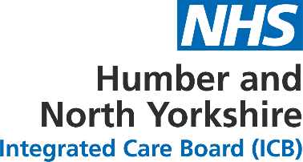

HNY ICB Committee Assurance and Escalation Report

Report to: HNY Integrated Care Board
Report from: Workforce Board
Date of meeting: Monday 17 February 2025

Committee Chair: Jason Stamp, Senior Responsible Officer for Workforce

Director Sponsor: Jayne Adamson, Executive Director of People

Author: Carly McIntyre, Senior Officer: Workforce Transformation

This report should be no more than 2 pages using bulleted lists.

Key agenda items covered by the meeting
(A bulleted list of the key agenda items discussed at the meeting)
- Workforce Board Assurance
  - Workforce Board Annual Report

- Humber and North Yorkshire Health and Care Partnership update
  - ICB Board

- Breakthrough 2024/25 programme update
  - Breakthrough update including 2025/26 planning
  - Survey results

- People Promise Exemplar Site update

- Centres for Dental Development update

- PAM Workstream Update

- Items for information only
  - HNY Workforce Transformation – NHS Futures
  - Leaders Briefing – January 2025

- Any other business
  - Hull Adult Social Care Workforce Strategy
ALERT
(BY EXCEPTION ONLY - key matters and / or risks to alert or escalate to the ICB Board)
ADVISE AND / OR ASSURE
(BY EXCEPTION ONLY - Key decisions and any updates to advise the ICB Board on the matters the Committee was able to take assurance on or where additional information was required)
END.

