Humber and North Yorkshire Health and Care Partnership
Communications and Marketing
2024 Advent Calendar – Winter messaging

Date | Theme | Message | Asset
1 December | Self-care | It’s the 1st of December, and the Christmas countdown begins!  Each day, we’ll share a sprinkle of self-care tips and winter wellness.  Your local pharmacy has a range of vitamins and multivitamins to support your body's natural defences against illness. Speak to your pharmacy team about your individual requirements.  Find your local Pharmacy - https://letsgetbetter.co.uk/get-the-right-care/pharmacy/  #HNYadvent2024 | 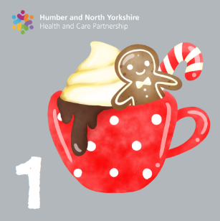
2 December | NHS 111 | If you need urgent medical help but you're not sure where to go, use 111 to get assessed and directed to the right place for you.​ Call, go online or use the NHS App.  ➡️ www.nhs.uk/111  #HNYadvent2024 | 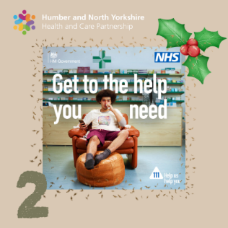

3 December | Vaccinations | Let's Get Vaccinated. Getting vaccinated helps keep you and your family safe from catching serious, and potentially fatal diseases.  Getting the flu and COVID-19 vaccines ahead of winter are two of the most important things you can do to keep yourself and others around you safe and ‘get winter strong’.  Find out more https://humberandnorthyorkshire.org.uk/vaccinated/seasonal-vaccines/  #HNYadvent2024 | 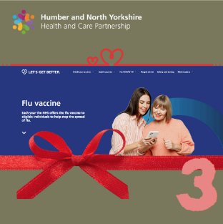
4 December | Place Christmas  Grimsby | Our Places at Christmas – Seasons Greetings from Grimsby, that glistens at night ✨  #HNYadvent2024 | 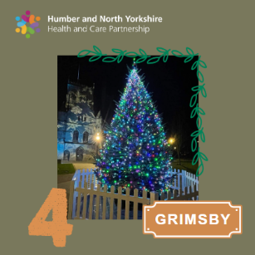
5 December | Healthier Together | We know what it’s like to be worried about your or someone else’s health. Healthier Together is a trusted source of advice and guidance available right when you need it.  From tummy bugs and rashes to bumped heads and mental wellbeing, there is loads of practical advice, with easy-to-follow information and resources.  https://www.hnyhealthiertogether.nhs.uk/  #HNYadvent2024 | 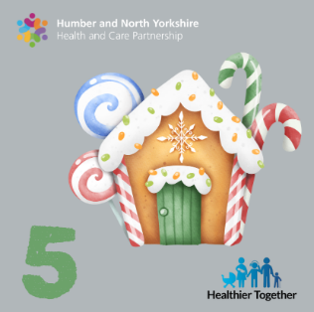
6 December | Children and Young People | There are a number of ways in which you can take your child's temperatures. Here local GP, Dr Natalie Dukes talks through her top tips for taking your child's temperature.  If you are worried about your Child's temperature, use the NHS 111 online service for help and information.  www.nhs.uk/111  #HNYadvent2024 | 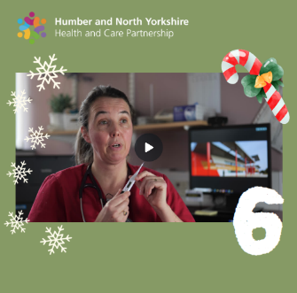
7 December | Self- care  Cost comparison | Sore throats are not usually anything to worry about. There are lots of remedies available from your local pharmacy and there's more self-care advice on the NHS website: https://www.nhs.uk/conditions/sore-throat/  #HNYadvent2024 | 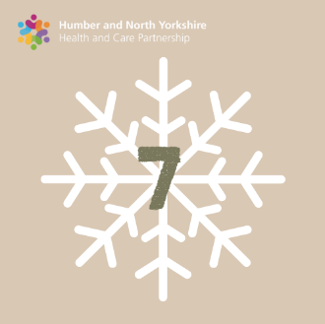
8 December | Place Christmas - York | Our Places at Christmas - the majestic City of York.  #HNYadvent2024 | 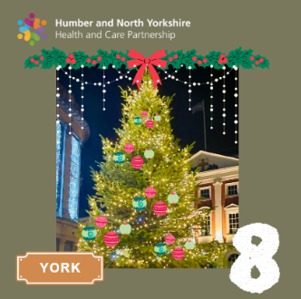

9 December | Winter strong / Vaccinations | It's time to get winter strong 💪  Getting your flu and COVID-19 vaccines means your symptoms will be milder & you’ll recover faster if you run into these viruses this winter. Vaccines are the most effective way to prevent infectious diseases and keep healthy.  Visit: www.letsgetbetter.co.uk/get-vaccinated/  #HNYadvent2024 | 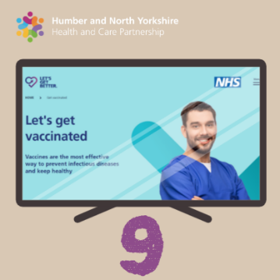
10 December | NHS APP | Planning on being away from home over the festive period? Did you know you can easily change your nominated pharmacy on the NHS App.  Find out more: www.nhs.uk/nhsapp  #HNYadvent2024 | 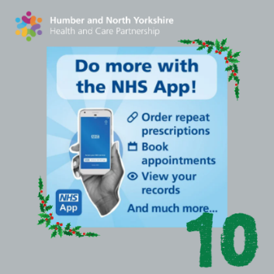
11 December | Orcha – digital health | Check out the NHS approved health apps this Winter. Brought to you by Orcha, the health apps library brings together every smartphone app you could possibly imagine helping you stay fit and healthy, or live your best life if you have a long-term medical condition.  View the Winter apps here https://hnyhealthapps.co.uk/en-GB/winter-pressures  #HNYadvent2024 | 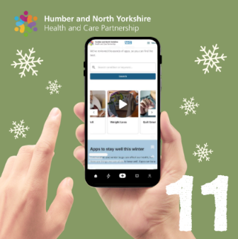

12 December | Place Christmas - Hull | Our Places at Christmas - Christmas lights in Hull have certainly got us into the Christmas spirit with a 50ft tree.  #HNYadvent2024 | 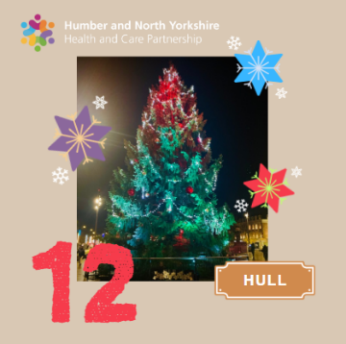
13 December | Self-care | Knowing what to keep in your medicine cabinet at home can really help when you or a family starts to feel unwell. Local GP, Dr Natalie Dukes gives us a rundown of her top items to have at home.  You can find more information on keeping a well-stocked medicine cabinet here – http://www.letsgetbetter.co.uk/get-the-right-care/self-care/  #HNYadvent2024 | 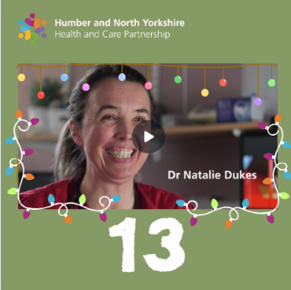
14 December | Self-care  Cost comparison | You can obtain paracetamol-based syrups for children from your local pharmacy without prescription.  To learn more, visit the NHS website: https://www.nhs.uk/medicines/paracetamol-for-children/  #HNYadvent2024 | 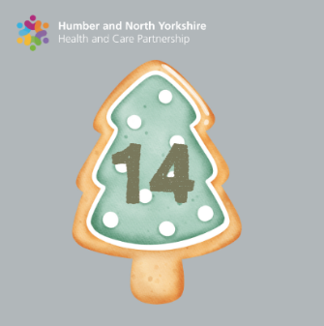
15 December | NHS 111 | If you need urgent medical help but you're not sure where to go, use 111 to get assessed and directed to the right place for you.​ Call, go online or use the NHS App.  ➡️ www.nhs.uk/111  #HNYadvent2024 | 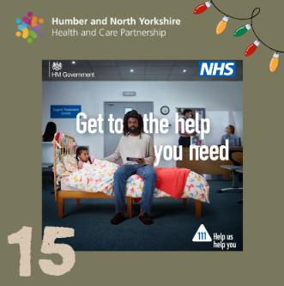
16 December | Falls prevention | Falls prevention - Preventing falls this winter indoors or outdoors.  Icy paths can be treacherous. Avoid slips and falls by wearing appropriate footwear with good traction and taking slow, deliberate steps. Install handrails and proper lighting outdoors for safer navigation.  Indoors, keep floors clutter-free, and use non-slip mats.  #HNYadvent2024 | 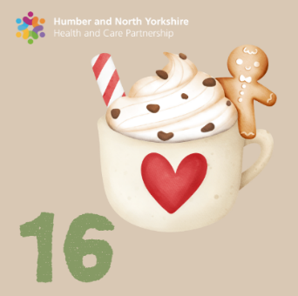
17 December | Place Christmas  Brigg | Our Places at Christmas – the beautiful market town of Brigg  in North Lincolnshire.  #HNYadvent2024 | 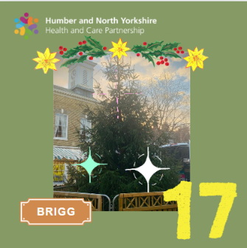
18 December | Healthier Together | Using the internet to search for your child's symptoms can often be scary – that’s why we have Healthier Together – an NHS website full of clinically approved help and guidance aimed at providing you with the best support for your family.  Visit: www.hnyhealthiertogether.co.uk  #HNYadvent2024 | 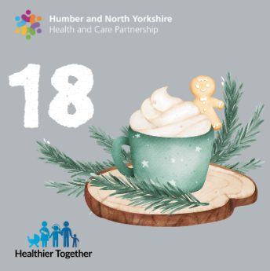
19 December | NHS APP – repeat prescriptions | Planning on being away from home over the festive period? Did you know you can easily change your nominated pharmacy on the NHS App.  Find out more: www.nhs.uk/nhsapp  #HNYadvent2024 | 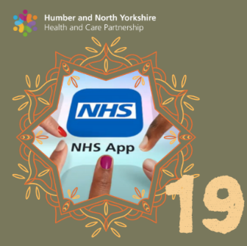
20 December | Place Christmas - Whitby | Our Places at Christmas - we couldn't wait to share this lovely festive image of Whitby.  #HNYadvent2024 | 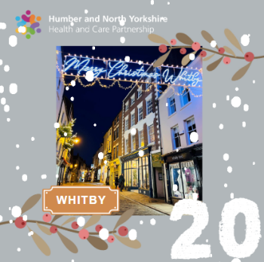
21 December | Self-care | It can sometimes be difficult to tell the difference between a cold and the flu, if you or your child is feeling unwell.  In this video, Dr Ekta Elston talks through the symptoms to look out for and when to seek advice.  #HNYadvent2024 | 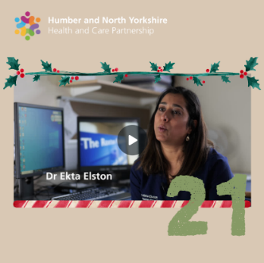
22 December | Winter strong | Embrace being Winter Strong.  Keep your spirits high and energy levels up this festive season. Let's prioritise our health and wellbeing over the Xmas break.  Visit: www.letsgetbetter.co.uk/get-the-right-care/self-care/  #HNYadvent2024 | 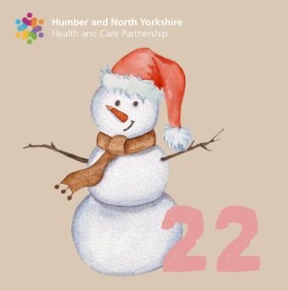
23 December | Place Christmas  Northallerton | Our Places at Christmas - enjoying the festive lights in Northallerton.  ✨  #HNYadvent2024 | 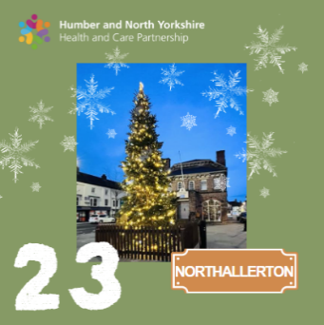
24 December | Self-care | Self-care is a gift you give yourself. Prioritise it this festive season.  Stay as active as you can as this will boost your mood. Stay well-nourished and hydrated. Schedule quiet time to recharge. Stock up on multivitamins from your local pharmacy. They can help support your body's natural defences to stay well this winter.  #HNYadvent2024 | 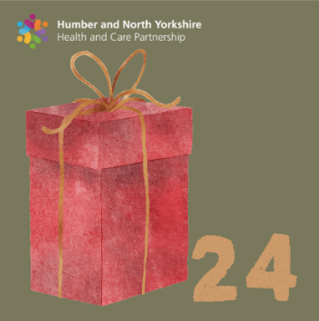
25 December | Festive message | Season’s Greetings  From the NHS Humber and North Yorkshire Integrated Care Board.  We wish you and your loved ones a wonderful holiday  season and a healthy and peaceful New Year.  #HNYadvent2024 | 

