


Humber and North Yorkshire Health and Care Partnership Mental Health, Learning Disabilities and Autism Collaborative Programme


Annual Report
2023-24

Contents

About Us 3
Introduction 5
Our Priority Workstreams 8
Engagement and Coproduction 35
Clinical Engagement 42
HNY MH LDA Annual Conference 45
Performance 47
Finance 49
What Next? 50
Meet the Team 51

2

About Us
Humber and North Yorkshire Integrated Care Board (ICB) is part of the wider system of Integrated Care System of organisations that hold responsibility for planning, paying for and providing healthcare services.
The Integrated Care System comprises of six local ‘places’: Hull, East Riding, North Lincolnshire, North East Lincolnshire, North Yorkshire and Vale of York, and serves the health and care needs of the population of 1.7 million people.
The Mental Health, Learning Disabilities and Autism Collaborative is one of five sector collaboratives which report into the Integrated Care Board. Our aim is to better support the health and wellbeing of our population and make the best use of the resources we have available to deliver safe and quality mental health, learning disabilities and autism services.
By working together with stakeholders from across our six local places, including with colleagues from providers, primary care, local authority and VCSEs, we can more effectively collaborate and plan together to ensure that Mental Health, Learning
Disabilities and Autism services are meeting the needs of our populations, are available to all who need them and that investment decisions are aligned to longer term strategic goals, supported by evidence-based needs.
Working across a geographical area of more than 1,500 square miles, Humber and North Yorkshire Integrated Care system comprises five acute trusts, three mental health trusts, six local authorities, two ambulance trusts, four community interest/not for profit organisations, 230 GP practices, 550 residential care homes, 10 hospices, 180 home care

companies and thousands of voluntary and community sector organisations all helping to keep our local people well. We need to all work together to provide the best services for our local populations.
We would like to thank all our partner organisations across Humber and North Yorkshire, including our providers; Local Authorities; Voluntary, Community and Social Enterprise organisations; and colleagues within our six local ‘Places’ for their continued hard work in delivering care to the people in our area, and their support in producing this report.

3


Humber and North Yorkshire Health and Care Partnership Mental Health, Learning Disabilities and Autism Collaborative Programme Annual Report 2023-24

North Yorkshire
Runswick Bay
Sandsend
York
East Riding of Yorkshire
Hull
North Lincolnshire
North East Lincolnshire

6 Local Authorities (Upper tier and unitary authorities)

3 mental health trusts

1000s of voluntary and community sector organisations
550 care homes
and 180 home care companies

4 acute hospital trusts (Operating across 9 sites)
c. 50,000 staff across health and adult social care
Second largest Integrated Care Board in England with a population of 1.7 million

42 Primary Care
Networks (181 GP Practices)
Total budget of approx. £3.5bn pa


10 hospices 2 ambulance
trusts
4 communty / not for profit providers

4

Introduction
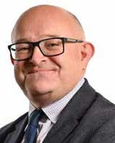

Brent Kilmurray
Chief Executive, Tees, Esk and Wear Valley NHS Foundation Trust; Chair of the Humber and North Yorkshire Health and Care Partnership Mental Health, Learning Disabilities and Autism Collaborative

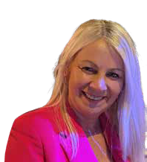

Alison Flack
Programme Director, Humber and North Yorkshire Health and Care Partnership, Mental Health, Learning Disabilities and Autism Collaborative Programme

Health and care organisations across Humber and North Yorkshire have continued to work increasingly close together to deliver Mental Health, Learning Disabilities and Autism services in the face of increased demand and limited resource. We are proud that despite the continuing challenges of working in this context we continue to see improving performance across a number of areas; and a real desire to ensure all services are providing safe, quality care for our population.
Our Collaborative’s programme of work remains closely aligned to the ICB operating models and strategic objectives, and we continue to review our internal strategies and work plans regularly to ensure they reflect the needs of our local areas and populations.
We are extremely proud of several successes achieved throughout 2023/24. You can learn more about our priority workstreams later in this document, but some key achievements are highlighted below.
- Children and Young People’s Trauma Informed Care - Established an ICB wide system change programme to embed a Trauma Informed Approach across a range of partners including 4 Test and Learn Sites and 2 Pilot Projects across Humber and North Yorkshire. The 3 fully mobilised Test and Learn Sites received 486 appropriate referrals, of which 456 young people accessed the service.
- Children and Young People’s Mental Health - We have continued to improve joint working between system and place to improve access, outcomes and experience for Children and Young People who need mental health support. This includes additional Mental Health Support Teams being mobilised in 4 of our 6 local Places, and the achievement of our CYP MH Access target through improving the data flow from
all delivery partners to the MHSDS (Mental Health Services Data Set). We have also improved services through effective engagement and coproduction with the Nothing About Us Without Us Mental Health lived experience advisory group.


Humber and North Yorkshire Health and Care Partnership Mental Health, Learning Disabilities and Autism Collaborative Programme Annual Report 2023-24

- Inpatient Quality and Safety - A comprehensive dashboard has been developed for all mental health, learning disability and autism out of area hospital placements, with data updated monthly. We have worked with system partners to develop a 3 year strategic plan to transform inpatient services in line with the national commissioning framework; this will be published in July 2024.
- Urgent and Emergency Care Mental Health - There was a primary focus on the roll out of a three digit number for people to easily access crisis support. The NHS 111 ‘Select Mental Health Option’ is now fully mobilised across Humber and North Yorkshire meaning people experiencing a mental health crisis can access help via NHS 111.
- Dementia – HNY ICS became collaborators on the Blood Biomarker Challenge with Dementias Platform UK. Funding of £4.5m was announced in March 2024 and a five year programme will see a full programme of research into a blood test to identify Alzheimer’s Disease.
- SMI Physical Health - Achieved 8,822 Annual Physical Health Checks (69.9% of those on the SMI register), up from the previous year’s uptake of 57.2%. Additionally, 4 of our 6 local Places in HNY succeeded in delivering health checks to more than 70% of people on their SMI registers.
- Culture and Workforce - Over the last year we have increased the visibility of psychological professional roles on the ICB Career Hub pages, including information about the varying roles and career pathways. In addition to this a ‘spotlight on
the Psychological Professions’ webinar took place in July 2024. We recruited to a Psychological Professions Workforce lead role, funded through NHS England, and their work has already identified a number of specific areas for action.
- Learning Disabilities and Autism - We established the Autism and ADHD Project Group whose primary focus is to work on the creation of a system wide autism referral criteria; pathway; and service specification for Humber and North Yorkshire to ensure consistency for our population. We also continued to implement the 3 year plan for the Oliver McGowan training. To date we have 6 Tier 2 Lead Trainers, 19 Facilitative Trainers and 12 Experts by Lived Experience Co-facilitators trained and ready to deliver.
- Suicide Prevention - Established a new and improved priority plan for the ICB, aligned to the Government 5-year Suicide Prevention Cross Sectional Strategy and Guidance. We also commissioned Suicide Prevention Community Business training across the region, delivered by MIND, to improve and enhance suicide prevention and awareness for local businesses.
- Resilience Hub - In 2023/2024, the Hub has supported 935 individual staff who work in health care across the system and 648 staff across 24 separate organisations through organisational and team support. This includes a vital critical incident response offer, post-traumatic event support, reflective practice, resilience training and emotional wellbeing support. The hub has also offered systemwide training and webinars relating to trauma, suicidality and wellbeing in the workplace.

- Community Mental Health - The transformation programme is now in its 3rd year across Humber and North Yorkshire. Through strong partnership working and an inclusive and coproduced approach we have successfully progressed the transformation of Community Mental Health Services across all parts of the region. We are proud to have achieved the national target for the number of adults and older adults receiving two+ contacts in new integrated models.
- We are also very proud to say that we have continued to work with the NHS Leadership Academy and have now welcomed 7 trainees into placements supported by our Collaborative since 2017. We are committed to taking an active role in investing in the future of our NHS workforce.
We continue to ensure that mental health, learning disabilities and autism services remain high on the agenda across our growing system. We will strive for the health and wellbeing of the people we serve to be prioritised and continue to make the most effective use of our resources to realise this, and to meet the national objectives we are held to. This can only happen with the support of our partners across the system who join us in working to ensure we provide the best support for our local population throughout their lives.



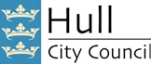
Our Partners

Yorkshire Ambulance Service

NHS Trust

Rotherham Doncaster and South Humber

NHS Foundation Trust






Tees, Esk and Wear Valleys
NHS Foundation Trust
East Midlands Ambulance Service
NHS Trust


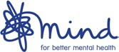
Humber Teaching
NHS Foundation Trust

Disabilities and Autism Collaborative Programme Annual Report 2023-24

Our Priority Workstreams
Learning Disabilities and Autism
Over the last twelve months we have moved forward at pace within our work on learning disability and autism; this includes recruiting a Learning Disability and Autism Programme Lead to give overall leadership to the programmes of work, and a Learning Disability Nursing Workforce Champion to focus on the recruitment and retention of this key profession across Humber and North Yorkshire. We have a clear focus on making a difference to our learning disability and autistic population and continue to engage with a variety of stakeholders to make sure we are working what is important to them.

Successes 2023/24
- Successfully raised the profile of Learning Disabilities and Autism with the theme of our Annual international Mental Health, Learning Disabilities and Autism Collaborative Conference being Autism. This was attended by 400+ people.
- Established the Autism and ADHD Project Group which has a primary focus to work on the creation of a system wide criteria for autism referrals, a system wide autism pathway and a service specification for Humber and North Yorkshire to ensure services are consistent for the population we serve.
- Continued successful work of the Learning Disabilities and Autism steering group.
- Continued to implement the 3 year plan for the Oliver McGowan training that is being delivered across Humber and North Yorkshire. To date we have 6 Tier 2 Lead Trainers, 19 Facilitative Trainers and 12 Experts by Lived Experience Co-facilitators trained and ready to deliver.
- Wrote and presented a paper to the ICB board on the increased level of demand for autism and ADHD assessments overwhelming the current capacity to address the needs.
- Developed the HNY All Age Autism and ADHD Waiting Times dashboard.
- Developed a 3 year Mental Health, Learning Disability, and Autism Inpatient Quality Transformation Plan for all mental health, learning disability and autism inpatient services for children, young adults, and older adults.
- Focused on resolving workforce challenges and inputted into emerging new roles across services by successfully recruiting a Learning Disability Nursing Workforce Champion role to work in partnership with the ICB People Team. Learning Disability Nursing now has a presence on the Humber and North Yorkshire Career web pages, showcasing the variety of possibilities in this field of working, as well as routes into the profession.

Priorities 2023/24
- Continue development and refinement of the ASD and ADHD Dashboard.
- Develop a HNY wide LDA Right to Choose Standard Operating Procedure.
- Evaluate test and learn pathways across HNY to help shape the pathway for the future.

- Continue work on improving the conditions of inpatient and community facilities for those with LDA as directed by the developed inpatient plan.
- Creating a working group to address the service quality concerns of people in HNY with a learning disability without another condition.
- Continued support of the wider collaborative workstreams on safe transition of young people to adult services.
- Develop the LDA Physical Health Check programme.
- Continue to implement the 3 year plan for the Oliver McGowan training that is being delivered across the patch.
A snapshot of our work can be seen below:
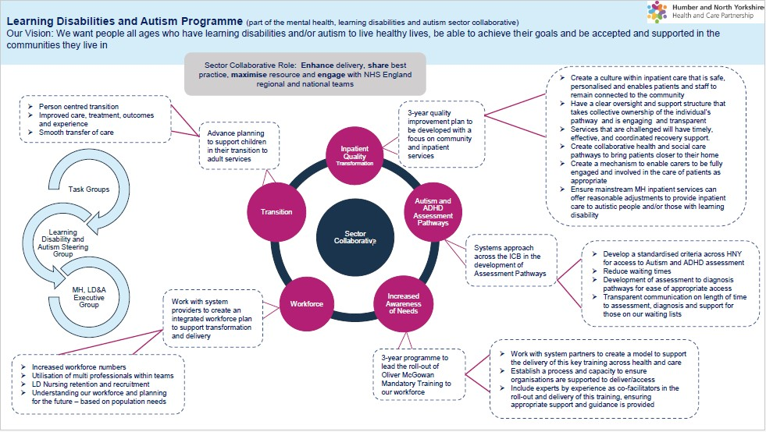

Children and Young People’s Mental Health
Over the last year we have worked with partners at place and across the system to deliver against our HNY CYP Mental Health strategic plan.

Successes 2022/23
- Improved joint working between system and place. The HNY Children and Young People’s (CYP) Mental Health steering group is well attended and includes
representation from all 6 place based leads for CYP Mental Health as well as public health, local authority children’s services and VCSE sector to provide a holistic response to CYP Mental Health issues.
- Development and mobilisation of additional Mental Health Support Teams in schools in North Yorkshire, York, Hull and North East Lincolnshire with additional teams planned in North Lincolnshire and East Riding in the coming year.
- Achievement of the HNY CYP Mental Health access target through improved data flow to the national MHSDS (Mental Health Services Data Set) to ensure all NHS funded services are flowing data, which contributes to the improved access target for the NHS long-term plan.
- We are working with CORC (Child Outcomes Research consortium) part of the National Anna Freud Centre for CYP Mental Health, to improve outcomes reporting in CAMHS services to evidence the impact of services.
- An improved approach to addressing health inequalities and delivering the CYP Core 20 plus 5 through targeting provision at areas of need e.g., areas of multiple deprivation.
- Services from across HNY have been invited to share the good practice they have developed across the ICB, regionally and nationally.
- Ongoing development of the HNY CYP Mental Health Data Dashboard to improve consistency of data reporting on access, witing times, outcomes and experience.
- Working with partners at place on implementation of recommendations from CYP consultations to improve access, outcomes and experience.
- Commissioned research project to inform service development to address disordered eating/Avoidant Restrictive Food Intake Disorder (ARFID).

Priorities 2023/24
- Refresh our system wide strategic workplan to build on successes delivered in 22/24 and address ongoing and newly emerging challenges.
- Improved prevention and early intervention enabling resilience and meeting need early and reduce need for clinical services.
- Improved equitable access to mental health services for those who need them.
- Championing Child/Young People friendly practice.
- Improving crisis care and managing risk.
- Improved clarity of thresholds/pathways for professionals as well as CYP and parents/ carers – graduated response for support and development of consistent no wrong door model.
- Improve Transition from CYP to adult mental health services for those who need them in line with NICE quality standards - needs led not age led.
- Develop a suicide prevention pathway for CYP including support in escalating cases of self-harm or suicidal ideation or following a suicide attempt.
- Reduce waiting times for services and improve support for those waiting to ensure issues do not further deteriorate.
- Deliver system wide plan to deliver against the NHSE workforce plan for CYP Mental Health.
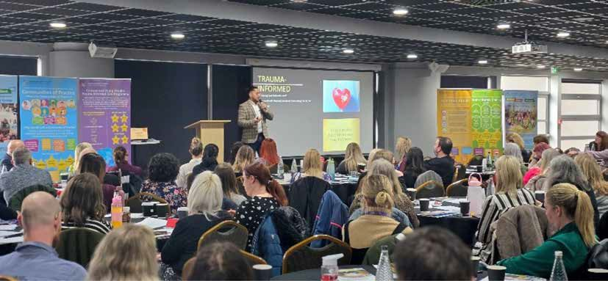
More information on our programme, strategic workplan and priorities can be found on the Humber and North Yorkshire Health and Care Partnership website.

Children and Young People’s Trauma Informed Care Programme

Aim of the Programme
The model of the Programme has two main aspects. One is delivering system change across the Partnership to develop and embed a consistent Trauma Informed approach across all partners working with vulnerable Children and Young People at risk of offending. The other is to test new interventions (known as Test and Learn Sites) which divert young people from becoming first time entrants into the Youth Justice System. In order to meet the objectives of the framework, our phased implementation will focus and build on the following four key areas:

ICS wide scoping:
trauma informed initiatives, data and service provision

2
Strengthen multi agency relationships and improving
co-ordination of existing services
1
Building a trauma informed integrated care system

3

Successes 2023/24
4

Implementation of place based models of intervention as test and learn pilots

- We have set up 4 Test and Learn Sites, and 2 Pilot Projects, with each following an individual model to address needs at Place level.
- In Hull there were 171 appropriate referrals, and 161 new young people who accessed the VCS led Flipside service delivered by The Warren and Cornerhouse. Flipside is a holistic model which aims to prevent first time entrants to the Youth Justice System, by delivering a range of 1-1 and group therapeutic and diversion Trauma Informed interventions.
- In North East Lincolnshire there were 200 referrals and 181 new young people who accessed the JEFF (Journey to Enrichment, Fulfilment, and Friendship) project, which aims to engage hard to reach Children and Young People and support them in accessing key local services such as The Young and Safe team, Compass Go, and We Are With You.
- In North Yorkshire there were 115 referrals and 114 new young people who accessed the service, which is delivered in partnership with North Yorkshire Council, North Yorkshire Youth, and Tees, Esk and Wear Valley NHS Foundation Trust. The service targets areas of high need across the county, applying a shared model of systemic, relational, and Trauma Informed practice.

- RETHINK! In North Lincolnshire is our new Test and Learn Site. RETHINK! is a multi- agency team to identify and support children (10-19) in North Lincolnshire, and their families who have experienced trauma and are at risk of entering or re-entering the Youth Justice System. The children in scope will be identified as being on the edge of exclusion from education, either attending an alternative provision, or at risk of
suspensions and exclusion, due to poor attendance or behaviour. Our overall ambition is for children to be thriving in their families, achieving in school, flourishing in their communities.
- York and East Riding are our new Pilot Projects. Their Youth Justice teams will be working to embed Trauma Informed approaches through dedicated specialist
practitioners and providing support with elements such as Speech and Language Therapy.
- We now have several Communities of Practice up and running: Leadership, Practitioner, Group Leads and Volunteers and ARC Champions. 18 Communities of Practice have taken place, attended by 127 people across 44 organisations. 80% of attendees said that attending Communities of Practice supported their professional development. 90% felt that being part of the community helped them to share organisational, or work-related knowledge, and join up relevant or dependent work.
- The Organisational Toolkit has continued to have uptake and participation from services across all 6 places. The Toolkit has been pivotal in supporting those using it to embed and work towards sustaining a Trauma Informed integrated system, and developing a consistent joint approach across Yorkshire & The Humber. 11
organisations are working collaboratively with the Core Team, to undertake the Trauma Informed Organisational Toolkit.
- We have continued to build on our training offer over the last year. We have a Framework of Trainers now delivering the multi-agency ARC training across the ICS attended by 738 professionals. We are continuing to use the national ARC trainer, Kati Taunt, to deliver the 2 day ARC Champions training, attended by 353 professionals, and the 2 half day ARC training for Senior Leaders, attended by 122 professionals. 90% of people said the training has increased their knowledge of Trauma Informed practice, and 89% of people said the training has given them the skills and knowledge to identify whether practice is Trauma Informed.
- We have developed our e-Learning training session which is now on our webpage. We are also sharing this with other organisations who will also include this as part of all staff training. The training is a short targeted 45 minute training session for
anyone who has direct or regular contact with Children and Young People, who may be affected by trauma (even if this is not known about). So far 1661 people have completed this training. 90% of people said the training has increased their knowledge of Trauma Informed practice, and 89% of people said the training has given them the skills and knowledge to identify whether practice is Trauma Informed.

ARC Framework

Attachment, Regulation and Competency (ARC)
A set of clinical interventions used to address complex trauma, and a framework for building Trauma Informed organisations/systems, is being developed to organisations within the partnership to enable them to become Trauma Informed.

Competency
Executive Functions | Self- Development & Identity |  | Relational Connection
Identification |  | Modulation
Caregiver Affect Management | Attunement |  | Effective Response
Engagement | Education |  | Routines & Rhythms

Regulation Attachment
Trauma Experience Integration

- We held our inaugural Humber and North Yorkshire Children and Young People's Trauma Informed Care Programme Conference. We were delighted to welcome over 200 colleagues to come and learn more about the considerable progress made by the Programme since it began. The conference was attended by a wide range
of stakeholders that we have worked with throughout the first 18 months of the Programme; those who can initiate system change at an operational and strategic level, and those working within systems to support young people who have or may have experienced trauma. We wanted to share our work on transformational system change, as well as to give our Test and Learn Sites the opportunity to showcase their excellent work and the positive outcomes and impact on Children and Young People.

Priorities 2024/25
- Work with CORC (Anna Freud) to support the Independent Evaluation.
- Continue to work with and support our 4 Test and Learn Sites: Hull, North East Lincolnshire, North Lincolnshire and North Yorkshire.
- Continue to work with our Pilot Projects: York and East Riding.
- Continue to develop our Training Offer.
- Work closely with our ARC Champions to sustain our Training Offer .
- Further develop Communities of Practice/Organisational Toolkit.
- Build on the work we have started on delivering Transformational System Change across the ICS.
- Sustain the good work taken place so far and focus on sharing the good practice across the ICB and wider.
- Continue to work with the Children and Young People’s Mental Health Advisory group to ensure our work is informed by Children and Young People with lived experience.

Pictures from the inaugural Children and Young People’s Trauma Informed Care Conference
A range of interesting and relevant workshops were delivered by a range of professionals, including Kati Taunt, on ‘How Trauma impacts whole systems.’ An overview of the national picture was given by Andrew Nichols-Clarke, Senior Development Lead - Health & Justice Children’s Programme, NHS England. Finally, we heard from keynote speaker, Gavin McKenna, Founder and Director of Reach Every Generation.

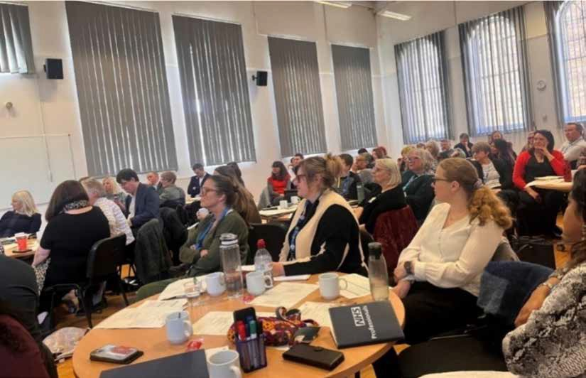
16
Inpatient Quality and Safety
New national guidance was published outlining the expectation to undertake whole scale transformation of inpatient services through a quality and safety lens. Subsequent commissioning guidance has been published to support systems in this work. This can be found here. Key actions include:
- To know where all of your people are placed in hospitals Out Of Area (OOA).
- Know what it will take to bring everyone back to their local area and prevent further inappropriate OOA placements.
- And to undertake repatriating individuals.
Each ICB is tasked with developing a strategic three-year plan in response. This has been developed in collaboration with partners, with a key stakeholder engagement event held in April 2024.
In readiness for this, a comprehensive dashboard has been developed and is updated monthly for all mental health, learning disability and autism out of area hospital placements. This information is crucial for us to understand where all of our people are placed as a system and is supporting the development of new ways of working including commissioning and quality oversight of placements, as well as repatriation plans for the individuals that are currently out of area.
Community and crisis services will be enhanced to prevent further inappropriate inpatient placements, and innovative housing solutions are being considered to support this. The diagram below outlines Humber and North Yorkshire’s Plan on a Page for this programme of work.

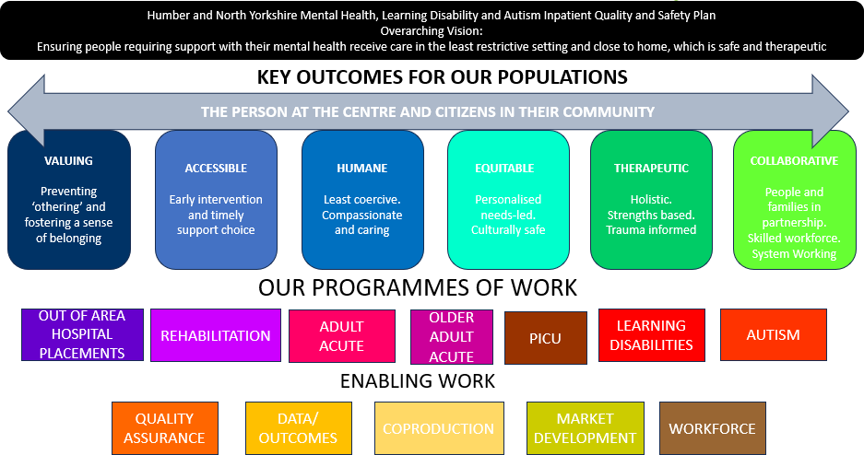

2024/25 Priorities
- Publish three-year strategic plan.
- Undertake detailed audit of current OOA placements, developing repatriation plans for individuals.
- Central rehabilitation referral panel will be established aiming to prevent further inappropriate long- term rehabilitation placements.
- Undertake market management with local independent sector providers and units.
- Develop business cases to develop the right local services.
- Workforce analysis in respect to safer staffing, MDT make-up and skills/training.
- Participate in the national Early Warning Signs Programme – the diagram below outlines what is included in this programme.
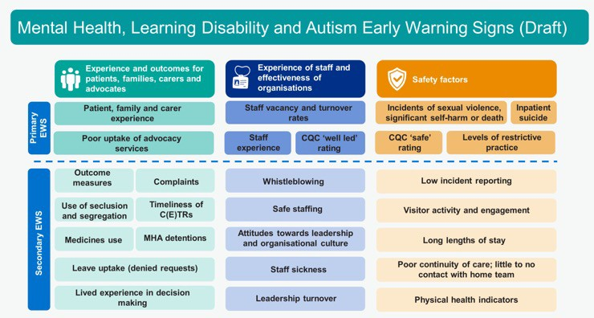

Community Mental Health Transformation
The national requirements for Community Mental Health in the NHS Long-Term Plan are to expand and transform community services. The transformation of community mental health services programme is now in its 3rd year across Humber and North Yorkshire.
Each place has a dedicated team leading the transformation programme which includes experts by experience, co production leadership and joined up partnerships.

Successes 2023/24
Reflecting on the last year, this programme has continued to develop and deliver much needed new services across the region. Our successes include:
- We have achieved the target for the access core indicator for transformed services: the number of adults and older adults receiving two+ contacts in a new integrated model across core and dedicated service provision in the last 12 months.
- Investment in the Voluntary, Community and Social Enterprise Sector (VCSE) has helped to create VCSE Alliances and community support roles including Peer Support, Involvement Workers, Social Prescribers, and Mental Health Coaches.
- New neighbourhood Community Mental Health Hubs now offer a new way to provide and access mental health services in the community to help change the way people are able to access mental health services. These new models of mental health care will promote citizenship, enabling local places, neighbourhoods, and systems to support change.
- Workforce re-design including recruitment to new roles within psychological professions is now helping to offer much needed psychological interventions.

Mental health support in North Yorkshire and York GP surgeries provides quick access to support and reduces referrals to specialist services.
Mental health practitioners based in GP surgeries are supporting local people to manage their mental health and have significantly reduced the need for referrals to specialist services.
David Kerr, Community Mental Health Transformation and Programme delivery lead, North Yorkshire and York Mental Health Alliance said: “The introduction of first contact mental health workers really is transforming the way people are being supported. Prior to the roles being introduced most people were referred to secondary mental health services, often waited a considerable time to be seen due to the high demand for support. A significant number were then passed back to primary care as they didn’t require the specialist intervention, by which time some people’s mental health had deteriorated further.
First contact mental health workers have been working into GP surgeries since 2021. Recent figures show, based on an average of 1,921 patients over a three-month period*, 92% of patients were supported directly, with only 5% needing to be seen by a GP and 3% requiring a referral to specialist secondary mental health services.

Priorities 2024/25
We strive to fully implement and embed changes, and ensure people can access flexible, personalised, holistic care. Looking ahead, the focus will increasingly be on the quality of care, experience and outcomes delivered in services.
We are using the ‘roadmap’ tool which sets out the key milestones and deliverables that underpin the transformation of community mental health. It is used as a guide for our system as to what needs to be delivered by the end of 2024/25 and is tailored according to our place plans.
We will be prioritising:
- Improving waiting times for treatment.
- Mobilising the universal standard of personalised care planning.
- Outcomes focused care and use of patient reported outcome measures.
- Improving access to psychological therapies.
- Spotlight on intensive case management approaches across Humber & North Yorkshire to focus on assertive approaches for people with the most complex needs.
- Linking with the NHSE inpatient programme to ensure people with specialist needs such as Adult eating disorders, complex emotional needs and mental rehabilitation have dedicated pathways of community treatment, and needs being supported in the community instead of in inpatient facilities.
19

Individual Placement and Support
Individual Placement and Support (IPS) is a structured programme to support people with severe and enduring mental health issues into employment.
Most people accessing mental health services report that they see gaining employment as key to their recovery, wellbeing and life opportunities. IPS employment specialists undertake a range of roles to support individuals to gain and stay in employment. This includes:
- Working with people accessing the service to find them employment that matches their aims, interests and skills, and offering continued support once they are in post.
- Integrating with the mental health team to support the individual with any issues that affect their work and recovery.
- Building relationships with employers to negotiate job opportunities.

Successes 2023/24

We are delighted to share that that the government has committed to expanding the IPS programme with combined new funding covering 2023/24 to 2028/29, aiming to reduce economic inactivity and increase labour market participation and retention for people with Severe Mental Illness.
The IPS services are now integrated within transformed Community Mental Health models, and they will continue to be available for anyone who can benefit from this unique and highly effective intervention.

Priorities 2024/25
We plan to utilise the additional funding to expand key health and employment programmes, to help those with mental health conditions stay in or find work.

20

NHS Talking Therapies

(Formerly Improving Access to Psychological Therapy (IAPT)
Aligned with the NHS Long Term Plan and the Advancing Mental Health Equalities strategy, NHS Talking Therapies services are working to reduce health inequalities, ensuring services meet the needs of the whole population that they serve. Our work on advancing equalities focuses on improving access, outcomes and experiences for specific populations and under- represented groups.
NHS Talking Therapies, for anxiety and depression services are characterised by three key principles:
- All psychological therapies offered are evidence-based and delivered at the appropriate dose: where NICE recommended therapies are matched to the mental health problem, and the intensity and duration of delivery is designed to optimise clinical outcomes.
- The clinical workforce are appropriately trained and supervised: high-quality care is provided by clinicians who are trained to an agreed level of competence and accredited in the specific therapies they deliver, and they receive weekly outcomes focused supervision from senior clinical practitioners with the relevant competences to support continual improvement.

- Routine outcome monitoring via standardised measures is used on a session-by-session basis, so that the person having therapy and the clinician offering it have up-to-date information on the person’s progress. The outcomes of all NHS Talking Therapies services are published so that the sector can learn from variation in outcomes and public transparency about the benefits and limitations of the services is maintained. This helps guide the course of each person’s treatment and provides a resource for service improvement, transparency, and public accountability.

Priorities for 2024/25
The NHS has set a new target recovery rate, at least half (50%) of people who complete a course (2 or more sessions) of treatment should recover. As a system we are supporting place-based providers to meet this new target.
NHS Talking Therapies will also work closely with community mental health services for people with severe mental health problems to ensure people are able to receive support from the right service for their needs. We continue to develop joint working pathways with the primary care networks (PCNs) and mental health providers.
Due to the changing nature of our population, development of guidance on the accessibility and acceptability of psychological therapies for autistic adults is needed.


Severe Mental Illness Physical Health Care
In 2023/24, the SMI Physical Health Care Programme continued to strive to achieve the national target for the number of people with SMI who received an annual physical health check. We welcomed a range of speakers to the steering group to share their best practice and innovations to support us to continue to develop this work and deliver holistic, quality health checks. The work of the steering group is now expanding to focus more broadly on the additional screening, interventions and support offered to people with severe mental illness, with a specific focus on cancer screening uptake, and access to smoking cessation interventions.

Successes 2023/24
- Achieved 8,822 Annual Physical Health Checks (69.9% of those on the SMI register), an increase of 12.7% on last year. Additionally, 4 of our 6 local Places in HNY succeeded in delivering health checks to more than 70% of people on their SMI registers.
- Our SMI RAIDR dashboard went live enabling access to a range of data including demographics, co-morbidities, long-term conditions, and access to acute healthcare services including A&E. Unfortunately this was retired in March 2024.
- Funded 20 staff to complete the National Centre for Smoking Cessation and Training (NCSCT) Very Brief Advice Course. This supports them in how best to approach conversations around quitting smoking to encourage individuals to accept a referral offer to a Quit service.
- Began to work with the HNY Cancer Alliance to understand uptake of cancer screening data for people with an SMI.
- Vale of York have been working to tackle interoperability issues through the development of a letter to support information transfer from secondary care back into primary care.
- Continued to share best practice through our steering group, with speakers including:
  - Jodie Hall, Sheffield Health and Social Care, on their Annual Physical Health Check model.
  - Zoe Bounds, HNY Cancer Alliance, on the Psychosocial Support for People with Cancer project.
  - Dave Jones, Centre for Excellence in Tobacco Control, on improving access to tobacco treatment for people with SMI
  - Updates from all local places on Engagement and Coproduction Practices.

Priorities 2024/25
- Achieve our target of 8,825 (69.6%) annual health checks to be completed, but work towards 75%.
- Continue to work closely with partners in the HNY Cancer Alliance to identify ways that cancer screening and care can be improved for people with an SMI.
- Work with the ICB BI team to develop a new SMI dashboard to provide access to live data.
- Deliver a teaching session to cancer professionals on the health inequalities faced by people with SMI, and how to increase uptake of cancer screening.
- Progress work with the Centre for Excellence in Tobacco Control on improving access to tobacco treatment for people with SMI.
- Deliver a 2 day NCSCT course to train staff who deliver smoking cessation interventions in how best to engage with people with a severe mental illness.

Resilience Hub

Successes 2023/24
The Humber and North Yorkshire Staff Resilience Hub provides confidential help and support for health care colleagues across the HNY system. The hub delivers:


Person - centred psychological assessments within 5 days of referral

1:1 Psychological support - range of evidence based therapies

Long covid and long term health condition support

Individual, group & neuro Assessment

Trauma informed care (TIC) pathway inc stabilisation and resourcing group, 1:1 individual trauma therapy, team debrief modelling (CISM)

Organisational consultation framework, supporting teams and leaders and specific training including burnout



Bereavement support

Relationship support (Relate)

Liaison and support with occupational health and human resources

Signposting and trusted assessor pathways
with multiple organisations and therapeutic offers

Medication advice and reviews and liaison with GP and other services

Evidence based resilience training for individuals, teams and leaders
In 2023/2024, the Hub has supported 935 individual staff who work in health care across the system and 648 staff across 24 separate organisations through organisational and team support. This includes a vital critical incident response offer, post-traumatic event support, reflective practice, resilience training and emotional wellbeing support. The hub has also offered systemwide training and webinars relating to trauma, suicidality and wellbeing in the workplace.

The HNY Resilience Hub won the Staff Wellbeing Initiative Award at the 2024 Health Service Journal (HSJ) Patient Safety Awards. The HSJ Patient Safety Awards recognises and acknowledges the hard-working teams and individuals across the UK who are continually striving to deliver improvements in safety, culture and positive experiences in patient care.

Through the Hub's collaboration with the ICB, all health and care staff across Humber and North Yorkshire also have access to the ‘HNY Our People’ smartphone app; a wellbeing portal designed to maintain and improve the wellbeing and physical and mental health
of staff by providing a range of self-help resources. The app offers a virtual library of wellbeing information and access to features such as healthy habits, self-help tools and podcasts.

Priorities 2024/25
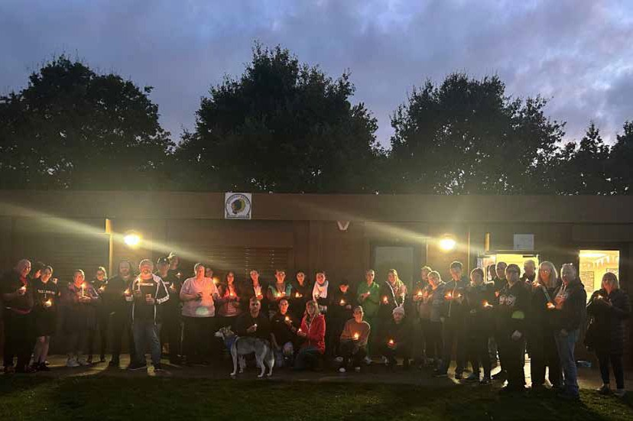Regretfully the Humber and North Yorkshire Resilience Hub is closing in 24/25. The Hub are unable to accept new referrals but will continue to support existing clients. The decision to close the Hub – amid significant financial challenges across the NHS - follows significant engagement with key stakeholders including system leaders, the ICB health and wellbeing committee and HR departments. Over the last four years the Hub has been a highly successful and impactful service, delivering high quality mental health and wellbeing support to more than 5,800 health, care and emergency service staff across Humber and North Yorkshire. As a system we are committed to utilise the learning and impact of the Hub in how we continue to champion and support the Humber and North Yorkshire workforce.

24


Humber and North Yorkshire Health and Care Partnership Mental Health, Learning Disabilities and Autism Collaborative Programme Annual Report 2023-24

Suicide Prevention

2023/24 Successes
  - Established a new and improved priority plan for the ICB, aligned to the Government 5-year Suicide Prevention Cross Sectional Strategy and Guidance.
  - Enhanced and prioritised connections with place-based VCSE services and integrated them into the Steering group.
  - Connected with the Children and Young People’s Coproduction and Involvement group to aid the development and re-launch of the #TalkSuicide website.
  - Continued delivery of the ‘Together’ postvention service in North East Lincolnshire, Hull, North Lincolnshire and East Riding whilst looking to enhance the overall provision of Postvention at scale, supporting those who have been bereaved or affected by a suicide.
  - Created alliances and stronger bonds with colleges, further education and universities to improve and build upon their Suicide Prevention and wellbeing initiatives.
  - Commissioned Suicide Prevention Community Business training across the region, delivered by MIND, to improve and enhance suicide prevention and awareness for local businesses, namely:
  - Pubs
  - Barbers
  - Taxi Drivers
  - Gyms and Leisure services

2024/25 Priorities
Continue to increase the number of individuals, professionals, volunteers and health care workers trained in Suicide Prevention.
Work closer with businesses, acute trusts, NHS and Local Authorities to embed the Baton of Hope Suicide Prevention Workplace Pledge.
Ensure that the voices, views and opinions of people with lived experience, and those impacted by Suicide, are prioritised throughout Place and at scale in decision making.
Work closer and better with ICB sector collaboratives and programmes to increase the impact of prevention work for mental health and wellbeing.

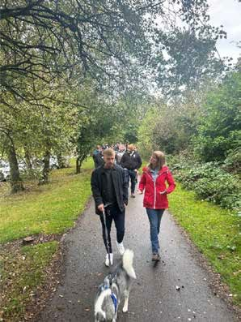
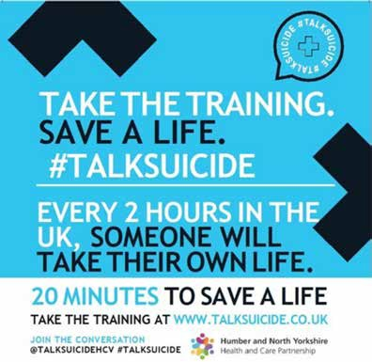

Perinatal Mental Health and Maternal Mental Health
The ICB commission two Specialist Perinatal Mental Health services across the region to support women within the perinatal period who are experiencing moderate to severe and/or complex mental health problems. Tees, Esk and Wear Valley (TEWV) NHS Foundation Trust provide a service for North Yorkshire and York, and Humber Teaching
NHS Foundation Trust in partnership with Navigo provide a service for the Humber Four which includes Hull, East Riding, North and North East Lincolnshire.
More information including testimonials from women can be found at EveryMumMatters.com

Humber Four
Within 23/24 the number of women accessing the Humber Four service has increased by 20% compared to the previous year. This has been enabled through the implementation of a direct referral and triage offer. Waiting times have remained
low, with outcomes and patient feedback high. The service is focussing on addressing health inequalities for women under the age of 25 and women from racially minoritized backgrounds as these groups typically experience poorer outcomes within the perinatal period. The service is doing this by making close links with local charity and faith groups, and also offering a full bio-psycho-social assessment for any women from these groups that are referred to the service.

North Yorkshire and York
Within 23/24 the service has worked hard to increase their capacity, including appointing a consultant psychiatrist and new clinical lead.
The service has been in business continuity for parts of the year due to staff vacancies and is working to improve the service offer through a quality improvement lens.

2024/25 Priorities
    - Humber Four service to meet 8.6% access target of the birth rate (2016 ONS).
    - North Yorkshire and York service to increase capacity through a sustainable workforce.
    - To ensure women and their families receive high quality care and that outcomes are high.
    - To implement a maternal mental health offer across Humber and North Yorkshire for women experiencing moderate to severe and/or complex mental health problems due to loss within the maternity context.




Humber and North Yorkshire Health and Care Partnership Mental Health, Learning Disabilities and Autism Collaborative Programme Annual Report 2023-24

Urgent and Emergency Care Mental Health

Successes 2023/24
    - The focus of 23/24 was on the roll out a three digit number for people to easily access crisis support. The NHS 111 ‘Select Mental Health Option’ is now fully mobilised across Humber and North Yorkshire meaning people experiencing a mental health crisis can access help via NHS 111.
    - A memorandum of understanding is now in place between the ambulance service and the mental health providers to ensure clear and agreed processes for patient transfer where needed.
    - A full review of all Directory of Service Profiles was undertaken to ensure that call handlers have the most up to date information relating to mental health crisis pathways and a new referral process is in place. This means that people who access the core 111 number, who also need mental health crisis support, will receive a call back from their local crisis team instead of being given a number to call.
    - A further mental health response vehicle was rolled out by Yorkshire Ambulance Service in York from October 2023, in addition to the Hull vehicle. This provides dedicated resource across those areas for 12 hours every day for those experiencing a mental health issue.
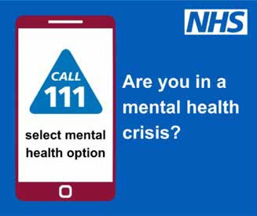
    - Benchmarking of the current crisis alternative provision across HNY took place to inform future planning for reducing variation.

Priorities 2024/25
A task and finish group has been established. In 24/25 this group will aim to maximise the use of the mental health response vehicles and develop further pathways between them and existing mental health crisis provision.
Greater focus on reducing variation in UEC MH provision across HNY to ensure services are equitable.
Expansion of the UEC MH Steering group to aid in the delivery of the acute pathways workstream in the National Inpatient Quality Transformation Programme (NIQTP).
Delivery of the Mental Health Discharge Challenge High Impact Initiatives – aligned to the NIQTP and Out of Area Placements Programme.
A greater focus on crisis prevention, drawing on lived experience expertise from across HNY.

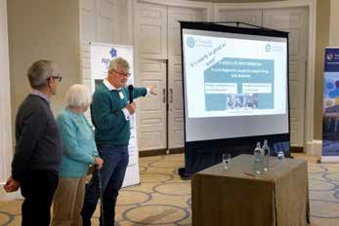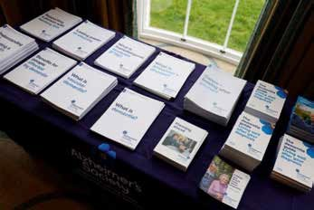

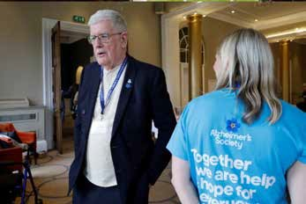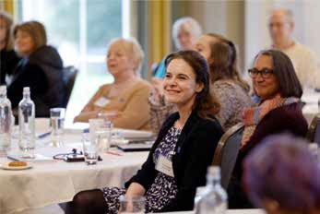

Dementia

Successes 2023/24
All Memory Assessment Services (MAS) across HNY are now either accredited or affiliated with the Memory Assessment Services National Accreditation Programme. This means they can access best-practice and up to date guidance and peer support from other MAS teams across the country.
The HNY Dementia Community of Practice commenced in January 2024 with a monthly programme of topics relevant to people living with dementia and their families, and to people working in dementia services. Topics so far have included the quality of annual dementia reviews and best practice in neuroimaging.
HNY ICS became collaborators on the Blood Biomarker Challenge with Dementias Platform UK. Funding of £4.5m was announced in March 2024 and a five year programme will see a full programme of research into a blood test to identify Alzheimer’s Disease.
A successful programme of engagement across Humber and North Yorkshire took place in partnership with the Alzheimer’s Society to fully coproduce the HNY Five Year Dementia Strategy: A Hope of a Life Still to be Lived.

Priorities 2024/25
The first HNY Research Steering Group commences in September 2024 and brings together people with dementia as research partners, and research leads, from across a variety of organisations within HNY, regionally and nationally.
Continuation of the monthly HNY Dementia Communities of Practice with topics including: How to write and produce accessible information for people with dementia, Ethics of Disease Modifying Treatments (DMTs), LGBTQ+ and dementia, and the research findings from the ‘Good Life’ course – a course co-designed by people with dementia, for people with dementia.
A renewed focus on improving the dementia diagnosis rates to ensure that people are able to access timely diagnosis and post-diagnostic support.

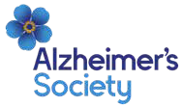
The focus of 24/25 will be around the delivery of the actions set out to implement the HNY Dementia Strategy. The six key priorities are set out below:

Communication: Improved communications around the importance of timely
diagnosis, where to access information and support, information sharing
and keeping people informed

Education and Training:
Starting with a baselining exercise to understand the current training offer
across all services and working with people with lived experience to create an improved training offer

Prevention:
Focussing on wider determinants of health, modifiable risk
factors, health inequalities. Maximising opportunities educate people through existing relationships (Making Every Contact Count) and to the
wider public

Our Six Key Priorities: Underpinned by Lived Experience

Future- Proofing: Ensuring our services are
sustainable and fit for purpose in the longer term, and reflective of the changing needs of our local population

Innovation and Research: Improving access to research in HNY
and ensuring that all of our communities have the opportunity to be involved.
Using this as a platform to secure more funding and innovation within HNY

Accessibility:
Improving the accessibility
of services, support, financial help, practical help, workforce, sustainable resources, culturally appropriate care

Workforce and Culture
The programme of work for this area has seen significant developments over the last 12 months, with collaboration extending to social care, education and the VCSE sector as well as integrating workforce elements into other programmes of work led by our Mental Health, Learning Disability and Autism Collaborative. The work led by the ICB People Team remains a core part of how we are working together to make sustainable change.
The team and progression of the work has also been supported by our Culture and Workforce Steering Group members, with regular attendance from providers within our geography and Chairing on a rotational basis. Sarah Dexter-Smith (Director of People and OD, TEWV) has kindly undertaken this role for the last 12 months and recently handed over to Karen Phillips (Associate Director of People and OD, HTFT). It is through these mechanisms that we have continued to enable the recruitment of more psychiatrists from Kerala; brought about changes to psychological professions organisational structures; and strengthened the profile of learning disability nursing within Humber and North Yorkshire.

Successes 2023/24

Psychological Professions
Learning Disability Nursing
Learning Disability & Autism Workforce
Oliver McGowan Mandatory Training

This last year has seen increased level of representation of the Mental Health, Learning Disabilities and Autism sector at the ICB People Team Breakthrough Groups, which enhances the voices of those working in this field on the priorities taken forward and subsequent shaping of these areas. Updates and developments are shared via the attendees of the Culture and Workforce Steering Group, and our work programme reports into the ICB Workforce Board and the wider work that is taking place for those working in our system.
An 18-month Psychological Professions Workforce lead post was successfully funded through NHS England and we recruited into this role in June 2023. Initial scoping of the challenges and development areas in relation to the psychological professions workforce in Humber and North Yorkshire was undertaken which led to the identification of some specific action areas that have focussed the work:
  - Visibility, Cohesion & Understanding.
  - Roles & Leadership.
  - Training & Apprenticeships.

Over the last year we have increased the visibility of psychological professional roles on the ICB Career Hub pages, including information about the varying roles and career pathways. In addition to this a ‘spotlight on the Psychological Professions’ webinar took place in July 2024. All this work is about inspiring our current and future workforce by giving people the opportunity to learn about the different opportunities, possibilities and routes into rewarding and diverse careers. Psychological professions leadership has also been strengthened, with the expansion of an existing strategic lead psychology role within one of our provider organisations to now include all psychological professions, meaning we now have senior leadership for these experts across all mental health, learning disability and autism providers in Humber and North Yorkshire.
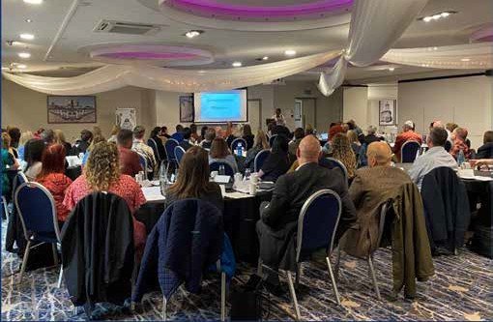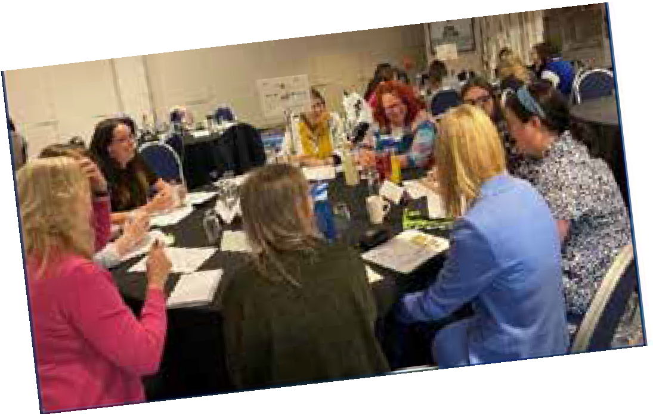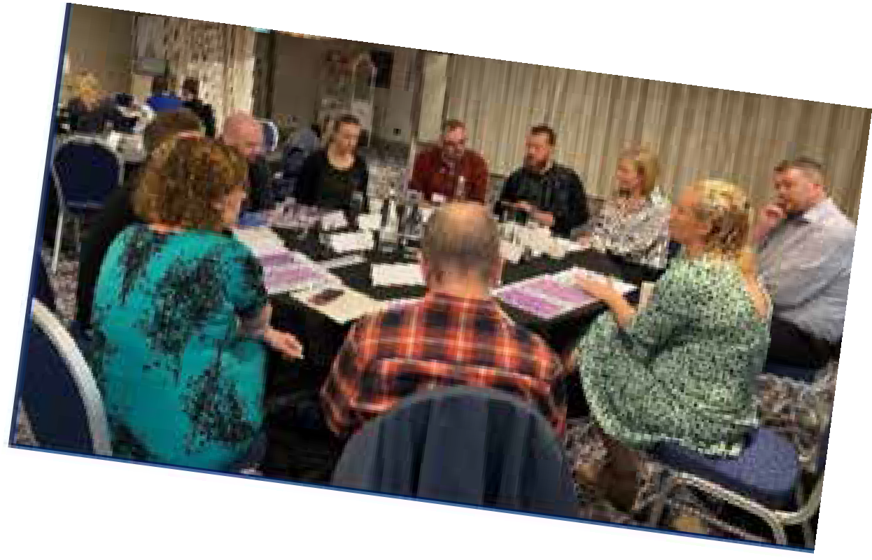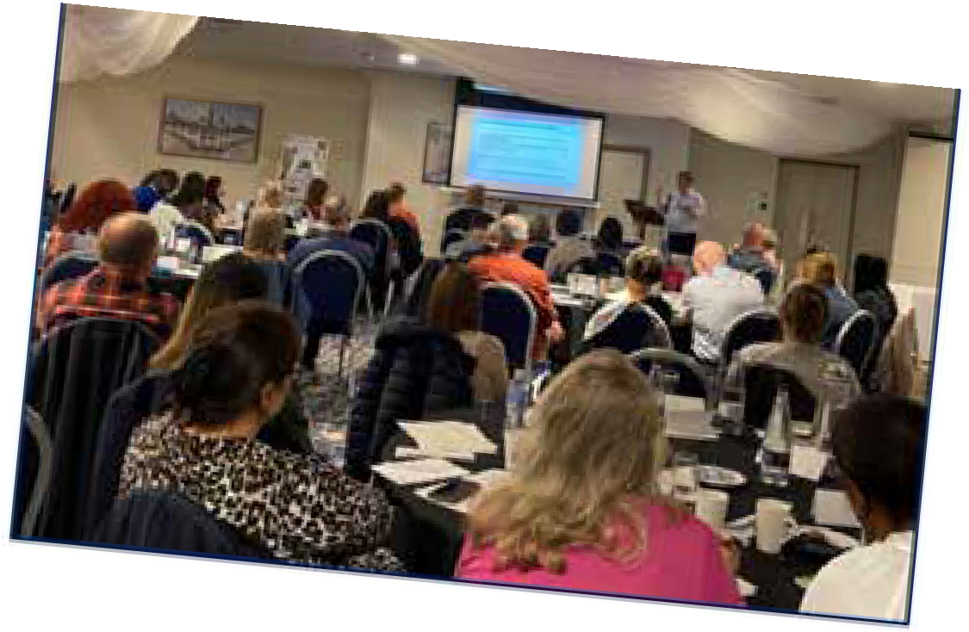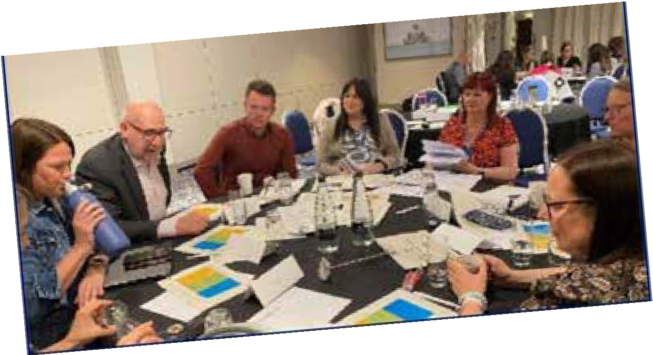Introducing new roles into mental health services, or expanding existing roles, formed a key part of Health Education England’s (now NHS England) Mental Health Programme to help with the staffing crisis and to provide new career pathways for clinicians; within the psychological professions workforce there are now six ‘new roles’. Initial research found that there was disparity around the uptake of these new roles with some teams describing stories of success and innovation, whilst others have faced greater challenges impacting on recruitment practices and retention. A ‘New Roles’ conference was held in June 2024, where partners came together from across Humber and North Yorkshire to discuss the impact and value of the new psychological professional roles. The aim was also to understand the dynamic effects of reorganisation, ensuring new roles and skill mixes benefit service users, and to learn from successes to date.

Following the statutory requirement (introduced in 2022), for all those working in health and social care to participate in the Oliver McGowan Mandatory Training in Learning Disabilities and Autism (or equivalent) we have been working with health, social care, VCSE, education partners to create a model of roll-out that works for Humber and North Yorkshire. This training aims to save lives by ensuring the health and social care workforce have the right skills and knowledge to provide safe, compassionate and informed care
to autistic people and people with a learning disability. Our approach has been to create a model that is collaboratively created, sustainable and utilises the funding from NHS
England for maximum reach and impact. Engaging with over 20 organisations to build the infrastructure for delivery at pace, we are hoping that delivery will begin in Summer 2024. Roll-out will start within the acute health sector and social care, followed by the mental health, learning disability and autism sector, primary care and the voluntary sector. With over 50,000 people to deliver this training to within health and social care alone, it is going to take a number of years to complete. You can find out more about this work in the Learning Disabilities and Autism pages.
We have begun to capture the workforce levels and potential growth needs for learning disability services, although this work is at an early stage. The NHS Long Term Workforce Plans identifies this area of work as a priority, and our early work supports development both in terms of increasing awareness locally and developing our systems in a way to support long term workforce planning.
As well as an increased presence of psychological professional roles, the Humber and North Yorkshire Careers Hub webpages have included additional content for Learning Disability Nursing, promoting this valued profession that really makes a difference to our population. The Learning Disability Nursing Workforce Champion 12-month project, funded by NHS England, has enabled us to increase the visibility of this role; and reach out to higher education establishments, in terms of career conversations with students, reviewing course content and reviewing the spaces on LD Nursing courses.

Priorities 2024/25
    - Sharing best practice.
    - Reciprocal mentoring approach.
    - Continuation of the Oliver McGowan Mandatory Training Rollout.
    - Collaborative Job Evaluation panels.
    - Learning Disabilities and Autism workforce data.
    - Visibility of career opportunities and pathways.

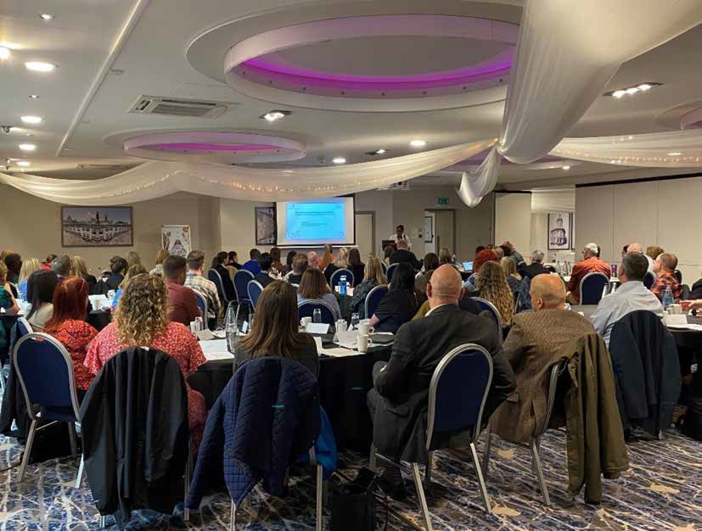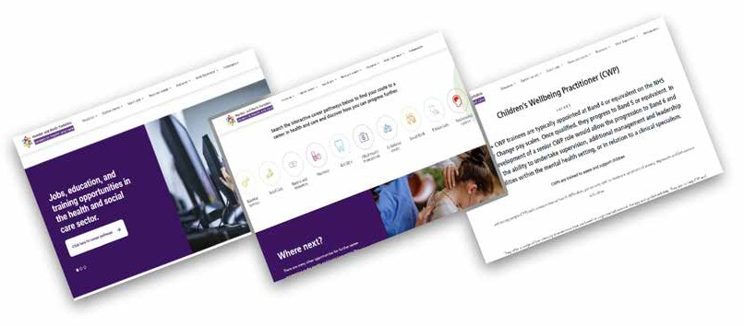Disabilities and Autism Collaborative Programme Annual Report 2023-24

“It is a great privilege to be stepping into the role of Chair of the Culture and Workforce Steering Group for the next cycle of activity. Having been a member of the group for some time, I welcome the opportunity to oversee the evolution of the great work already taking place and thank Sarah for her work up to this point. Delivering upon work that will support the ongoing endeavours of Mental Health, Learning Disability and Autism providers to address workforce challenges and realise positive outcomes for our patients, their carers and our local communities will remain a key area of focus over the months ahead.”

Karen Phillips, Associate Director of People and OD Humber Teaching NHS Foundation Trust

34

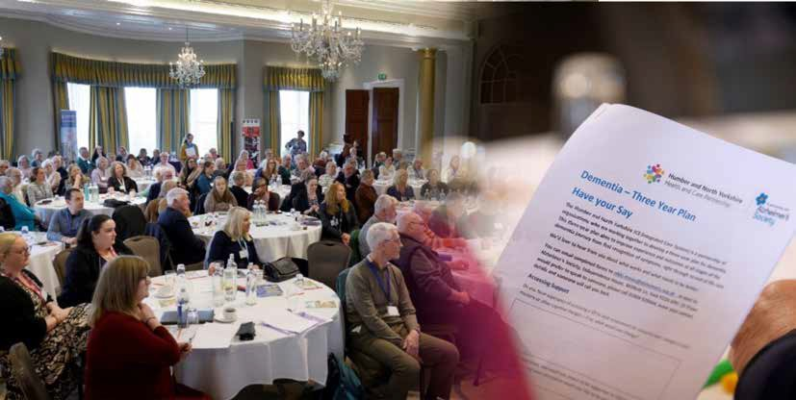
Engagement and Co-production

Adult
We understand that engagement and coproduction are a vital part of our work, and are committed to ensure that this is embedded throughout each of our work streams. Our ‘experts by experience’ include people with first hand experience, their families and carers, and they offer valuable insight, guidance and contributions across all areas of our work.
We strive to ensure that the voices of lived experience are heard, so they can influence decision making, pathway development and service implementation at all levels.
The development of our Humber and North Yorkshire Strategic Coproduction Group, which meets monthly, will support us to do further improve our engagement and coproduction efforts. The group brings together people with lived experience of mental health, learning disabilities and autism services, their carers and families alongside strategic leads for coproduction and relevant stakeholders. The groups aims to ensure that lived experience leadership is valued and enabled at all levels of the Collaborative; to ensure the voice of marginalised and/ or underrepresented people is heard, listened to, and valued; to provide support and oversight of all HNY Mental Health, Learning Disabilities and Autism lived experience groups; to provide a forum for networking and support for coproduction leaders across HNY.

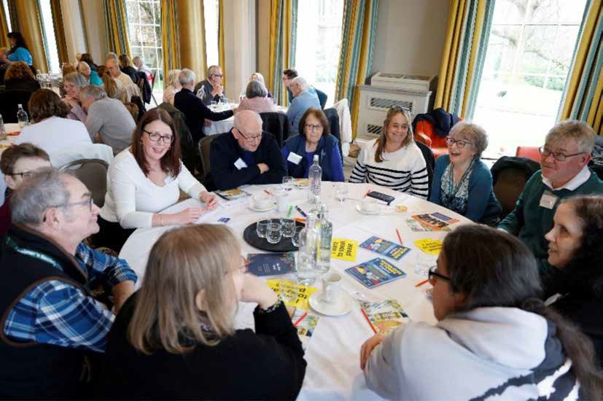

Some of the key objectives that have been identified as areas of focus include:
    - Ensure lived experience representation at key strategic and operational meetings.
    - Work towards a consistent approach to achieving fair remuneration for people bringing their lived experience to improving services.
    - Establish a working group to consider how to ensure that the voices of marginalized and/or underrepresented people are heard, listened to, and valued.
    - Consider expanding the scope of the “Kite mark” quality standard developed in Hull & East Yorkshire (HWE) to support the rest of Humber & North Yorkshire.
    - Develop a plan for identifying and responding to poor quality coproduction: incorporating recommendations for improvement, support and investment.

Coproduction remains of vital importance to the work that we do, and by working closely with people who have first-hand experience of both using and delivering mental health, learning disabilities and autism services to co-produce the solutions to key issues that affect them will only increase the opportunity for success.

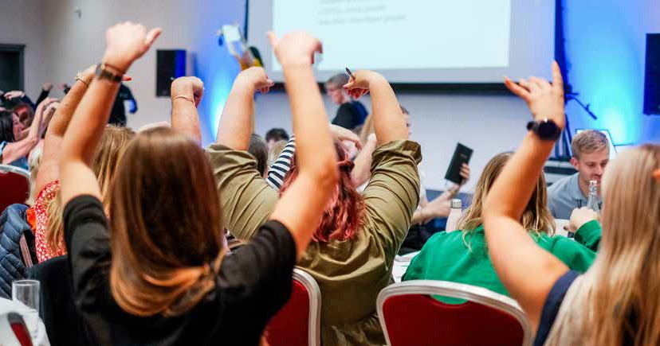
Children and Young People
It has been a very exciting year for the development of children and young people’s engagement and coproduction across Humber and North Yorkshire (HNY). With the support of a growing network of children and young people and a wide range of partners, Nothing About Us Without Us (the Humber and North Yorkshire Children and Young People’s Mental Health Advisory Group) has gone from strength to strength to ensure we meet the statutory guidance for Integrated Care Boards, NHS Trusts, Foundation Trusts and NHS England to ensure that people are appropriately ‘involved’ in planning, proposals and decisions regarding NHS services.
Improved Engagement and Coproduction with Children and Young People is one of 6 priorities in the Humber and North Yorkshire Children and Young People’s Mental
Health Strategic plan. Within this priority there are 4 key deliverables. Below we set out how we have achieved these over the last year.
Establishment of Engagement and Coproduction Strategy: The Humber and North Yorkshire (HNY) CYP Mental Health Engagement and Coproduction Manager has spearheaded the development of an ICS-wide engagement and coproduction strategy and workplan (working in collaboration with the national organisation Young Minds as well as a wide range of partners across Humber and North Yorkshire including health, local authorities, VCS and Children and Young People). This comprehensive framework builds upon existing place-based activity to develop a consistent approach across the system and aims to capture and measure the engagement of Children and Young People and the impact of their involvement. The “On Your Terms” CYP Engagement and Coproduction strategy is now being finalised and is set to be completed by the end of June 2024. The “On Your Terms” strategy promotes a trauma informed approach

to children and young people’s engagement and coproduction and promotes the Lundy model of participation which is a national model of good practice.

Coordination of Communities of Practice:

“Nothing About Us Without Us has become another family for me. We create these amazing opportunities for CYP’s mental health services to be improved and the work that Clair and the team does is absolutely amazing and has such a big impact on young people. There have been so many offers to CYP to become more involved and they have
been taken up almost instantly because CYP are always involved from start to finish.

Aimee (young volunteer):
Recognising the importance of consistency and peer-to-peer support, we have implemented regular communities of practice/networks with place-based engagement and coproduction leads/workers across the ICS partners. This coordinated approach supports work to reduce duplication and ensure that findings from previous engagements and consultations are shared across places. This addresses feedback from young people that they are often asked the same things repeatedly in consultations
without seeing their views and recommendations being actioned. By fostering shared learning
and strategic support, we empower partners to embed engagement and coproduction in all
processes effectively and avoid tokenism. With a network of over 240 staff now established, we are poised to facilitate regular network meetings and communities of practice, promoting consistency, and reducing duplication across the ICS.
Consultancy, Advice and Guidance Provision: The HNY CYP Mental Health Engagement and Coproduction manager provides consultancy, advice, and guidance to a wide range of place-based services and partners, supporting the embedding of evidence-based practice and enabling sustainability of delivery. By sharing resources, skills, and knowledge across the ICS, we empower partners to effectively engage and coproduce with CYP and their families. Over the last year initial workshops and training sessions have been delivered to 49 partners in June/July 2023 at place and at an ICS- wide level, laying the foundation for ongoing support and consultancy. The HNY CYP Mental Health Engagement and Coproduction Manager has also worked with a range of partners and organisations across the patch, providing tailored guidance to ensure consistency of approach and good practice in delivery.
This work has also facilitated opportunities to bring together strategic leaders, operational staff and CYP to coproduce solutions to issues identified in consultations.
These Nothing About Us Without Us events have been system wide and at place to ensure CYP voice and influence is embedded throughout developments and improvements.
Recruitment and Support of Young Volunteers: A key aspect of our strategy involves recruiting, training, and supporting a team of young volunteers with lived experience from across the ICS geography. These volunteers act as advisory groups to relevant steering groups and boards, providing invaluable insights and perspectives on CYP mental health issues. The CYP Mental Health Engagement and Coproduction Manager has successfully established a network of over 200 young people with lived experience, aged 10-25. This diverse group called “Nothing About Us Without Us” represents all six places within the system and a range of protected characteristics.

Actively engaged in various aspects of coproduction, the advisory group has identified four key priorities for the CYP Mental Health Steering Group to address in its forward plan. You can hear about their priorities and work to deliver them in the film they made here: https://www.youtube.com/watch?v=qMvlce6Fa1o&t=187s

Humber and North Yorkshire’s Young People’s Mental Health Advisory Group’s Top Priorities for Improving the Mental Health of Children and Young People
across Humber and North Yorkshire: -

1 | Young people led awareness-raising and training, on the signs and symptoms of mental health problems, and issues impacting young people’s mental health, including LGBTQ+, racism, etc.
2 | Easier access to services
3 | Young people leading on work and courses about children and young people’s mental health, to ensure their voices are heard, their lived experience is valued, and they are not ‘shrugged off’ by professionals
4 | Listen to us more
During the year the work of the volunteers was recognised with 3 Young Volunteers (Aimee Jones, Ryan Laybourne and Alex Porter) receiving Volunteen East Riding Youth Awards for their work on the Nothing About Us Without Us CYP advisory group in October 2023. The HNY CYP Mental Health Engagement and Coproduction Manager also received the Volunteen Champion Award
for championing youth voice, supporting young volunteers, and creating opportunities for CYP to actively inform services.

“I had the privilege of attending a NAUWU session recently, and it was such an energetic, engaging and productive use of time. The group was facilitated brilliantly, participant-led, inclusive, and had some very helpful things to say and input into the topic I asked for their views on. A real asset for the city and for the wider system around children and young people’s mental health.”
Peter Roderick FFPH, Director of Public Health, City of York Council

Leading on System Wide Consultations and Engagement to improve CYP Mental Health
The HNY CYP Mental Health Engagement and Coproduction manager has led on the coproduction of system wide consultations with CYP on:
  - Improving Digital Access
  - Improving support for CYP Admitted to Acute Paediatrics with Mental Health Needs.
  - Improving Access to Mental Health Support and Services.
  - Improving Outcome Reporting.

Overall, we have 50 recommendations across the Thrive framework from these consultations. Moving forward we will be working with partners and the Nothing About Us Without Us CYP Mental Health Advisory group to coproduce solutions to implement CYP’s recommendations and senior leaders’ pledges to deliver change based on these findings.
“Over the past year volunteering for Nothing About Us Without Us really helped me deal with my mental health and also do something positive.”
Ryan (young volunteer)

Highlights and Impact
Our efforts have led to several notable achievements, including:
    - Facilitation of two system wide Humber and North Yorkshire-wide events, bringing together CYP and decision-makers to improve mental health provision. This inspired 27 senior leaders to make pledges in support of our mission, amplifying our impact across the patch.
    - Consultation with 242 CYP to improve access to mental health services, resulting in 50 actionable recommendations.
    - Developing animations to be used in staff training on issues such as improving mental health support and reducing health inequalities for LGBT+ young people and for racially minoritized young people.
    - Feedback from partners who have started to implement the recommendations from the recent consultations.
    - CYP Engagement and Coproduction Manager and 2 Young Volunteers joining the Leading Lundy National Community of Practice .

“I really enjoy being able to have my say and I feel like my voice is always being listened to and valued. It gives me a sense of purpose that I can use my own experiences to hopefully help other young people, and being in spaces with so many people all wanting to improve things provides me with real hope for the future of mental health services. The events are always things I look forward to and I come out of them feeling better and more optimistic.

Keiron (young volunteer)

Priorities 2024/25
    - Implement and embed the “On Our Terms” CYP coproduction strategy.
    - Continue to provide consultancy, support and advice and communities of practice to partners to improve coproduction with CYP.
    - Work with partners across the system to implement the 50 recommendations from the consultations carried out to improve CYP mental health access, outcomes and experience.
    - Work with the young volunteers from “Nothing about us without us” to implement their 4 priorities across the system.

“It’s been a truly valuable support having Nothing About Us Without Us (NAUWU) to work with in the East Riding around youth voice and influence, particularly in regard to improving services and support around youth mental health and emotional wellbeing, which The East Riding Youth Council has identified as a priority area of work for young people. It is exciting to see how future developments of NAUWU in the East Riding
are starting to take place by working in closer partnership to ensure that we can reach more young people across all localities of our large geographic area, as well as raising awareness of effective youth participation and involvement by working together to promote the Lundy Model across the wider Humber area.”

Detty Tyler Community Vision, East Riding VCS provider


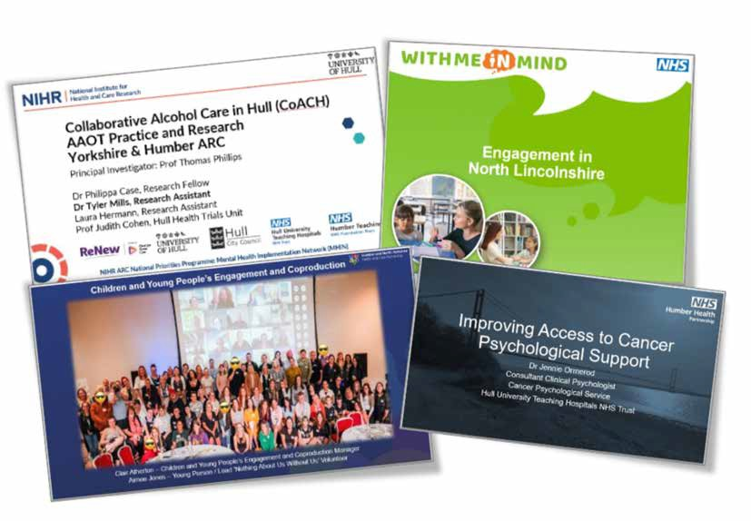Humber and North Yorkshire Health and Care Partnership Mental Health, Learning Disabilities and Autism Collaborative Programme Annual Report 2023-24

Clinical Engagement
Mental Health, Learning Disabilities and Autism Clinical Assembly
The Humber and North Yorkshire Health and Care Partnership Mental Health, Learning Disabilities and Autism Clinical Assembly entered its fourth year of contributing to clinical engagement in 2024. The primary aim of the assembly remains to promote clinical engagement across the collaborative between clinicians and professionals of all disciplines and from all partner organisations (including NHS providers, primary care, local authority, and voluntary organisations).
The assemblies have focussed on topical and system wide issues within the HNY ICS with an aim of supporting the goals and ambitions of the ICS. As in previous years we heard from experts in the field from within and outside our ICS, including academics from local and regional universities who have discussed pertinent research. We have showcased innovative models of care from across our ICS and have collaborated with other programmes within the ICS e.g. the cancer alliance and the smoking cessation programme. The assemblies continue to be regarded as a forum for learning and sharing good practice, facilitating cross-sector collaboration, networking and dialogue.

The following clinical assemblies were held in 2024:
8th February – Children and Young People (CYP) clinical assembly ‘My Voice Matters’. This was held in CYP mental health week and looked at work done locally about improving engagement between services and CYP in order to improve access. We heard from young people involved in the ICB wide ‘Nothing About Us Without Us’ Mental Health Lived Experience Advisory Group.

20th March – The Mental Health, Learning Disability and Autism Collaborative
- our future direction and how you can help shape it. Brent Kilmurray (CEO, TEWV NHS Foundation Trust, SRO, MHLDA Collaborative, ICB Board member for MHLDA Collaborative, HNY Health and Care Partnership) and Alison Flack (Programme Director,
MHLDA Collaborative) spoke at this assembly about priorities for the collaborative and used Mentimeter to gain feedback from attendees. This feedback is invaluable in
understanding the key issues for clinicians and also how the collaborative can support and engage them in strategy development, particularly around achieving parity of esteem for mental health, and in moving to a more preventative approach.
24th April – Improving mental health care for people with a pre-existing cancer diagnosis and improving cancer screening and outcomes in people with severe mental illness (SMI). This was a joint venture with the HNY cancer alliance. We heard about the work being done by the cancer alliance to improve access to psychosocial support for people with a cancer diagnosis. Academics at Teesside University spoke about their research looking at the barriers and facilitators to cancer screening in people with Severe Mental Illness (SMI). This was pertinent, since cancer screening rates are
low in people with SMI and outcomes poor. The assembly was the ‘driver’ to initiate the development of joint work between the HNY cancer alliance and the MHLDA collaborative to improve cancer screening uptake in people with SMI across our ICS.

8th May – Improving the health status of people with a learning disability. At this assembly we heard about the work of the ‘Learning from lives and deaths – People with a learning disability and autistic people’ (LeDeR) programme locally. We also heard about the work being done to support people with a learning disability when admitted or seen within a large acute trust within the ICS.
18th June – Update on CMHT transformation with a focus on rehabilitation. This assembly was jointly chaired by Dr Steve Wright (Senior Clinical Lead, MHLD and Autism collab) and Ros Savage (Carer Rep. Faculty of Rehab. RCPsychiatrists and Co-Chair TEWV Co-Creation Board. Dr Sunil Nodiyal, Consultant Psychiatrist and Rehabilitation Faculty Lead at the RCPsych spoke about the history, the challenges and the recommendations relating to rehabilitation services and supporting recovery across the system. There was an update about out of area rehabilitation placements and plans to reduce these. This assembly initiated the development of an Expert Reference Group to support service improvement.
10th July – Meeting the unmet need in patients with alcohol and complex health problems: a system wide approach - This was a joint collaboration with Prof Tom Philips, University of Hull who put together an exciting programme about complex alcohol issues. This was a first for the assembly, as we had not focused on alcohol issues before and were keen to highlight the gaps in services for this vulnerable group as well as highlighting research and work being done locally to deliver improvements.

24th September – Smoking Cessation, medication, patient safety and planning.
Local Authorities smoking cessation services have received increased funding in order to support work on health inequalities. Our hope is that more people prescribed with psychotropics will be coming forward for smoking cessation interventions, in particular those with a Severe Mental Illness as this is an area of both inequality of access, and of
reduced life expectancy. There are potential clinical safety issues with smoking cessation and psychotropic medications, which should not be a barrier to smoking cessation. In order to support this work an initial meeting was held in July and this clinical assembly was held to develop this further in terms of clinical engagement and to promote wider understanding and discussion.

13th November – Annual Review of the clinical assemblies held in 2024.
We are looking forward to planning the 2025 programme together with feedback from assembly members.
All staff members from partners across the ICS are encouraged to attend and can email
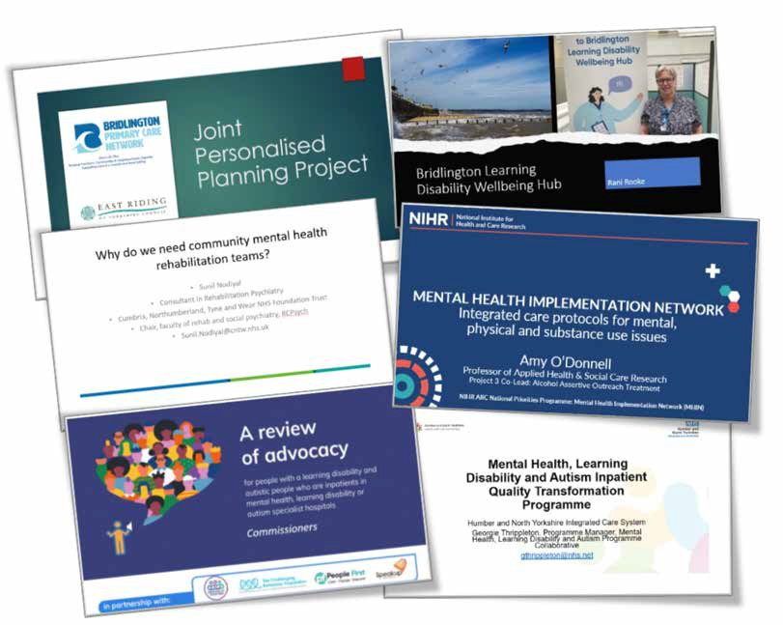
hnf-tr.hnymhpmo@nhs.net to join the clinical assembly mailing list.

The Humber and North Yorkshire Mental Health, Learning Disabilities and Autism International Conference 2023/24
On Thursday 9th November 2023, over 400 colleagues joined us for our fifth annual Mental Health, Learning Disabilities and Autism conference via MS Teams. The conference was titled ‘Let’s Talk Autism’, and topics covered by our speakers included the tension between autistic people being more likely to experience mental health difficulties and their risk of being misdiagnosed with a mental health condition. Our Annual Conference continues to grow from strength to strength as each year more people than before sign up and join us to hear from a range of inspiring local and national speakers.
We were proud to welcome the following keynote speakers:

Professor Sheila The Baroness Hollins, Professor of the Psychiatry of Learning Disability at St George’s, University of London; President of the Royal Medical Benevolent Fund on Autism and Mental Health.
    - Tom Cahill, National Learning Disability and Autism Director, NHSE and Gavin Harding MBE, Learning Disability Advisor, Learning Disability Programme, NHSE giving a national update on the Learning Disability and Autism Programme.
    - Claire Murdoch CBE, National Mental Health Director, NHSE on the national picture for Mental Health.
    - Jill Corbyn, Director, Neurodiverse Connection on Translating the neurodivergent experience, a lived experience approach.
    - Lynsey Webster and Anne-marie Marin, Senior Key Workers, HNY Keyworker service on the HNY Keyworker Service for Children and Young People.
    - Gill Poole, CEO, Matthew’s Hub on Building the Right Support.
Brent Kilmurray, Chair of Humber and North Yorkshire Health and Care Partnership Mental Health, Learning Disabilities and Autism Collaborative Programme and Chief Executive for Tees, Esk and Wear Valley NHS Foundation Trust shared the following updates and successes from the Collaborative:
    - Community Mental Health Transformation has focussed on stronger integration between Primary Care and mental health organisations. Each place has dedicated mental health models based in Primary Care.
    - New mental health practitioner roles (via the Additional Roles Reimbursement Schemes ARRs) have been successfully recruited into most Primary Care Networks within Humber and North Yorkshire.
    - We are proud to share that 82.6% of individuals with a learning disability received an annual health check in 22/23.
    - There has been a reduction in the re-offending rate among young people since the establishment of the Children and Young People’s Trauma Informed Care programme.
    - An Autism and ADHD Pathway steering group has been set up to assess the best way to provide Autism and ADHD services across HNY going forward, following significantly increased demand in North Yorkshire and York. A pilot using revised access criteria and an online profiling tool will run until June 2024.

    - We shared about the work of one of our partners, Care Plus Group. Care Plus Group deliver well established Adult Autism Diagnostic Services and Adult Autism Support Services in North East Lincolnshire. They also work in partnership with local Peer-Led Organisation –The Faraway CIC, which provides a range of 1:1 and group peer-led support and training around understanding Autism, supporting local artists and authors to generate income, providing safe spaces for like-minded individuals to connect, and outdoor green social activities. All of these services work in partnership with other Neurodiversity Services (ADHD, CLDT, FOLS, IST) and other agencies, such as FOCUS Adult Social Care, NAVIGO Mental Health Services, CYP Services, and the DWP.
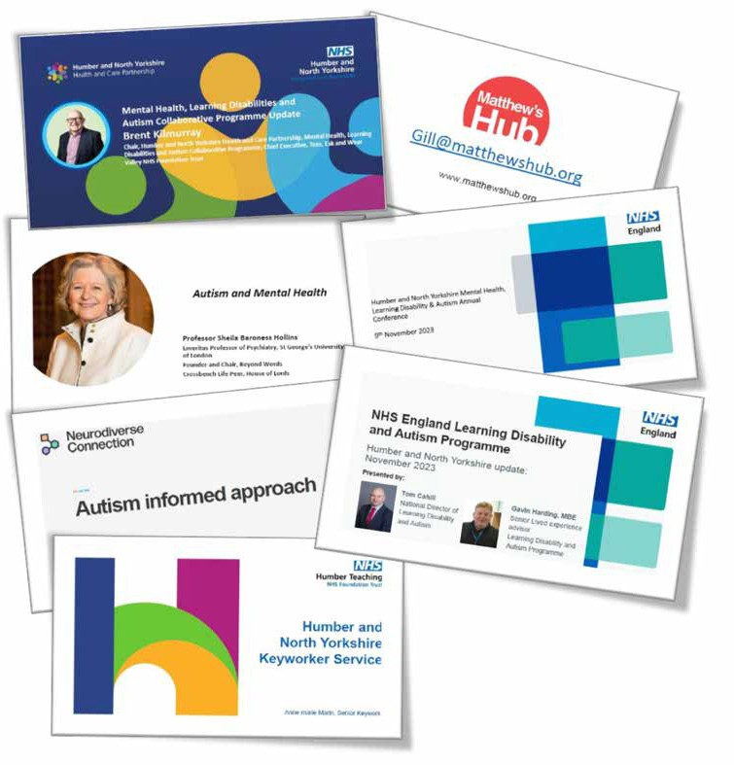

Performance
In 2023/24, we continued to work towards achieving the planned delivery targets of a number of core indicators. This has continued to be a challenge as we deal with increasing pressures on health and care services. Below you can see Humber and North Yorkshire’s performance against some of NHS England’s core indicators.
Target 23/24
Actual March
Actual March
Mar-24 vs
23/24
Plan

Indicator  Inappropriate Adult Acute Mental Health |  | 2023 | 2024 | Mar-23 | Achieved
Out of Area Placement (OAP) Bed Days | 125 | 1,175 | 1,125
Overall Access to Core Community Mental Health Services for Adults and Older Adults with Severe Mental Illnesses | 19,140 | 18,828 | 18,785
Access to Children and Young People’s Mental Health Services | 21,171 | 17,850 | 21,595
Estimated Diagnosis Rate for People With Dementia | 64.4% | 58.1% | 58.6%
Access to NHS Talking Therapies | 3,078 | 2,820 | 2,625
Women Accessing Specialist Community Perinatal Mental Health Services | 1,389 | 992 | 1,139
Inpatients with a Learning Disability and/or Autism Per Million Head of Population | 28.67 | 47.79 | 44.11
Reliance on Inpatient Care for People with a Learning Disability and/or Autism -  Care for Children | 9.01 | 21.02 | 21.02
Learning Disability Annual Health Checks Delivered by GPs | 75% | 80.3% | 77.7%

The following areas saw an improvement on performance against the previous year, or achieved their planned target for 23/24:
    - Learning Disability Annual Health Checks Delivered by GPs: The overall end of year ICB performance exceeded the national target of 75% but not the performance of the previous year. However, there was an overall increase of 5.4% of the Learning Disability register size this year and a total of 2.1% more health checks conducted in 23/24 than the previous year. There was also a notable 22.7% increase in the number of people declining a health check compared to 22/23.

- Access to Children and Young People’s Mental Health Services: CYP Access has seen the biggest relative increase in performance throughout the year. A great deal of work has taken place to ensure all data is flowing to the MHSDS for every CYP Provider (including our NHS funded VCS partners); this has had a significantly positive impact, as evidenced in the year-end performance.
- Estimated Diagnosis Rate for People with Dementia: We did not meet the 23/24 planned target and by year end this was 5.8% below the plan. There has, however, been an increase in the diagnosis rate from the 22/23 position.
- Women Accessing Specialist Community Perinatal Mental Health Services: Although the 23/24 target was not achieved, from March 2023 to March 2024 Perinatal Access has seen a 14.8% increase. Staffing issues at one Provider have now largely been resolved and we expect to see an improvement in performance for North Yorkshire and York over the coming months. If a maternal mental health service can be implemented, workforce will increase, the offer to patients will be more comprehensive, and the overall access performance will improve.
- Inpatients with a Learning Disability and/or Autism: All individual Places are outside of their expected target. Cumulatively this adds up to the ICB total being 21 patients above expectation. However, performance in this area has improved from the 22/23 position and the number of Inpatients with LDA has reduced. LDA placements will form part of the HNY ICB response to the national inpatient review to commence in 24/25.
We still have some challenges to address in a number of areas, including:
- Inappropriate Adult Acute Mental Health Out of Area Placement (OAP) Bed Days: Although the 23/24 target was not achieved, from March 2023 to March 2024 bed days decreased by 4.3%. In 2024/25 the metric for OAP has been changed to measure “active inappropriate OAPs” rather than bed days. The Out of Area Placements programme
has been launched alongside the Inpatient Quality Transformation programme, and a dashboard has now been created to support with this work which flows data from all of our providers.
- Overall Access to Core Community Mental Health Services for Adults and Older Adults with Severe Mental Illnesses: There was a reduction in access from the previous year of 43 patients. We do not anticipate any risk for this metric going into the 24/25 Planning year; the national target is below current levels of performance. It is anticipated that there will be a stepped-increase from August 2024, when Providers are expecting services to be fully transformed (as per the new methodology for this metric).
- Access to NHS Talking Therapies: There was a reduction in access from the previous year of 195 patients. It is likely this reduction is a consequence of the CMH transformation leading to reduced referrals. This metric has been altered for 24/25
Operational Planning and has a new focus on outcome measures (reliable recovery and improvement); this is an area where the ICB is performing well.
- Children and Young People’s Mental Health: Although we have seen an increase in the numbers of Children and Young People accessing mental health support, waiting times for first contact and levels of acuity at first presentation continue to be of concern so more work is needed to improve early intervention and reduce waiting times.

Finance
NHSE allocated £30.1m of SDF investment through the 2023/24 financial period, the majority of which was allocated to continuation or growth of existing funding streams. As in previous years, the Mental Health, Learning Disabilities and Autism collaborative utilised the funding across the full Humber and North Yorkshire footprint to deliver on either ICS wide programmes of work or those prioritised by local need dependent upon the nature of the funding stream.
A summary of the funding showing how it was distributed across a number of key categories is below:

Scheme Type | Funding £m
Children and Young People | 5.1
Mental Health Support Teams | 6.0
Adult Crisis | 2.3
Adult Community | 11.3
DWP NHS Talking Therapies | 1.4
Individual Placement Support | 0.2
Sub-total – Mental Health (MH) | 26.3
Community / CYP Keyworkers (LD&A) | 3.7
Autism | 0.1
Sub-total Learning Disability and Autism (LD&A) | 3.8
TOTAL MH, LD&A | 30.1

What Next?
We will continue to work in collaboration with all partners across the system to drive forward transformation, improvement and achievement of nationally set targets. As well as the key priorities identified within this report, we will also work to:
- Meet the national target that at least 50% of people who complete an NHS Talking Therapies course of treatment should recover.
- Improve access to mental health support for children and young people in line with the national ambition for 21,690 children and young people in HNY aged 0-18 accessing NHS funded services.
- Work towards eliminating inappropriate adult acute out of area placements.
- Recover the dementia diagnosis rate to 62.5%.
- Support over 1300 women to access Perinatal Mental Health support.
- Work towards the national stretch ambition that 75% of people with Severe Mental Illness receive an Annual Physical Health Check.
- Ensure 75% of people aged over 14 on GP learning disability registers continue to receive an annual health check and health action plan.
- Develop new ways of working to ensure commissioning and quality oversight of inpatient placements, as well as out in place repatriation plans for individuals currently out of area.
- Build on the great clinical engagement work led by our Clinical Assembly through which we have welcomed many experts to present to clinicians and professionals on new and innovative models of care, and engage our audiences in rich discussion. Future topics under consideration include: all age pathway for eating disorders including an update on ARFID in CAMHS; needs led transition from CAMHS to Adult services; a focus on carers for people involved in mental health services; new models of care in Mental Health; and ADHD.
ICS 5 year Jo Forward Pla
National Priorities 2023-24
Children and Young People
Think person
- Increase access to community mental health services, including IAPT and EIP
- Recover dementia diagnosis rate to 66.7%
- Reduce out of area placements
- Increase access to children and young people’s mental health services
- Increase access to perinatal mental health services
- Deliver annual health checks to 75% of those aged over 14 on the LD register
- Reduce reliance on inpatient care and improve quality
- Address health inequalities and deliver on the Core20PLUS5 approach
ICS 2 year Operational Plan
Dementia
Community Mental Health
Think family
Perinatal and Maternal Mental Health
Think community
our delivery workstreams
Health Inequalities
Suicide Prevention
Start Well
Live Well
Age Well
Die Well
Learning Disabilities and Autism
- Experts by lived experience
- Co-production and partnerships
- Data and governance
- Focus on quality and efficiency
- Culture development
- Resource triangulation
- Clinical leadership
Adult and Older Inpatient
People Mental Quality Health Transformation
Enablers
int n
Improve outcomes in All Age Autism Assessment and Pathways
Improve health and wellbeing of vulnerable children through Health and Justice Framework for Integrated Care
Improve quality and safety through Inpatient Quality Transformation
National Programmes
Deliver Expand early comprehensive, quality intervention and
care and treatment prevention
Ensure equal access and outcomes for all ages
Reduce reliance on hospital care and Transform community services
NHS Long Term Plan Ambitions
ICS Strategy
Mental Health, Learning Disabilities and Autism Sector Collaborative
Our Vision: We want people of all ages who experience mental health problems, have learning disabilities and/or autism to live healthy lives, be able to achieve their goals and be accepted and supported in the communities they live in
Responsibilities: Deliver key targets; Act between provider members, place, and other delivery partners to deliver
transformation at scale, as part of the ICS strategy; Provider and service strategic transformation
ICB Purpose: improve the lives of the people who live and work in Humber and North Yorkshire
Improving outcomes │ Tackling inequalities │ Enhancing quality and productivity │Supporting social and economic recovery

Meet the Team

Michele Moran, Chief Executive, Humber Teaching NHS Foundation Trust
Michele is a Nurse, Midwife and Health Visitor by background and has more than 35 years’ experience of front-line roles in NHS management and care. Michele was appointed to the role of Chief Executive at Humber on a permanent basis in February 2017. Prior to this Michele was Chief Executive in Manchester for four years. Michele served as Deputy Chief Executive/Chief Operating Officer/ Chief Nurse at Leeds and York Partnership NHS Foundation Trust for seven years.
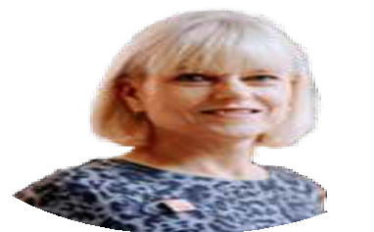Michele has extensive experience across all sectors in the NHS, with substantial experience in integrating systems and is an advocate for integrated care, speaking at many national conferences on collaboration in care. Michele is Chair of the Yorkshire and Humber Clinical Research Network.
Michele is committed to putting patients at the heart of everything that we do and supporting staff health and wellbeing. A qualified nurse, mental health nurse and midwife, Michele also has a Master’s degree in Health Services Management from the University of Manchester.

Alison Flack,
Programme Director
Alison plays a pivotal role in the Humber and North Yorkshire Health and Care Partnership Mental Health, Learning Disabilities and Autism Collaborative Programme as the Programme Director. She is passionate about ensuring our partners across the patch work together collaboratively to improve mental health outcomes for everyone in our area. Alison has a wealth of experience working at a senior level in health and care organisations, and is proud to be part of a team transforming and improving mental health services for our communities.

Pete’s role as finance lead for the partnership sees him coordinate the sharing and reporting of financial
information across partners. This includes the coordination and monitoring of investments to support national planning priorities. Pete is passionate about directing investments
to the most beneficial areas to ensure people receive high quality treatment and support.

Pete Beckwith,
Chief Finance Officer

Doug Flockhart,
Head of Performance and Programme Delivery
Doug has worked in health and care organisations across the Humber and North Yorkshire patch since 2007. He became increasingly interested in the wider health and care system, particularly what can be achieved when partner organisations work collaboratively. Over the past few years, Doug has focused on integration and system development work, taking up a programme lead role in the Humber and North Yorkshire Health and Care Partnership Mental Health, Learning Disabilities and Autism Collaborative Programme in 2018.
Mental Health is now rightly receiving the focus and attention it deserves and, through the work of our programme, Doug wants to ensure all of our residents have access to the support they need in a way that works for them and their families.



Clair Atherton,
Children and Young People’s Engagement and Coproduction Manager,
Children and Young People’s Mental Health and Trauma Informed Care Programme
With a background in community and youth work, Clair has extensive experience of engaging vulnerable groups across a range of sectors and specialises in coproduction with children and young people.
Before joining the team Clair worked on a Strategic Children and Young People’s Mental Health Programme, involving young people with lived experience in the development of services, campaigns, training, and resources, and supporting partners across education, Local Authority, health, and the Voluntary and Community Sector to develop and embed effective coproduction practices. Clair is passionate about creating opportunities for Children and Young
People to thrive and be recognised as partners in influencing change, and actively promotes a culture of ‘nothing about us without us’.

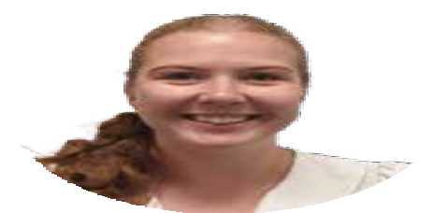Emily Davey, Programme and Performance Manager
Emily is an alumnus of the General Management Training Scheme with the NHS Leadership Academy. Since graduating from the scheme Emily has led on work to improve physical health checks for people with Severe Mental Illness in Humber and North Yorkshire. She is passionate about meeting the physical health needs of individuals with mental illness, and most recently led the launch of a pilot service for individuals with Type 1 Diabetes and an Eating Disorder in Hull and East Riding.

Tracy Fee,
Clinical Lead for CYP Mental health and the CYP Trauma Informed Care Programme
Tracy joined the team in February 2024 on a part time basis,as the clinical lead for Children and Young People’s Mental Health programme and the Children and Young People’s Trauma Informed Care programme.
Tracy has extensive experience within the NHS, particularly in CAMHS, spanning a 30 year career which also incorporates experience in the private and voluntary sectors.
As a mental health nurse and social worker, Tracy has worked as a Clinician, Therapist and Senior Leader in various roles including areas of Looked After Children, Fostering and Adoption, Youth Offending in both community and residential/inpatient settings.

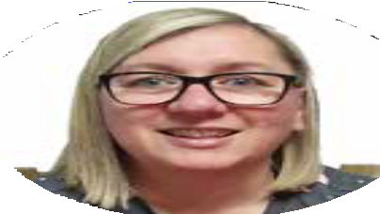Lisa provides administration support to the Children and Young People’s Trauma Informed Care Programme and the wider collaborative. She has previously worked in a strategic Children and Young People’s Mental Health Programme, and is excited to be working with people who are passionate about improving the mental health of children and young people.

Lisa Hudson,
Senior Administration Assistant, Children and Young People’s Mental Health and Trauma Informed Care Programme

Cat joined the team from outside the NHS, with a background in education and more recently working on a strategic Children and Young People’s Mental Health Programme within a Local Authority. Cat has extensive experience in driving initiatives within schools during her time as a Senior Leader and Headteacher, and also implementing national policy and practice change across the schools in a city. Cat has taken on the role as Programme Partnership Manager of the Children and Young People’s Trauma Informed Care Programme.

Cat Jones,
Programme Partnership Manager, Children and Young People’s Trauma Informed Care Programme

Katy Marshall, Strategic Workforce and Cultural Lead
With a background in strategy, leadership, engagement and organisational development, Katy joined the team to provide strategic direction on workforce and culture, and the learning disability and autism agenda. She is passionate about working collaboratively and believes this is the best way to shape how we move forward as a community. Being part of the ICS enables her to support positive change on a wide scale and work with lots of great organisations and individuals to meet the needs of our local populations and workforce.

Dr Stella Morris,
Clinical Lead
Stella is a consultant psychiatrist with over 30 years’ experience of working in mental health services. In collaboration with Dr Steve Wright, she is focusing on improving clinicians’ engagement with the work of the ICS and has established the Mental Health, Learning Disability and Autism Clinical Assembly. In addition, she contributes to the wider programme and strategic work and co-chairs the ICS wide Severe Mental Illness physical health steering group.

Ryan Nicholls, Suicide Prevention Programme Lead
With a background in health and wellbeing, health inclusion and improvement, Ryan joined the team in August 2023 to focus on the wider prevention agenda. He is passionate about making a positive change for his community and promoting the VCSE services that are available locally and regionally. Connecting across the ICB will be a true focus in the future for Ryan to ensure that
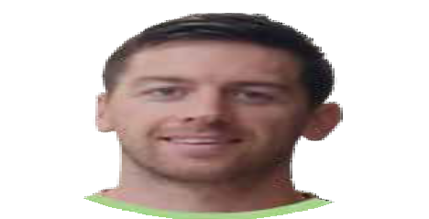Suicide Prevention is on everyone’s radar and how working together collaboratively will benefit all.

Lynnette leads on the Community Mental Health transformation and NHS talking therapies, including the specialist areas of Early intervention psychosis & Individual placement support.

Lynnette Robinson, Mental Health Programme Lead

Gail Teasdale, Children and Young People’s Mental Health Programme Lead
Gail joined the collaborative in November 2021 after 20 years leading on system change and commissioning services for Children and Young People’s health at place across local authority children’s services, public health and CCGs. Her work to improve outcomes for Children and Young People has been recognised as national
best practice by the Department of Health, Department for Education, Local Government Association and the National Children’s Bureau. Gail leads the Children and Young People’s Mental Health Programme, working with a wide range of partners at place including VCSEs, Local Authorities, and Health commissioners and providers. Gail is passionate about ensuring that the voice and influence of Children and Young People with lived experience is embedded throughout our work.

Georgie Thrippleton, , Perinatal Mental Health Programme Lead; Inpatient Quality and Safety Programme Lead
Georgie is passionate about improving mental health support for mothers and families in the perinatal period. By ensuring mother’s mental health needs are met early, this greatly improves outcomes for babies and improves relationships. Georgie wants to work with women, families and all partners to reduce the stigma surrounding mental health as new parents as mental illness at this time is very common and with the right support outcomes for families are positive.
Georgie is also enjoying the new challenge as the Inpatient Lead, working with partners to cease inappropriate out of area hospital placements by having the right support locally both in the community and within an inpatient setting.

Kelly provides administrative support to the programme. She feels lucky to be part of a passionate team and to have the opportunity to support the various workstreams. Kelly enjoys being able to assist the programme leads and help contribute to improving the mental health care for the local community.

Kelly Toes,
Administration Team Lead

Kayleigh Wells,
Performance Analyst
Kayleigh is a relatively new member of the Humber Mental Health Collaborative, joining the team in November 2023 as a Performance Analyst. Her background lies within data analysis, a field she has worked within for over 15 years; starting her career with Humberside Police before moving to the NHS in 2020.
She describes her job as “telling stories with numbers”. Kayleigh is an avid supporter of cross-organisational collaboration and truly believes in the benefit of data sharing across the wider sectors.



Gemma Willingham-Storr,
Dementia Programme Lead
Gemma is a Learning Disability Nurse and DBT Therapist by background and has worked in the NHS for 16 years.
Gemma is also the Clinical Lead for Out of Area Placements in the NHSE North East and Yorkshire Regional Mental Health Team. Having worked across Mental Health and Learning Disability services for the last 16 years, and as a carer for a loved one with dementia, Gemma has seen first- hand some of the challenges faced by our population and is keen to support systems to make meaningful sustainable
change. Gemma is keen to make sure that people are at the heart of all that we do and that their voices truly contribute to the way in which our services work.

Debbie provides support to the Humber and North Yorkshire Partnership (Mental Health, Learning Disabilities and Autism) Senior Management Team. She enjoys the variation in her role, and the opportunities to play a part in helping to shape the future of mental health, learning disabilities and autism services across the Humber and North Yorkshire.

Debbie Wilson,
Senior Administration Officer


Katy Winfield, Community of Practice Manager, Children and Young People’s Trauma Informed Care Programme
LeadWith over 20 years’ experience of working within health service settings, supporting vulnerable and socially isolated individuals, Katy has a broad understanding of their needs and a passion to make a positive impact. Katy thrives when engaging with communities and services that work to make a positive difference. Katy brings an extensive amount of knowledge and experience working within a clinical setting,
and supporting staff to achieve positive outcomes, with service user groups experiencing health inequalities.

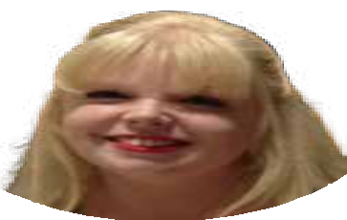

Nicola Wood,
Finance and Performance Manager
Nicola enjoys supporting the programme with the monitoring and reporting of the funding coming into the system. She enjoys working with partners across the system to ensure funding is invested to achieve the best outcomes for our population.
Mental Health and Learning Disabilities are subjects close to her heart after seeing the impact that the challenges surrounding accessing the right services, not only in the NHS but in the wider social care and local authority sector, has placed on her loved ones over her lifetime. She believes that good Mental Health is a priority for all and rightly deserves de-stigmatisation.

Dr Steve Wright,
Clinical Lead
Steve is a psychiatrist and a former medical director with Tees, Esk and Wear Valleys (TEWV) NHS Foundation Trust.
Alongside his role as a clinical lead for mental health in Humber and North Yorkshire, he is co-chair of York Mental Health Partnership in a voluntary capacity and remains actively involved in research. In HNY his key
areas of support are the community (and now) inpatient transformation programmes as well as the mental health clinical assemblies with his colleague Dr Stella Morris.
He has worked in early intervention services since their introduction, supporting their increasingly preventive role. In recent years he has also been working with international collaborators to promote a “whole person, whole life, whole community” approach to mental health including developing a system-wide learning partnership with Trieste in Italy.



If you would like to find out more about the work of the Humber and North Yorkshire Health and Care Partnership,
please get in touch.

Write to us: Humber and North Yorkshire Health and Care Partnership,

Health House, Grange Park Lane, Willerby, HU10 6DT
Email: hnyicb.contactus@nhs.net
website: humberandnorthyorkshire.org.uk

