Learning Disability and Autism Mortality Review (LeDeR) Programme
Easy Read Annual Report 1st April 2024 to 31st March 2025

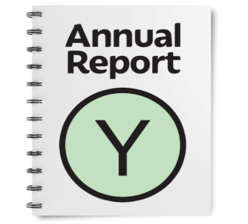  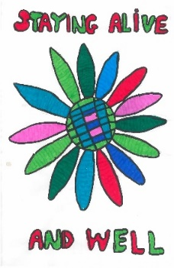   | There is lots of information in this report.  And this report will talk about sad things
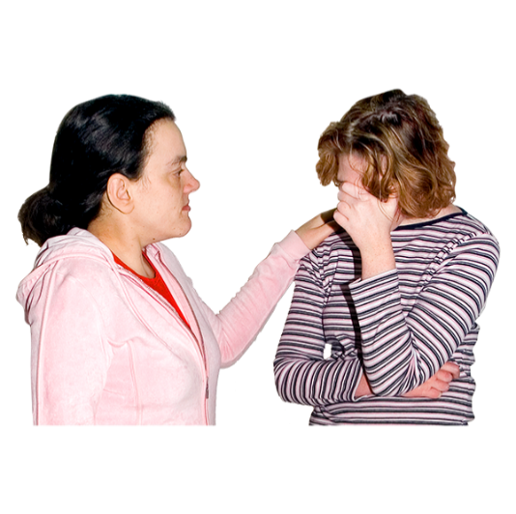 | About people with a learning disability and autistic people dying too young.  You may want to have someone to support you when you read this
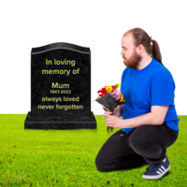 | What Is LeDeR?  Learning from the lives and deaths of people with a learning disability and autistic people
 | What happens?  When someone who had a learning disability dies, there is always a review of the care they were given when they died.  Since 2022 every autistic person who dies also has a review
 | Why?  It is important to learn what we can do better so we can improve care for people
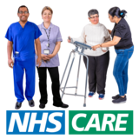 | Health care should be accessible for everyone  To give people with a learning disability and autistic people good health care
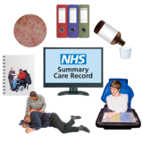 | How?  A reviewer will look at a person's medical records
 | They will talk to the person's family and carers or anyone else important to that person
 | A panel meeting is held every month to hear what the reviewer found out.  They agree any learning and actions
 | An Initial Review is a quick look at a person's life and death.  The panel look at where people lived, who cared for them and how their health was managed
 | A Focused Review looks closer at a person's life and death.  We do this where we think there is important learning and where we can improve
 | A Focused Review is always done for someone who was autistic without a learning disability
 | A Focused Review is always done if a person was from an ethnic background that was not white British
 | A Focused Review was done in our area if the person died from cancer
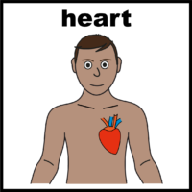 | A Focused Review was done in our area if the person died from heart problems
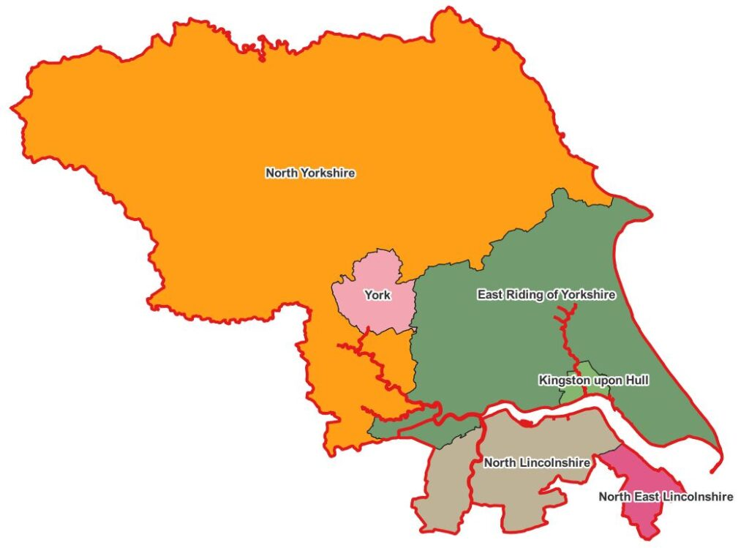 | We do a review for anyone with a learning disability or autism who died in:  North Yorkshire  York  East Riding  Hull  North Lincolnshire  North-East Lincolnshire
 | Not many autistic people were reported to LeDeR so their reviews are not included in the results of the report
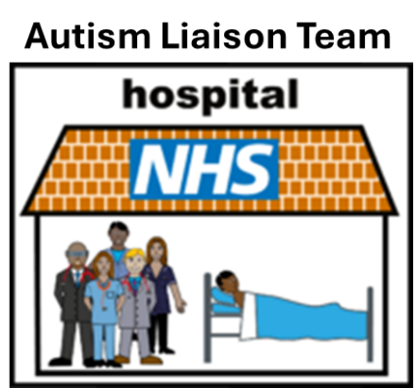 | Hospitals are doing lots of work to get to know the autistic people who come to hospital to offer them help and support
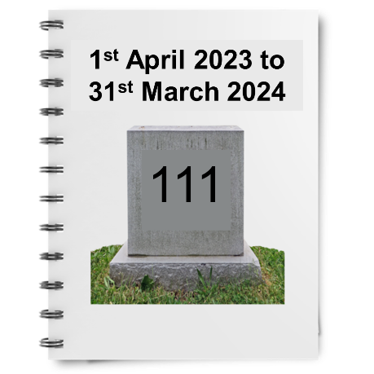 | Last year, between 1st April 2024 and 31st March 2025 we were told about 111 people with a learning disability that had died across our area
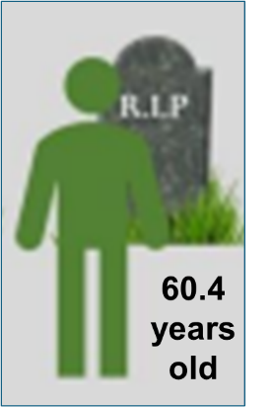 | The average age of death was 60.4 years old  Some people died much older than this and some people died much younger
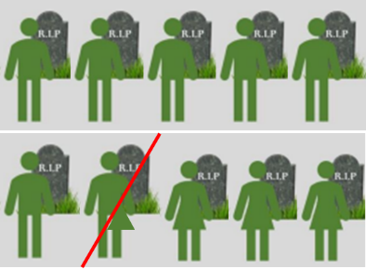 | 65% or 6.5 out of 10 people who died were male
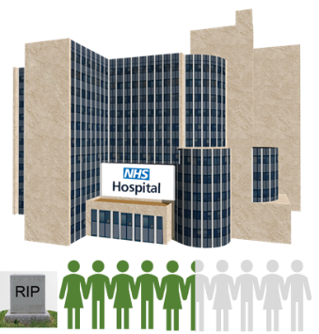 | 54% or 5.4 out of 10 people died in hospital
 | 41% or 4.1 out of 10 people died in their own home or care home
 | We completed reviews for 110 people who died between 2022 and 2024 this is because some reviews take a long time to finish
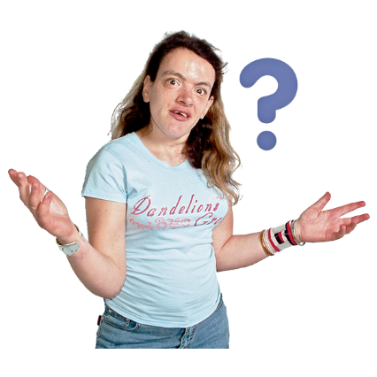 | What did we find out?
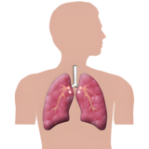 | Respiratory or lung conditions was the highest cause of death  Lung conditions caused or partly caused the death of 48 people
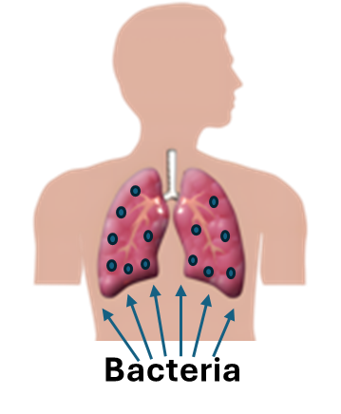 | One of the lung conditions was Aspiration Pneumonia  This is when bacteria gets into the lungs when we accidentally breathe in food, drink or saliva instead of swallowing  It can cause a severe infection and be a cause of death
Cardiac or heart conditions was the second highest cause of death
Heart conditions caused or partly caused the death of 15 people
Cancer was the third highest cause of death
Cancer caused or partly caused the death of 6 people
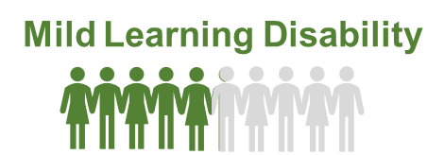 | 50% or 5 out of 10 people who died had a mild learning disability
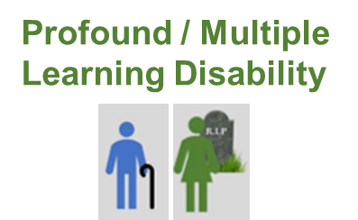 | People with a profound or multiple learning disability died slightly younger
 | Most people had their annual health check at their GP surgery
 | Some people had not had an invite for their annual health check
 | Some people did not attend for their annual health check and they were not followed up
 | Some people did not have their cancer screening tests
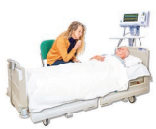 | Most people were supported well at the end of their life
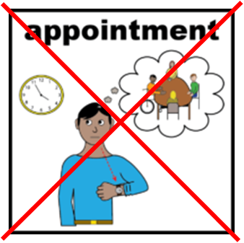 | A few people did not have follow-up appointments for scans and tests
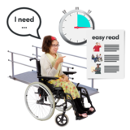 | 7 people were not given enough reasonable adjustments  4 people did not have an accurate record of their learning disability
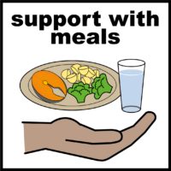 | A few people could have received better support in hospital to eat and drink properly
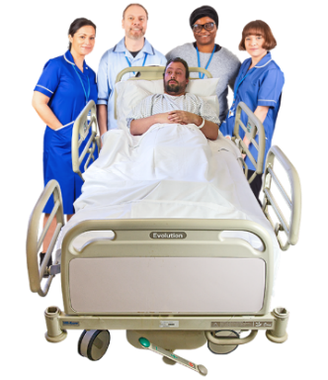   | But most people received good care while they were in hospital
 | Most people lived in the same place for many years with people who knew them and loved them  50 people had good or excellent support from carers
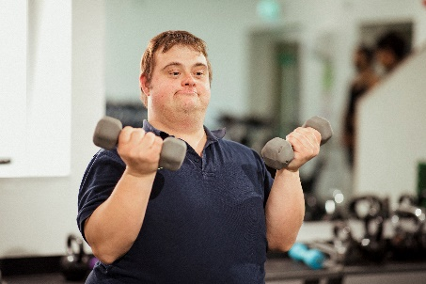 | Most people had full and active lives
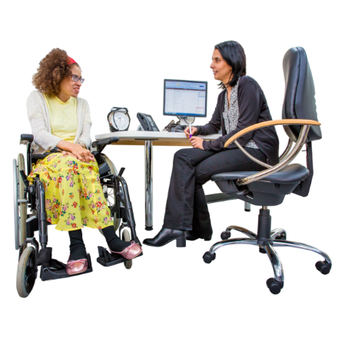 | The care people had from their GPs was very good  8 people had excellent support from their GP
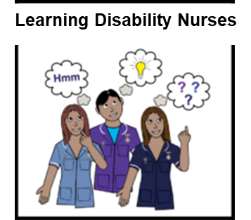 | The care people had from learning disability nurses was very good
 | What we will do…
  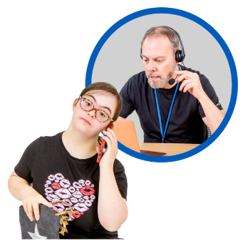 | Hospital staff are working to make sure that people are contacted when they miss appointments
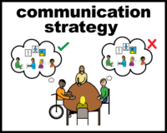 | We will communicate better with the Medical Examiner to make sure we know about every person who has died
 | Every person who dies from Aspiration Pneumonia or Aspiration will get a focused review
 | We need to make sure everyone attends their cancer screening appointments
 | We will look at how to make eating and drinking in hospitals better for people
 | The LeDeR Steering Group has a plan so we know what we need to do to make things better

Author: Jenny MacNeill
Patient Safety Lead, Deputy Local Area Contact, Mental Health Nurse,
Humber and North Yorkshire Integrated Care Board
Easy Read by: Tanja Entwistle
Learning Disability and Autism Project Officer
Humber and North Yorkshire Integrated Care Board
Created with the use of Photosymbols and pictures from the image bank of Leeds and York Partnership NHS Foundation Trust

