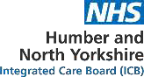

**NHS Humber and North Yorkshire**

**Integrated Care Board**

**Governance Handbook**

|  |  |
| --- | --- |
| **Authorship:** | **Governance and Compliance Team** |
| **Board / Committee Approval:** | **Integrated Care Board** |
| **Approved date:** | **July 2025** |
| **Review Date:** | **June 2026** |
| **Target Audience:** | **Integrated Care Board, Integrated Care Partnership, Committees and Sub-Committees, ICB Staff, agency and temporary staff & third parties under contract** |
| **Version Number:** | **3.0** |

**The online version is the only version that is maintained.**

**Any printed copies should, therefore, be viewed as ‘uncontrolled’.**

**and as such may not necessarily contain the latest updates and amendments.**

**POLICY AMENDMENTS**

Amendments to the document will be issued from time to time. A new amendment history will be issued with each change.

|  |  |  |  |  |  |
| --- | --- | --- | --- | --- | --- |
| **New version number** | **Issued by** | **Nature of amendment** | **Approving body** | **Approval date** | **Date published on website** |
| 1.0 | Executive Director of Corporate  Affairs | New Document | ICB Board | 01/07/22 | 01/07/22 |
| 2.0 | Executive Director of Corporate  Affairs | Annual Review | ICB Board | 08/05/2024 | 09/05/2024 |
| 3.0 | Executive Director of Corporate Affairs | Annual Review | ICB Board | 09/07/2025 | 16/07/2025 |

**Contents**

1.0 INTRODUCTION 4

1.1 Who are we? 4

2.0 PURPOSE OF THE GOVERNANCE HANDBOOK AND ACCOUNTABILITY 4

3.0 DECISION MAKING: OUR GOVERNANCE 4

3.1 The Role of Our Board 4

3.2 Integrated Care Partnership 5

3.3 Our Governance Structure 5

3.4 Functions and Decisions Map 6

4.0 KEY DOCUMENTS 7

4.1 Scheme of Reservation and Delegation (SoRD) 7

4.2 Standing Financial Instructions (SFIs) 7

4.3 Scheme of Financial Delegation (OSD) 7

5.0 GOVERNANCE POLICIES 8

6.0 APPENDICES 8

APPENDIX A – NHS Humber and North Yorkshire ICB Governance Structure 9

APPENDIX B– Specialist Roles 10

APPENDIX C - List of providers of primary medical services; Humber & North Yorkshire 10

# INTRODUCTION

# Who are we?

The NHS Humber and North Yorkshire Integrated Care Board (ICB) is a statutory NHS body with those functions and duties conferred to it as set out within the Health and Care Act 2022 (The Act).

The ICB forms part of the Humber and North Yorkshire Integrated Care System (ICS) which brings together a partnership of the NHS, top tier local authorities and other health and care providers, including the voluntary, community and social enterprise sectors. It covers a diverse geographical area of more than 1500 square miles taking in cities, market towns and remote rural and coastal communities.

As per The Act, the ICB works together to achieve the triple aim of:

* better health and wellbeing for everyone,
* better care for all people, and
* the sustainable use of resources.

# 2.0 PURPOSE OF THE GOVERNANCE HANDBOOK AND ACCOUNTABILITY

The NHS Humber and North Yorkshire ICB Governance Handbook sets out our governance structures and arrangements, including respective terms of reference, decision making powers and membership.

The Governance Handbook brings together a wide range of documents that support our Constitution and our commitment to the principles of good governance. This handbook is not a legal requirement; however, it will assist the ICB to build a consistent corporate approach and form part of the corporate memory.

Amendments to any documents contained within this Governance Handbook are approved in line with the arrangements detailed within the Constitution.

The Governance Handbook will be updated at least annually and will be published on the [NHS Humber and North Yorkshire ICB website](https://humberandnorthyorkshire.icb.nhs.uk/governance-publications/).

# DECISION MAKING: OUR GOVERNANCE

# The Role of Our Board

The NHS Humber and North Yorkshire ICB has a unitary Board, led by a Chair and Chief Executive. The purpose of the Board is to govern the organisation effectively and maintain public confidence in the discharge of its duties and ensure that services are safe, high quality, patient-centred and represent value for money. It provides strategic leadership within a framework of practical and effective controls which enables risk to be assessed and managed. Further details of the ICB Board can be found on our [website](http://humberandnorthyorkshire.icb.nhs.uk/board-members/).

The function of the Board includes allocating resources, financial accountability for the public money it is responsible for, establishing joint working arrangements with partners, and leading system-wide action on workforce, digital and data capabilities, estates, and procurement.

The Board may delegate functions and budgets to place-based partnerships and to sector collaboratives while maintaining overall accountability for the delegation of NHS resources within its area. Arrangements for the reservation and delegation of powers are set out in the ICB's Scheme of Financial Delegation (SOFD) & Scheme of Reservation and Delegation (SoRD) (see Appendix C).

# 3.2 Integrated Care Partnership

Under the Health and Care Act 2022, every ICS is required to establish an Integrated Care Partnership (ICP) as a statutory committee. The Integrated Care Partnership is a statutory committee jointly convened by six Local Authorities and the NHS Humber & North Yorkshire Integrated Care Board and comprises of a broad alliance of organisations and other representatives as equal partners concerned with improving the health, public health and social care services provided to their population.

The ICP’s core statutory duty is to develop and publish an Integrated Care Strategy for the ICS area. This strategy must be informed by Joint Strategic Needs Assessments (JSNAs) and Health and Wellbeing Board priorities, and it should guide how the ICB and local authorities plan and deliver services to improve population health and reduce inequalities

The ICP Terms of Reference outlines how this requirement has been implemented. Humber and North Yorkshire Integrated Care Partnership published our refreshed [Integrated Strategy for Wellbeing, Health and Care](https://indd.adobe.com/view/22476d3b-afd0-4e28-af0d-7be658b88b3b) which builds on existing strengths, such as the person-centred and strengths-based approach, while identifying areas for targeted investment.

# Our Governance Structure

Our Governance Structure sets out accountability of Committees and forums to the Board.

The Board has established the following Committees to assist it in the discharge of its functions. The responsibilities Including remit, and membership of each of the Committees are set out in their individual Terms of Reference. Please see below for details of the committees and full Terms of Reference are published on our website <https://humberandnorthyorkshire.icb.nhs.uk/governance/>

**ICB Committees of the Board**

* Audit Committee
* Remuneration Committee
* Quality Committee
* Integrated Care Partnership Committee
* Finance, Performance and Delivery Committee
* Workforce Committee (Workforce Board)
* Transition Committee

**Committees required by National Guidance or Delegation Agreements**

* Specialised Commissioning Joint Committee
* Pharmaceutical Services Regulations Committee (Committees in Common)
* North East Lincolnshire Joint Committee
* North Lincolnshire Joint Committee
* York Health & Care Partnership Executive Committee
* North Yorkshire Joint Committee
* Hull Joint Committee
* East Riding Joint Committee

Other board groups have been established to provide stakeholder informed advice to the board and its committees, helping shape strategy and policy (SRO led)

Our Governance Structure Summary can be found at Appendix A.

**Place Based Arrangements**

Place-based arrangements are central to the Humber and North Yorkshire operating framework, which identifies delegation to our six Places as key to the sustainability of health and care systems (Hull, East Riding of Yorkshire, North Lincolnshire, North East Lincolnshire, City of York, North Yorkshire). These arrangements enable the development and delivery of services with local system partners, focusing on the needs of local populations. The ICB created legal and governance mechanisms to form Joint Committees and section 75 agreements across all six Places. This will support the upcoming 10-year Health plan, focusing on system transformation and integration.

**Sector Collaboratives**

Sector collaboratives are arrangements where providers come together to work across the ICS, with a shared purpose, best practices, reduce unwarranted variation, and improve overall care to deliver specific objectives aligned with the system's strategic priorities (Each provider within these collaboratives works together to achieve agreed-upon goals, contributing to the overall health and wellbeing of the population.

There are four sector collaboratives:

* Neighbourhood Health Provider Collaborative
* Collaborative of Acute Providers
* Primary Care Collaborative
* Mental Health, Learning Disabilities and Autism Collaborative

# Functions and Decisions Map

The Functions and Decisions Map sets out, in summary form, a guide to the decision-making and accountability arrangements within the ICB and between the ICB and its wider partners within the Integrated Care System. The ICB Functions and Decisions Map can be viewed via the following link:

<https://humberandnorthyorkshire.icb.nhs.uk/governance-publications/>

# KEY DOCUMENTS

# Scheme of Reservation and Delegation (SoRD)

The 2022 Act (or 2012 Act as amended in 2022) provides the ICB with powers to delegate its functions to certain bodies (such as committees or collaboratives) and certain persons. The ICB has decided that certain decisions may only be exercised in formal session. These decisions and those delegated are contained in the ICB’s Scheme of Reservation and Delegation.

The Scheme of Reservation and Delegation has been drawn up to ensure the delegated functions regulate the proceedings of the ICB and can fulfil its obligations, as set out largely in the 2022 Act (or 2012 Act as amended in 2022) and related Regulations. They are effective from the date the ICB is established.

The ICB Scheme of Reservation and Delegation (SORD) sets out those decisions that are reserved to the ICB Board and those decisions that have been delegated to either committees, individuals, or others. The SORD should be read in conjunction with the Operational Scheme of Delegation which sets out the detailed operational approved financial delegated limits.

Failure to comply with Scheme of Reservation and Delegation may be regarded as a disciplinary matter that could result in formal action and/or dismissal.

The ICB’s Scheme of Reservation and Delegation (SoRD) can be viewed via the following link: <https://humberandnorthyorkshire.icb.nhs.uk/governance-publications/>

# Standing Financial Instructions (SFIs)

The Standing Financial Instructions are part of the ICB's control environment for managing the organisation’s financial affairs. They contribute to good corporate governance, internal control and managing risks. They enable sound administration, lessen the risk of irregularities and support commissioning and delivery of effective, efficient, and economical services. They also help the Accountable Officer and Director of Finance and Investment to discharge their responsibilities effectively. They should be read in conjunction with the ICB's SoRD.

The Standing Financial Instruction and supporting detailed financial policies shall have effect as if incorporated into the ICB's Constitution.

The ICB Standing Financial Instructions can be viewed via the following link:

<https://humberandnorthyorkshire.icb.nhs.uk/governance-publications/>

# 4.3 Scheme of Financial Delegation (OSD)

The ICB’s Scheme of Financial Delegation supports the ICB’s Scheme of Reservation and Delegation and sets out who has ‘day to day’ operational decision making defining delegated limits and routes of escalation for sign off where appropriate and lays down financial limits to the authority of ICB and others to commit or approve expenditure on behalf of the ICB.

This should be read in conjunction with the Scheme of Reservation and Delegation and Standing Financial Instructions.

The ICB’s Operational Scheme of Delegation can be viewed via the following link:

<https://humberandnorthyorkshire.icb.nhs.uk/governance-publications/>

# 5.0 GOVERNANCE POLICIES

The ICB has a suite of mandated documents and policies as an essential part of the safe and effective operation of the Integrated Care Board as a statutory NHS body. Each of the policies and documents supplements the ICB Constitution and supports the ICB’s accountability as a public body.

The suite of governance documents can be viewed via the following link:

<https://humberandnorthyorkshire.icb.nhs.uk/governance-publications/>

# 6.0 APPENDICES

**Appendix A:** NHS Humber and North Yorkshire ICB Governance Structure Summary

**Appendix B:** Specialist Roles

**Appendix C:** List of providers of primary medical services; Humber & North Yorkshire

 

# APPENDIX A – NHS Humber and North Yorkshire ICB Governance Structure

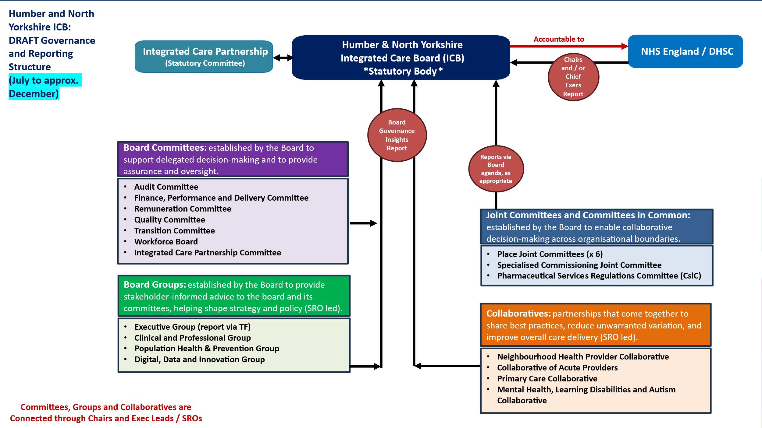

# APPENDIX B– Specialist Roles

In July 2024, NHS England published updated guidance on Integrated Care Board Constitutions and Governance, including revised specialist executive lead roles. The guidance reinforces the requirement for ICBs to assign clear executive leadership responsibilities at board level for key population groups and statutory functions. These roles are designed to engender board level commitment and focus around key areas of service development or delivery. Details of Specialist roles can be viewed via the following link: <https://humberandnorthyorkshire.icb.nhs.uk/board-members/>

# APPENDIX C - List of providers of primary medical services; Humber & North Yorkshire

The following provides a link to where the list of primary medical service providers within Humber and North Yorkshire can be viewed:

<https://humberandnorthyorkshire.icb.nhs.uk/governance-publications/>